Exam 3 (December 9, 2003)
Please read the problems carefully and answer them in the space provided. Write on the back of the page, if necessary. Show all your work. Partial credit will be given unless specified otherwise.

Problem 1 (12 pts, briefly justify your answers to get credit):

Consider The vessels in the figure below. They each contain liquids of the same density. The vessel that has the greatest pressure at its base is

- 1
- 2
- 3
- 4
- 5
- any vessel, since all vessels have the same pressure at the base.

An identical pebble sits on the bottom surface of each vessel. In which container will the apparent weight of the pebble be the least? That is to say, in which vessel will the normal force of the base on the pebble be least? Assume the fluid is incompressible (has constant density throughout the volume).

- 1
- 2
- 3
- 4
- 5
- It will be the same in each vessel.

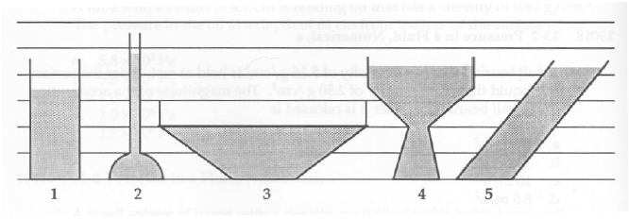
Problem 2 (10 pts, briefly justify your answers to get credit):

Two identical cylindrical disks have a common axis. Initially one of the disks is spinning. When the two disks are brought into contact, they stick together. Which of the following is true?

- The total kinetic energy and the total angular momentum are unchanged from their initial values.
- /12
- /10
- /10
- /10
- /10
- /16
- /16
- /16
__________

tot /100

- Both the total kinetic energy and the total angular momentum are reduced to half of their original value.
- The total angular momentum is unchanged, but the total kinetic energy is reduced to half its original value.
- The total angular momentum is reduced to half its original value, but the total kinetic energy is unchanged.
- The total angular momentum is unchanged, and the total kinetic energy is reduced to one-quarter of its original value.

Problem 3 (10 pts):

Spaceman Spiff flies his spacecraft near two planets whose centers of mass are separated by a distance d. He finds that when he is at a position P between the two planets (as shown below) the gravitational field is zero, i.e. there is no net gravitational force on Spiff and his spacecraft. Spiff determines through a careful measurement that the point P lies at a distance X=4d/5. “Ah ha!” Spiff declares. “Now I know the mass of the large planet (M) in terms of the mass of the small planet (m)!”

Duplicate Spiff’s calculation here. That is to say, calculate how much more massive is the large planet than the small planet in terms of multiples of the small planet’s mass.
M
m
d
P
X

Problem 4 (10 pts, no partial credit):

A particle of mass m is moving with a velocity v in the yz plane as shown in the figure. The vector that most nearly represents the angular momentum about the x axis is
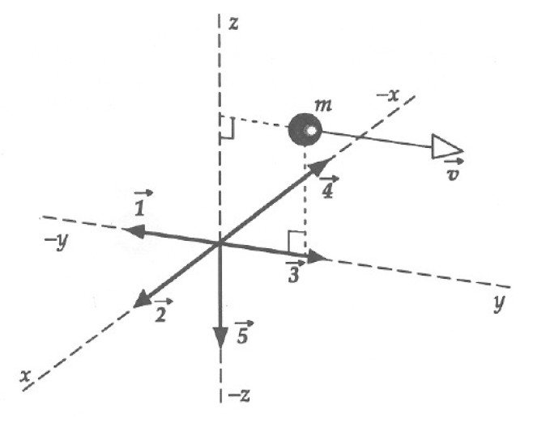
- 1
- 2
- 3
- 4
- 5

Problem 5 (10 pts, no partial credit):

A wheel is rotating clockwise on a fixed axis perpendicular to the page (vector 3 is into the page, vector 1 is out of the page). A torque that causes the wheel to slow down is best represented by the vector

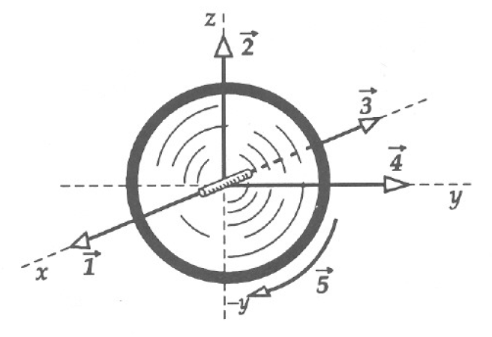
- 1
- 2
- 3
- 4
- 5

Problem 6 (16 pts):

Overcome with Christmas spirit. Joe Cool decides to put Christmas lights around his dorm window on the second floor of Hoeing. He asks you help him carry a ladder to the base of the wall underneath his window. Unfortunately, you find the ground beneath his window covered with a sheet of ice. Joe tells you not to worry because he is an expert in matters of physics and love. Joe says, “Chill out, man! Look! The top edge of the ladder is rubbery and there will be a great deal of friction between the ladder and the brick wall of the building. This will keep the ladder from slipping even though the bottom of the ladder is on a frictionless surface (ice).”

Briefly discuss the merits of Joe’s argument. Is he right? Why or why not? Will Joe be able to share his Christmas spirit with lights around his window in Hoeing, or will Joe’s scheme end in disaster?
Problem 7 (16 pts):

In a weak moment, Joe Cool and his brother, Jethro, decide to play a practical joke on their buddies in the dorm. They plan to dump a box of marbles in the hallway and pull the fire alarm. (Joe and Jethro are Cool, obviously. And they have perfect teeth. But they aren’t real bright.) Anyway, they have a box of marbles that is 1 ft by 1 ft in width and 2 ft high.
They place the box of marbles on a board and lift the board up by one end. The box of marbles will tip over and spill when the board makes what angle with the floor? Assume the friction between the board and the bottom of the box is sufficient that the box does not slide as the board is lifted.
Problem 8 (16 pts):

A 300 gram metal top spinning at 10 rev/s makes an angle of 30 degrees to the vertical. The center of mass of the top is 4 cm from its tip along its symmetry axis. The moment of inertia of the spinning top is 1x10⁻³ kg-m² and it has a total volume of 2x10⁻⁴ m³. The top is spinning on the bottom of a large tub with a flat, frictionless bottom.

- What is the angular velocity of precession of this top?

- Now the tub is filled with water and the top is spun again. Aside from the presence of the water, consider the initial conditions to be identical to those in part (a). What is the angular velocity of precession of the top under water? Assume the water is non-viscous (i.e. no friction).

$\begin{aligned}\text{sinθ}=\frac{\text{opp}}{\text{hyp}} \\ \text{cosθ}=\frac{\text{adj}}{\text{hyp}} \\ \text{tanθ}=\frac{\text{opp}}{\text{adj}} \\ v=v_{o}+\text{at} \\ x=x_{o}+v_{o}t+\frac{1}{2}{\text{at}}^{2} \\ x=x_{o}+\left(\frac{v_{o}+v}{2}\right)t \\ v^{2}=v_{o}^{2}+\text{2a}(x−x_{o}) \\ x−x_{o}=\int_{t_{o}}^{t}{\text{vdt}} \\ v−v_{o}=\int_{t_{o}}^{t}{\text{adt}} \\ \sum{\vec{F}=m\vec{a}} \\ F_{\text{friction}}=μ_{k}N \\ F_{\text{friction}}=μ_{s}N \\ F_{\text{centripetal}}=\frac{{\text{mv}}^{2}}{r}\end{aligned}$ $\begin{aligned}{\vec{F}}_{\text{spring}}=−k(\vec{x}−{\vec{x}}_{o}) \\ \text{work}=\int{F⋅\text{ds}} \\ \text{power}=\frac{\text{dw}}{\text{dt}} \\ \vec{A}⋅\vec{B}=\left|\vec{A}\right|\left|\vec{B}\right|\text{cos}θ=A_{x}B_{x}+A_{y}B_{y}+A_{z}B_{z} \\ s=\text{rθ} \\ v=rω \\ a=rα \\ ω=ω_{o}+αt \\ θ=θ_{o}+ω_{o}t+\frac{1}{2}{αt}^{2} \\ {\text{KE}}_{\text{translation}}=\frac{1}{2}{\text{MV}}^{2} \\ {\text{KE}}_{\text{rotation}}=\frac{1}{2}{Iω}^{2} \\ I=\sum{m_{i}r_{i}^{2}}=\int{r^{2}\text{dm}} \\ X_{\text{cm}}=\frac{\sum{x_{i}m_{i}}}{M}=\frac{\int{\text{xdm}}}{M}\end{aligned}$
θ
hyp
adj
opp

$\begin{aligned}\frac{d(x^{n})}{\text{dx}}={\text{nx}}^{n−1} \\ \int{x^{n}\text{dx}}=\frac{x^{n+1}}{n+1}\end{aligned}$ $\begin{aligned}I=I_{\text{cm}}+{\text{mh}}^{2} \\ \vec{τ}=\vec{r}×\vec{F}=I\vec{α}=\frac{d\vec{L}}{\text{dt}} \\ \vec{L}=\vec{r}×\vec{p}=I\vec{ω} \\ P=P_{o}+\text{ρgh} \\ \text{AV}=\text{constant} \\ P+\frac{1}{2}{\text{ρv}}^{2}+\text{ρgy}=\text{constant}\end{aligned}$

