Exam 1 (February 18, 2003)
Please read the problems carefully and answer them in the space provided. Write on the back of the page, if necessary. Show all your work. Partial credit will be given.

Problem 1 (multiple choice, no partial credit, 20 pts):

i) Two point charges of unknown magnitude and sign are a distance d apart. If the electric field strength is zero at a point between them on the line joining them, you can conclude that
- the charges are equal in magnitude but opposite in sign.
- the charges are equal in magnitude and have the same sign.
- the charges are not necessarily equal in magnitude but have opposite sign.
- the charges are not necessarily equal in magnitude but have the same sign.
- there is not enough information to say anything specific about the charges.

ii) In the figure, the direction of the electric field at a point equidistant from two equally charged bodies A and B is indicated by a vector. The direction of the vector indicates that
- both A and B are positive.
- both A and B are negative.
- A is positive and B is negative.
- B is positive and A is negative.
A
B
E
- B is negative and A is neutral.

iii) A cubical surface with no charge enclosed and with sides 2.0 m long is oriented with right and left faces perpendicular to a uniform electric field $\vec{E}$ of 1.6x10⁵ N/C $\hat{i}$. The net electric flux through the cubical surface is approximately
- Zero
- 6.4x10⁵ Nm²/C
- 13x10⁵ Nm²/C
- 3.2x10⁵ Nm²/C
- 0.4x10⁵ Nm²/C

Problem 2 (20 pts):
- /20
- /20
- /20
- /20
- /20

____________

tot /100

A charged comb will often attract small bits of dry paper that fly away when they touch the comb. Briefly explain why this is so.

Problem 3 (20 pts):

Prove that the magnitude of the electric field at a point just outside a uniformly charged spherical shell is σ/ε_{o,} where σ is the charge per unit area on the shell.
Problem 4 (20 pts):

A long, conducting wire of radius A is carrying a linear charge density (charge per unit length) of +2Q/L = +2λ. This wire is surrounded by a two concentric, conducting, thin, cylindrical shells of radius B and C, repectively. The inner shell, or sheath, with radius B, has a linear charge density of +Q/L = +λ. The outer shell, or sheath, with radius C, has a linear charge density of -Q/L = -λ. Find the electric field in the regions
A
B
C

- r<A

- A<r<B

- B<r<C

- C<r

A
B
C

Now suppose the conducting sheaths/shells with r=A and r=B are joined together by a conducting wire. Now what is the electric field in the regions

- r<A
Conducting wire

- A<r<B

- B<r<C

- C<r

Problem 5 (20 pts):

A positive point charge +Q is located at x = -a.

- How much work is required to bring a second equal positive point charge +Q from infinity to x = +a?

- With the two equal positive point charges at x = -a and x = +a, how much work is required to bring a third charge -Q from infinity to the origin?

- How much work is required to move the charge -Q from the origin to the point x = 2a along the semicircular path shown in the sketch below?

0
+a
+2a
-a
-Q
+Q
+Q

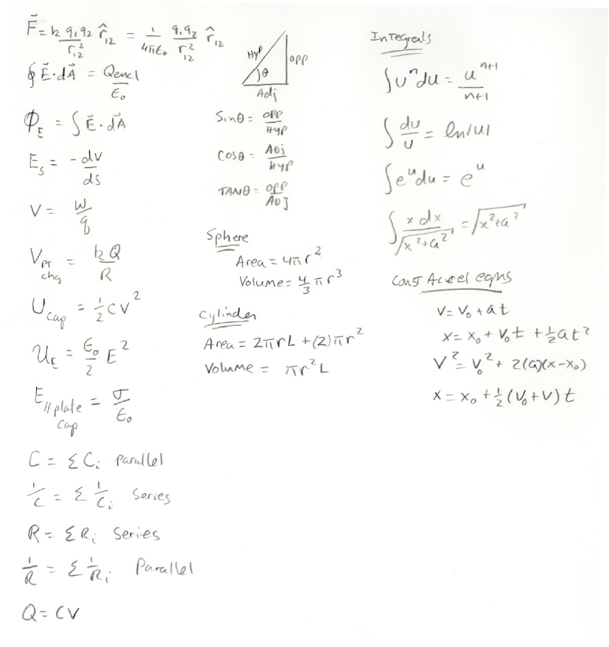

Potentially useful formulas

