Exam 2 (March 25, 2003)
Please read the problems carefully and answer them in the space provided. Write on the back of the page, if necessary. Show all your work. Partial credit will be given.

Problem 1 (24 pts, 6 parts at 4 pts per part):

a) A positively charged particle is coming out of the paper toward you (with a nonzero velocity) as it enters a region with a uniform magnetic field to the right. Draw and/or state the direction of the force of the magnetic field on the moving particle at this instant.
B
V

b) A negatively charged particle moves through a region of uniform magnetic field as shown in the sketch below. At t=0, both the B field and the particle velocity are in the plane of the paper. Draw and/or state the direction of the force of the magnetic field on the moving particle at this instant.
B
V
-q

c) Two parallel conducting wires carry positive current as shown in the sketch below. Draw and state the direction of the magnetic field at point A due to the top current.
I
I
A

d) Given your answer to the part above, draw and state the direction of the force on the bottom wire at point A due to the magnetic field generated by the current in the top wire.

The sketch below shows two circular, conducting loops in the plane of the page. The uniform magnetic field coming out of the page in the middle of the center loop is increasing in strength as a function of time.

e) State/draw the direction of the induced current in the left-hand loop due to the changing magnetic field?

f) State/draw the direction of the induced current in the right-hand loop due to the current in the left-hand loop.
B
Problem 2 (19 pts):
- /24
- /19
- /19
- /19
- /19

____________

tot /100

To the dismay of his med school classmates, Fred Coulomb decided to drop out of med school to work for Defillibrators-R-Us. In his laboratory at work, Fred has a box measuring 0.6 cubic meters in size where he can create a uniform magnetic field to make measurements relevant to the development of the latest and greatest defillibrators. What minimum energy does it take to create an magnetic field of strength 2 T in the box?

If the 2T magnetic field is oriented downward and Fred shoots an electron (mass=9x10⁻³¹ kg, charge=1.6x10⁻¹⁹ C) of energy 2500 electron-volts (1 eV=1.6x10⁻¹⁹ J) horizontally into the box, it follows a horizontal circular path of what radius while it is in the volume of the box?

Problem 3 (19 pts):

Consider two conducting rods that slide frictionlessly on two conducting rails as shown in the sketch below. Each rod moves at a constant speed of 5 m/s with respect to the rails. The right-hand rod moves to the right and the left-hand rod moves to the left. The magnetic field has a uniform magnitude of 2 T and is pointed into the paper. The resistance on the lower rail has a value of R=100 ohms. What is the direction and the magnitude of the current passing through the resistor R?

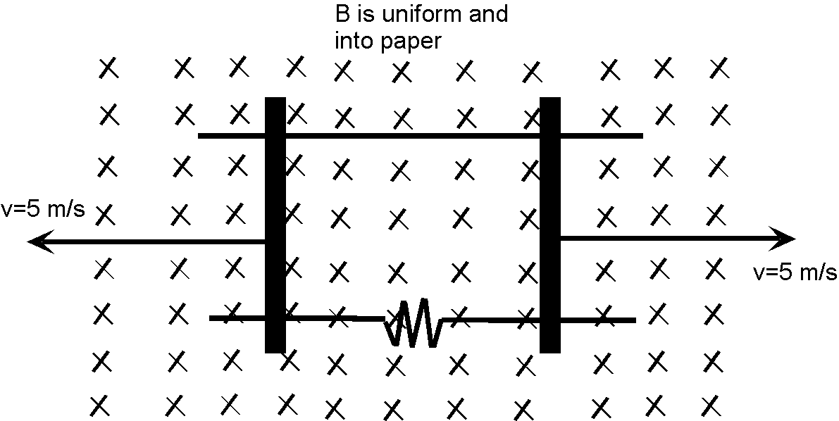
L=0.1 m
Problem 4 (19 pts):

Consider the circuit sketched below. Determine the current in this circuit at points A, B and C. You must use the notation and the (arbitrarily chosen) current directions I have put on the sketch in order to receive credit. (This is essential for the grading of the problem.)

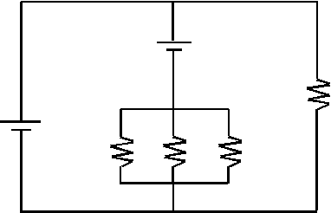
R₁=2Ω
R₄=4Ω
R₃=2Ω
R₂=2Ω
ε₂=6 V
ε₁=12 V
A
B
C
I_{A}
I_{B}
I_{C}
Problem 5 (19 pts):

Consider a uniformly charged, thin, nonconducting, spinning disk as illustrated in the figure below. The radius of the disk is R. The uniform area charge density on the disk is σ. The angular velocity of the disk spinning about an axis through its center is ω. Derive and circle the correct expression for the magnetic field at the very center of the disk. Hint: First, consider the field from a small part of the disk at a radius r with thickness dr (along r). Think of this as producing a magnetic field at the center which is the same as that of a current in a circular wire. You must show how you got your answer to get full or partial credit.

a) $μ_{o}\text{σω}R$ b) $\frac{μ_{o}i}{2R}$ c) $\frac{μ_{o}\text{σω}R}{2}$ d) $\frac{μ_{o}σ}{2R}$ e) $\frac{μ_{o}iπR}{2}$

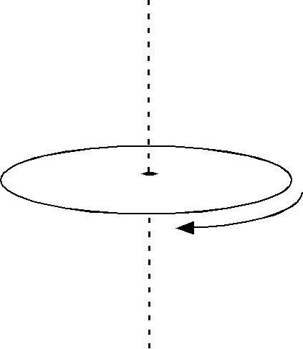
R

Potentially useful formulas

