Exam 2 (March 23, 2004)
Please read the problems carefully and answer them in the space provided. Write on the back of the page, if necessary. Show all your work. Partial credit will be given unless stated otherwise..

Problem 1 (8 pts, no partial credit given):
A
i

What is the direction of the magnetic field at point A due
to the current i ?

Problem 2 (8 pts, show work/logic to get credit):
+q
v
B down
What is the direction of the force of the magnetic field
on the charge q ?

X

X

X

X

X
X

X

X

X

X
X

X

X

X

X
X

X

X

X

X
+q
v
B into paper
Problem 3 (8 pts, show work/logic to get credit):

What is the direction of the force of the magnetic field
i
X

X

X

X

X
X

X

X

X

X
X

X

X

X

X
X

X

X

X

X
+q
v
B into paper
on the charge q ?

Problem 4 (10 pts, show work/logic to get credit):
i

Suppose the magnitude of the current shown is decreasing with time.
What is the direction of the induced current in the loop?
Please justify your answer to get credit. (Assume the loop and the line
are in the same plane.)
Problem 5 (9 pts, show work/logic to get credit):
- /8
- /8
- /8
- /10
- /9
- /9
- /12
- /12
- /12
- /12

____________

tot /100

A ⁷Li nucleus contaminates a beam of protons used for cancer treatment. The ⁷Li nucleus has a charge of +3|e| and a mass of 7m_{p}. Protons have a charge of +1|e| and a mass of 1m_{p}.
Both the protons and the lithium move in a plane perpendicular to a magnetic field. The particles all have the same momentum. The ratio of the radius of curvature of the path of the proton (R_{p}) to that of the ⁷Li nucleus (R_{Li}) is

- R_{p}/R_{Li}=3
- R_{p}/R_{Li}=1/3
- R_{p}/R_{Li}=1/7
- R_{p}/R_{Li}=3/7
- R_{p}/R_{Li}=7
- None of the above

Problem 6 (9 pts, show work/logic to get credit):

A capacitor consisting of two charged parallel plates exists in a vacuum. A dielectric is inserted into the space between the two parallel charged plates. When the dielectric is inserted, the energy stored in the system

- is increased
- is decreased
- stays the same
Problem 7 (12 pts, show work/logic to get credit):

Welcome to the real world! Shortly after graduation you land a great job at Burt’s Cloning Research and Donut Emporium. Because of your stellar grades in physics and your love for donuts you are hired into the position of biophysical engineer! Your boss hands you a small dish of some important biological crud made from E. Coli. This dish has two conducting leads emanating from the sample, as shown in the sketch below. Your boss also hands you one ammeter, one voltmeter and a 12 volt battery and he says, “Yo hotshot! Determine the electrical resistance of this substance.” Please connect the given circuit elements in a sketch below of a circuit that would allow you to measure the resistance and please your new boss.
Biological crud
Problem 8 (12 pts, show work/logic to get credit):

If you walk near a room containing an instrument that uses a magnetic field (such as an NMR), you will often see a sign warning people with a heart pacemaker to stay away. Briefly explain why this is so using the concepts we have discussed in class recently.
Problem 9 (12 pts, show work/logic to get credit):
Professor Earnest Fudd, world famous marine biologist, encounters some difficulties with a sensitive instrument recently installed in his remote research outpost near Miami Beach. While pondering his difficulties over a Twinkie one evening, he notices a large power line passing over his small research outpost. He becomes concerned that the magnetic field generated by the power line might be the source of difficulty with his instrument. Professor Fudd calls the power company and is told the wires are 30 meters high (above his instrument) and that the line operates at 10 kilovolts and provides a maximum of 40 Megawatts to the local area.

Estimate the magnitude of the magnetic field that the power line generates at Professor Fudd’s instrument.
Problem 10 (12 pts, show work/logic to get credit):

Referring to the circuit below:

- What is the total capacitance in this circuit?

- What is the total resistance in this circuit?

- If the switch S is closed at t=0, how much time passes before the capacitors are half charged?

- At the time the capacitors are half charged, how much charge is on C₁?

S
R₁=1000 Ohms
R₂=2000 Ohms
C₁=10 microFarad
C₂=15 microFarad
ε=25 V

- At that time the capacitors are half charged,
how much charge is on C₂?
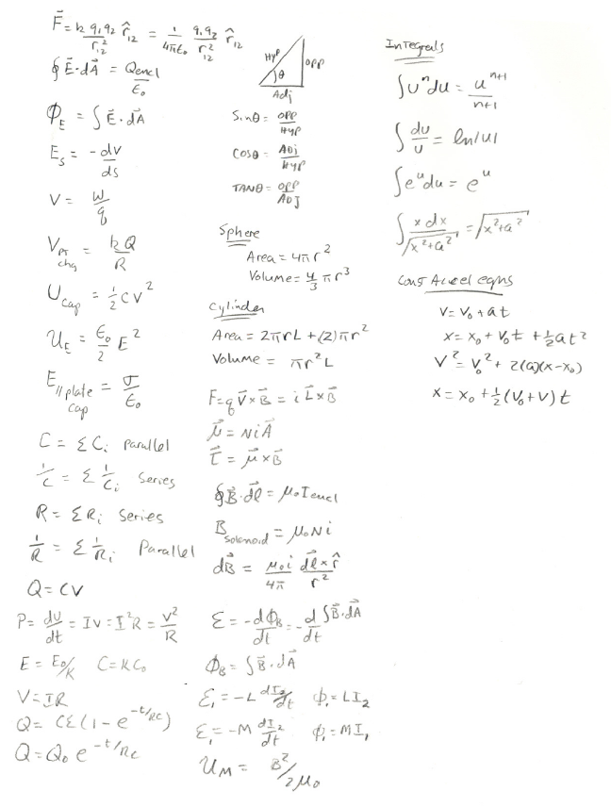

Potentially useful formulas

