Final Exam (May 5, 2004)
Please read the problems carefully and answer them in the space provided. Write on the back of the page, if necessary. Show all your work. Partial credit will be given unless stated otherwise. Where partial credit is available, no credit will be given if you do not justify your answer. On this exam, no justification is required for problems 1-8. Justification is required for all the other problems.

Problem 1 (3 pts, no partial credit given):

The force between two small charged particles is found to be F. If the distance between them is doubled without altering their charges, the force between them becomes

- F/2
- 2F
- F/4
- 4F
- 1/F²

Problem 2 (3 pts, no partial credit given):

A spherical shell of radius 9 cm carries a uniform surface charge density of 9.0 nC/m². The electric field at r=4.0 cm is approximately

a) 1.0 kN/C
b) 0.l3 kN/C
c) 0.32 kN/C
d) 0.75 kN/C
e) zero

Problem 3 (3 pts, no partial credit given):

Which point in the uniform electric field in the diagram is at the highest potential?

a) 1
E
5
4
3
2
1
b) 2
c) 3
d) 4
e) 5

Problem 4 (3 pts, no partial credit given):
- /4
- /4
- /4
- /4
- /4
- /4
- /4
- /4
- /4
- /4
- /4
- /4
- /5
- /10
- /9
- /9
- /9
- /10

____________

tot /100

When a small, positively charged metal ball comes in contact with the interior of a positively charged metal shell,

a) the charge on the ball becomes negative.
b) the amount of positive charge on the ball increases.
c) the positive charge on the shell decreases.
d) the charge on the shell and the ball reach the same value.
e) the ball loses all of its excess charge.

Problem 5 (3 pts, no partial credit given):

Two straight wires are perpendicular to the plane of this page. One, located at point M, carries a positive current into the page. One, located at point N, carries a positive current out of the page. The vector that best represents the resultant magnetic field at point P is

a) 1
M
X
N
.
P
1
3
4
2
b) 2
c) 3
d) 4
e) none of these is correct.

Problem 6 (3 pts, no partial credit given):

A conducting loop around a bar magnet begins to move away from the magnet. Which of the following is true?

a) The magnet and the loop repel one another.
b) The magnet and the loop attract one another.
c) The magnet is attracted, but the loop is repelled.
d) The magnet is repelled, but the loop is attracted.
e) The magnet and loop neither attract nor repel one another.

Problem 7 (3 pts, no partial credit given):

In the Bohr model of the atom, Bohr’s quantum condition on electron orbits required

a) that the angular momentum of the electron about the hydrogen nucleus equal nh/(2π).
b) that the circumference of the electron’s circular orbit be equal to [n+(1/2)]λ, where λ is the De Broglie wavelength of the electron.
c) the electron spiral into the nucleus while radiating electromagnetic waves.
d) that the energies of an electron in a hydrogen atom be equal to nEo, where Eo is a constant energy and n is an integer.
e) none of these is correct.

Problem 8 (3 pts, no partial credit given):

A student looks through a transmission grating at the light from a helium light source. He sees the red, yellow, and green light from the source superimposed on a meterstick. If the yellow lines are the ones indicated in the figure, then

a) 1 and 2 are green; 3 and 4 are red.
b) 1 and 4 are red; 2 and 3 are green.
c) 1 and 4 are green; 2 and 3 are red.
d) 1 and 3 are red; 2 and 4 are green.
e) 1 and 3 are green; 2 and 4 are red.

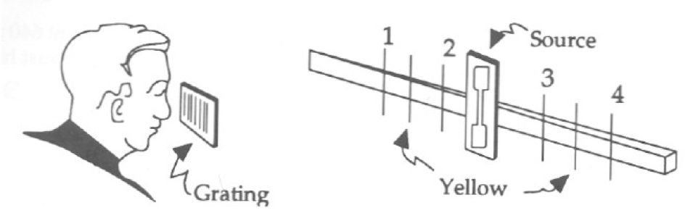

Problem 9 (4 pts, JUSTIFY, partial credit given): (c=3x10⁸ m/s)

The wavelength of a 150 MHz television signal is approximately

a) 1.0 m
b) 1.5 m
c) 2.0 m
d) 2.0 cm
e) 50 cm

Problem 10 (4 pts, JUSTIFY, partial credit given):

You connect two similar heating coils (think resistors) in series on a constant-voltage line. When you later connect them in parallel to the same line, the heat developed per minute, compared with the former rate, is approximately

a) the same.
b) twice as great.
c) one-half as much.
d) four times as great.
e) one-fourth as much.

Problem 11 (4 pts, JUSTIFY, partial credit given):

A real object is 42 cm from a negative lens with f=-21cm. The image is

a) real and 14 cm from the lens.
b) real and 42 cm from the lens.
c) virtual and 42 cm from the lens.
d) virtual and 21 cm from the lens.
e) virtual and 14 cm from the lens.

Problem 12 (4 pts, JUSTIFY, partial credit given):

A sample of particles are measured to have a lifetime of 1 μs when at rest. When you go down the street to your local neighborhood particle accelerator, you measure the lifetime of the same type of particle (now accelerated in a beam) to be 4 μs. How fast are the particles in the beam moving relative to you when you measure them?

a) 0.90c
b) 0.94c
c) 0.97c
d) 1.03c
e) 0.25c

Problem 13 (5 pts, JUSTIFY, partial credit given):

Joe radiologist operates (or, more likely, asks an X-ray technician to operate) an X-ray machine with a nickel target. (The machine consists of a beam of electrons accelerated to some energy incident on a nickel target, where the X-rays are created.) The X-ray machine is being operated at a potential of 50 keV. The energy level diagram for nickel is shown below. From this information, determine the wavelength of the K-alpha X-rays emitted by this machine. (h=4.1x10⁻¹⁸ keV-sec)

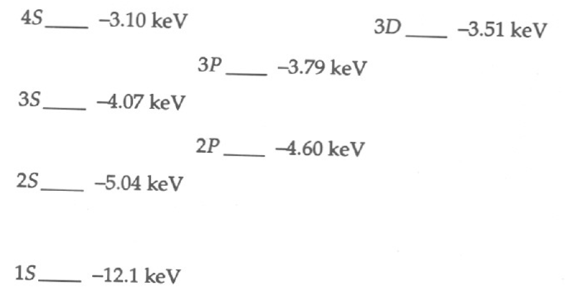

Problem 14 (10 pts, partial credit):

Junior Skidmore buys his true love, Buffy, a diamond engagement ring. Being a suspicious sort, Buffy looks at it and says, “How do I know it is a diamond instead of cut glass?” Junior realizes he is in luck because he did so well in physics 114!! “Buffy, you unromantic &^%*$! One way to tell that it is a diamond instead of glass is to observe the intense sparkles. They are much more intense for diamond than glass.” Buffy, not wanting to marry anyone who does not understand basic optics replied, “Tell me why that is true, or I won’t marry you.”

Help Junior out here. Without making a judgment about whether or not he should marry this girl, briefly explain, using text, calculations and/or diagrams if needed, why a well-cut diamond seems to sparkle with more intensity than a comparably cut piece of glass.
The index of refraction of diamond is 2.4. That of glass is 1.5.

Problem 15 (9 pts, partial credit):

The vast majority of the carbon found in nature is made up of the stable isotope carbon-12. Radioactive carbon-14 is formed when cosmic rays from the sun interact with nitrogen-14 in the atmosphere. This process is ongoing and provides a roughly constant amount of carbon-14 in the ecosphere (see below). Carbon-14 and carbon-12 have nearly identical chemical properties. As a consequence, living organisms incorporate carbon-14 in their bodies in the same proportion as it is found in the environment around them. When an organism dies, that process stops and, as the radioactive carbon-14 decays, the carbon-14/carbon-12 ratio changes. By measuring the amount of carbon-14 in an artifact that contains organic matter, one can establish the age of the organic material. ¹⁴₆C decays to ¹⁴₇N with a half-life of 5730 years.

- How does ¹⁴C differ from ¹²C?

- Write the nuclear equation describing the decay of ¹⁴₆C.

- Suppose it is determined that the ¹⁴C/¹²C ratio in the Shroud of Turin is 92% of that measured in living material. Determine the date of origin of the Shroud of Turin consistent with this nuclear data. (FYI - Professor Gove in the Dept. of Physics and Astronomy dated the Shroud of Turin using nuclear dating techniques.)

(Because the rate of incidence of cosmic rays varies due to fluctuations in processes in the sun, the amount of carbon-14 in the ecosystem varies from year to year. High precision radiocarbon dating must take this variation into account. This is commonly done by analyzing the carbon-14/carbon-12 ratio in the rings of old trees and using this information to create a calibration curve for the amount of carbon-14 present in the ecosystem from year to year. Is this cool or what?!)

Problem 16 (8 pts, partial credit):

Tarzan gets his tail hauled to the eye doctor when he sees Jane at a distance and calls her Cheetah. It may have been a bad hair day, but she was not amused. The eye doctor measures Tarzan’s far point to be 30 cm. Assume the lens of Tarzan’s new glasses will be held 1.5 cm from the eye by the eyeglass frames. What power spectacle lens is needed to correct Tarzan’s vision?

Problem 17 (8 pts, partial credit):

Time flies. You graduate. Soon you find yourself working as a repair technician for Joebob’s Snowboard and Heart Pacemaker Repair Company. Because of your amazing love for complex physics problems, Joebob puts you in charge of the pacemaker repair unit. One of Joebob’s favorite local heart surgeons comes in and wants you to refurbish an old pacemaker so he can use in a new patient. Before doing that you run a test. You observe the pacemaker fires 72 times a minute. You look carefully at the circuit and see that it fires whenever a 25 nF capacitor is charged by a battery in series with a resistor to 0.6 of its full voltage. Calculate the value of the resistance?
STOP!! For problem 18, you have two choices. Do the problem that you think you can do best. We will only grade one of them. If you do work on both, you MUST SPECIFY clearly at the top of the page which problem you want us to grade.

Problem 18 (10 pts, partial credit):

A thin, conducting spherical shell with radius R₁=0.1m has a positive charge Q= 0.3 Coulombs distributed evenly on it. This shell is surrounded by a concentric thin, conducting spherical shell of radius R₂=0.2m which has a negative charge of 0.3 Coulombs distributed evenly on it. Determine the total energy stored in the electric field for this configuration.
R₁
R₂
+Q
-Q
Problem 18 (10 pts, partial credit):

A rectangular conducting loop of width L, resistance R and mass m, is hung in a horizontal, uniform magnetic field B that is directed into the page and that exists only above the line running from a to b. The loop is dropped. During its fall, it accelerates until it reaches a terminal velocity (that is to say, constant velocity). Ignore air friction. Find the magnitude of the terminal velocity in terms of B, L, R, M and g.
mg
a
b
L
X X X X X X X X X X X X

X X X X X X X X X X X X

X X X X X X X X X X X X

X X X X X X X X X X X X

X X X X X X X X X X X X

X X X X X X X X X X X X

Whew! Welcome to the end of your introductory physics sequence! I hope you will find some of what you have learned about useful through the years. You’ve been great sports. I’ve enjoyed your class and getting to know a few of you.

As for grades: I do not expect to have the exam grades in hand until Saturday. I will post all the grades on WebCT once I have processed them and submitted them to the registrar. Trust me when I tell you I am more anxious to get your grades out than some of you are to get them!

Have a wonderful summer! Good luck moving out into the real world if you are graduating! -- SLM

Did you specify which problem 18 you wish us to grade?
Did you put your name on the exam?
Did you think to put a beer in the fridge?
