Exam 1 (February 18, 2003)
Please read the problems carefully and answer them in the space provided. Write on the back of the page, if necessary. Show all your work. Partial credit will be given.

Problem 1 (20 pts):

The 1-dimensional motion of a particle is described by the velocity-time graph given below. Draw the appropriate qualitative position-time and acceleration-time graphs for this particle. Assume the particle starts at x=0 at t=0.
X(t)
t
v(t)
t
a(t)
t
0
0
0
+
-
+
-
+
-
Problem 2 (20 pts, no partial credit):
- /20
- /20
- /20
- /20
- /20

____________

tot /100

The sketch below represents the trajectory of a golf ball going from point A to point E on the surface of the earth.

What is the direction of the acceleration at point B?
- It is up and to the right.
- It is down and to the left.
- It is straight up.
- It is straight down.
- It is zero.

What would your answer to this question be if the golf ball were hit on the moon instead of the earth?

Back on earth, at point C the velocity of the ball is
- a maximum and is directed to the right.
- Directed to the left.
- A maximum.
- A minimum and is directed to the right
- Zero.
A
B
C
D
E

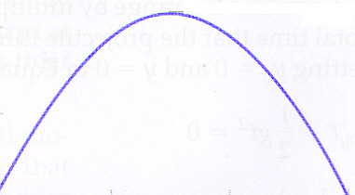

Problem 3 (20 pts):

Briefly explain why you feel pressed back into your seat when sitting in an airplane that is taking off. You can use a diagram and refer to it if you wish.

Problem 4 ( 20 pts):

A steel ball of mass M=1.2 kg is tethered to the end of a massless cable. The ball is attached to a spinning axle that causes the ball and cable to rotate in a vertical circle as shown below. The ball moves in a circle of radius 0.6 m centered at a height of 2.0 m above a flat surface. The rate of rotation increases VERY SLOWLY until the cable snaps. The cable snaps when the tension in the cable reaches 100 Newtons. Relative to the position of the axle over the floor (x=0 in the sketch), where does the ball hit the floor
R = 0.6 m
H=2.0 m
X=0
X increasing and >0
X decreasing and <0
Problem 5 ( 20 pts):

Consider the arrangement of masses shown below. Let M1=3 kg and M2=6 kg and M3=4 kg. The pulley is massless and frictionless and the string is massless. The table surface is frictionless. The coefficient of static friction between the surfaces of M1 and M3 is μ_{s}. The coefficient of kinetic friction between the surfaces of M1 and M3 is μ_{k}. Assume the system is held initially and then let go, so it starts from rest. Find the minimum μ_{s} such that mass 3 does not slip along the top of mass 1 as the system moves. Also find the acceleration of each mass and the tension in the string.

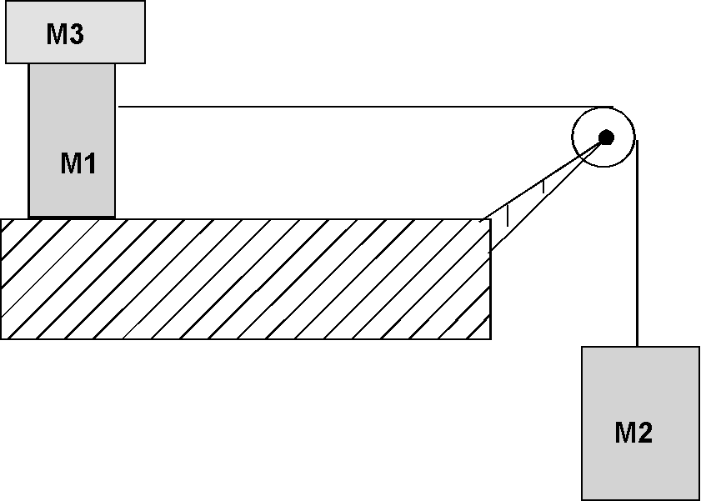

$\begin{aligned}\text{sinθ}=\frac{\text{opp}}{\text{hyp}} \\ \text{cosθ}=\frac{\text{adj}}{\text{hyp}} \\ \text{tanθ}=\frac{\text{opp}}{\text{adj}} \\ v=v_{o}+\text{at} \\ x=x_{o}+v_{o}t+\frac{1}{2}{\text{at}}^{2} \\ x=x_{o}+\left(\frac{v_{o}+v}{2}\right)t \\ v^{2}=v_{o}^{2}+\text{2a}(x−x_{o}) \\ x−x_{o}=\int_{t_{o}}^{t}{\text{vdt}} \\ v−v_{o}=\int_{t_{o}}^{t}{\text{adt}} \\ \sum{\vec{F}=m\vec{a}} \\ F_{\text{friction}}=μ_{k}N \\ F_{\text{friction}}=μ_{s}N \\ F_{\text{centripetal}}=\frac{{\text{mv}}^{2}}{r}\end{aligned}$
θ
hyp
adj
opp

$\begin{aligned}\frac{d(x^{n})}{\text{dx}}={\text{nx}}^{n−1} \\ \int{x^{n}\text{dx}}=\frac{x^{n+1}}{n+1}\end{aligned}$
$\begin{aligned}\text{circumference of circle}=2πr \\ \text{area of circle}={πr}^{2} \\ \text{quadratic equation }=\frac{\text{-b}±\sqrt{b^{2}−4\text{ac}}}{2a}\end{aligned}$

