Exam 2 (March 25, 2003)
Please read the problems carefully and answer them in the space provided. Write on the back of the page, if necessary. Show all your work. Partial credit will be given.

Problem 1 (14 pts):

If mechanical work is done to a body, the body must

- accelerate.
- be in equilibrium.
- not exert any force.
- have no friction force exerted on it.
- move.

A body moves in a region where the potential energy of the system U as a function of coordinate r is given in Figure A. The force on the body is given in Figure B by curve

a) 1. b) 2. c) 3. d) 4. e) 5.

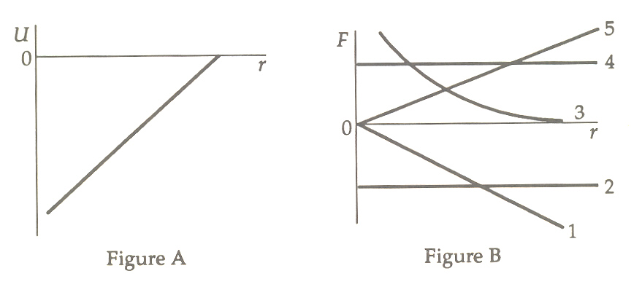

Problem 2 (17 pts):

A spring with a pointer attached is hanging next to a scale marked in millimeters. Three different weights are hung from the spring, in turn, as shown in the sketch below. (a) If all weight is removed from the spring, which mark on the scale will the pointer indicate? (b) What is the weight, W, of the third mass?
- /14
- /17
- /17
- /17
- /17
- /18

____________

tot /100

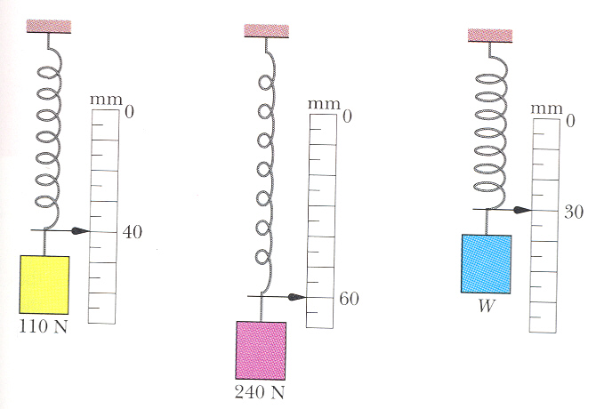

Problem 3 (17 pts):

Fast forward: You graduate and use your degree in biomedical engineering to found the field of paleontological physics. Paleontology is the science dealing with understanding extinct species and past geological periods from fossil remains. One of your graduate students makes that observation that of the many bipedal (able to walk on two hind legs) dinosaurs that existed long ago, all of those with long necks also had long tails. You look at your student and say, "Ah! But, of course! Let me explain to you why this is so …"
Briefly explain, using physics topics we have covered recently, why a bipedal dinosaur with a long neck and tail might have a survival advantage over one with a long neck and no tail.

Problem 4 (17 pts):

Two spheres of mass m and a third sphere of mass M form an equilateral triangle, and a fourth sphere of mass m₄ is at the center of the triangle. The net gravitational force on m₄ from the three other spheres is zero. What is (how large is) M in terms of m?

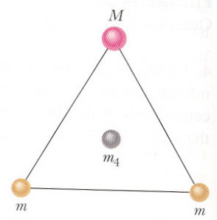

Problem 5 (17 pts):

Two identical masses are hung on strings of the same length. One mass is released from a height h = 0.2 meters above its free-hanging position and strikes the second mass. The two masses stick together when they collide and move off. To what height H do the two masses rise after the collision? (Assume the heights are measured with respect to the relevant center of masses. That is to say, do not worry about the size of the balls relative to the height measurements.)

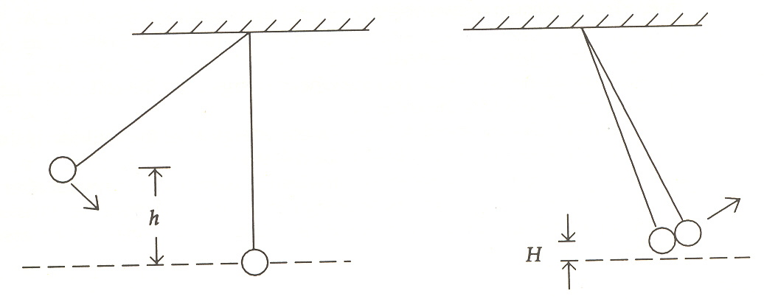
Problem 6 (18 pts):

The brothers of the I Luv Toplay fraternity recently decided to create an outdoor study center on the second floor deck of their fraternity house. Of course, the first thing such a study center needs is a hot tub! So, the brothers bought a hot tub with a mass of 200 kg and pulled it up a 45 degree ramp to the second floor deck which is 5 m above the ground. The coefficient of kinetic friction of the tub on the ramp surface was μ_{k}=0.1.

a) What is the total work done by the boys as they pulled the hot tub up the ramp, assuming the tub was pulled up slowly with constant velocity?

One of the brothers, Pervis Pinhead, was taking physics 121 at the time. He told his brothers that they would have to do less work if they moved the hot tub up in less time. Let's see if this is true.

b) How much mechanical work would the brothers have done on the hot tub if they moved it up the ramp with a constant acceleration of 0.2 m/s²?

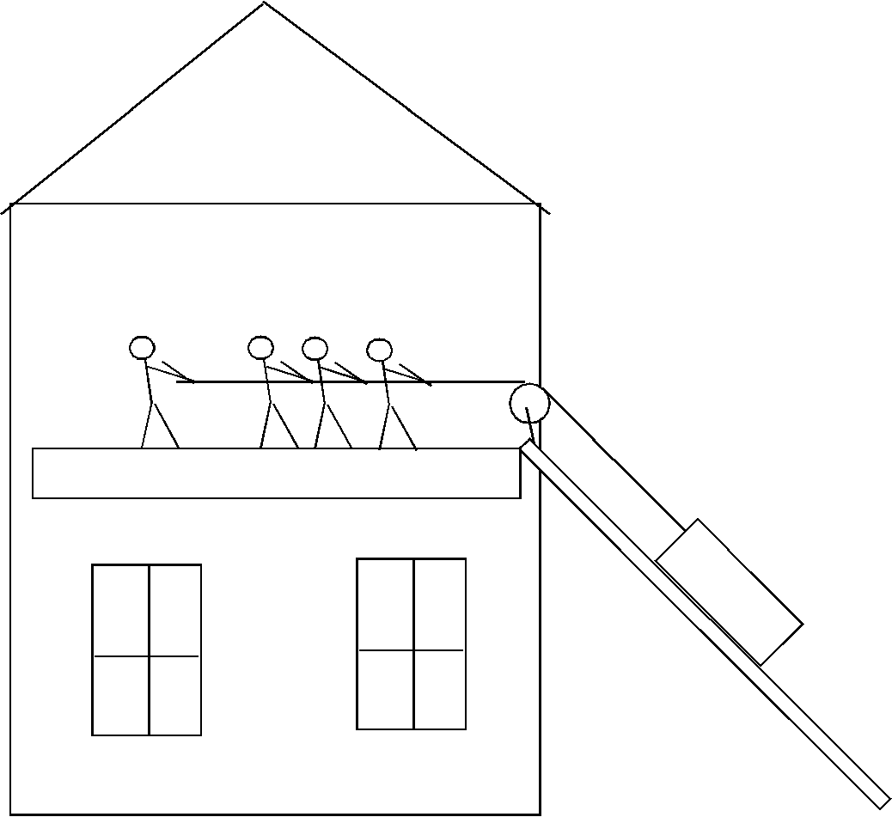

$\begin{aligned}\text{sinθ}=\frac{\text{opp}}{\text{hyp}} \\ \text{cosθ}=\frac{\text{adj}}{\text{hyp}} \\ \text{tanθ}=\frac{\text{opp}}{\text{adj}} \\ v=v_{o}+\text{at} \\ x=x_{o}+v_{o}t+\frac{1}{2}{\text{at}}^{2} \\ x=x_{o}+\left(\frac{v_{o}+v}{2}\right)t \\ v^{2}=v_{o}^{2}+\text{2a}(x−x_{o}) \\ x−x_{o}=\int_{t_{o}}^{t}{\text{vdt}} \\ v−v_{o}=\int_{t_{o}}^{t}{\text{adt}} \\ \sum{\vec{F}=m\vec{a}} \\ F_{\text{friction}}=μ_{k}N \\ F_{\text{friction}}=μ_{s}N \\ F_{\text{centripetal}}=\frac{{\text{mv}}^{2}}{r}\end{aligned}$ $\begin{aligned}{\vec{F}}_{\text{spring}}=−k(\vec{x}−{\vec{x}}_{o}) \\ \text{work}=\int{F⋅\text{ds}} \\ \text{power}=\frac{\text{dw}}{\text{dt}} \\ \vec{A}⋅\vec{B}=\left|\vec{A}\right|\left|\vec{B}\right|\text{cos}θ=A_{x}B_{x}+A_{y}B_{y}+A_{z}B_{z} \\ s=\text{rθ} \\ v=rω \\ a=rα \\ ω=ω_{o}+αt \\ θ=θ_{o}+ω_{o}t+\frac{1}{2}{αt}^{2} \\ {\text{KE}}_{\text{translation}}=\frac{1}{2}{\text{MV}}^{2} \\ {\text{KE}}_{\text{rotation}}=\frac{1}{2}{Iω}^{2} \\ I=\sum{m_{i}r_{i}^{2}}=\int{r^{2}\text{dm}} \\ X_{\text{cm}}=\frac{\sum{x_{i}m_{i}}}{M}=\frac{\int{\text{xdm}}}{M}\end{aligned}$
θ
hyp
adj
opp

$\begin{aligned}\frac{d(x^{n})}{\text{dx}}={\text{nx}}^{n−1} \\ \int{x^{n}\text{dx}}=\frac{x^{n+1}}{n+1}\end{aligned}$ $F_{\text{grav}}=−\frac{{\text{Gm}}_{1}m_{2}}{r^{2}}\hat{r}$
$\begin{aligned}\text{circumference of circle}=2πr \\ \text{area of circle}={πr}^{2} \\ \text{quadratic equation }=\frac{\text{-b}±\sqrt{b^{2}−4\text{ac}}}{2a}\end{aligned}$

