Exam 1 (October 6, 2005)
Please read the problems carefully and answer them in the space provided. Write on the back of the page, if necessary. Show all your work. Partial credit will be given.

Problem 1 (9 pts, show work/logic to get credit):

Charges Q₁ = -q and Q₂ = +4q are placed as shown. Of the six positions on the axis indicated by the numbered arrows, the one at which the electric field is zero is (do not expect the positioning in the drawing to be perfect)

- 1
- 2
- 3
- 4
- 5
- 6
Q₁
Q₂

1
2
3
4
5
6

Problem 2 (9 pts, show work/logic to get credit):

The vector that best represents the direction of the electric field at point P is

- 1
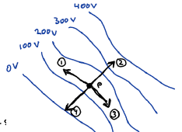
- 2
- 3
- 4

Problem 3 (9 pts):

If the potential of an array of charges as a function of r is shown on the graph, draw the electric field as a function of r on the second graph
V
r
E
r
- /9
- /9
- /9
- /9
- /12
- /12
- /10
- /15
- /15
____________

tot /100

Problem 4 (9 pts, show work/logic to get credit):

A spherical rubber balloon with radius R has a positive charge Q placed uniformly on its surface. The balloon is placed in a uniform electric field of 120 N/C. What is the net electric field inside the balloon? (Justify your answer)

Problem 5 (12 pts):

After graduation from this fine institution, you get a job with the Virgin Group working on designs for customized toenail clippers for the discriminating business traveler. One day, to your amazement, the man himself … the head of the Virgin Group, Richard Branson, calls you into his office suite. Branson sits you down and says, “I’ve heard about this legendary physics training and expertise of yours. I’ve got this new idea to make a few billion dollars. I was wondering if you would tell me what you think about it. You see, the other evening I was reading a good physics book and I noticed that both gravitation and electrostatics follow inverse square force laws. Then I read that you can surround a region with a conductor to shield it from external electric fields. Since gravity and electrostatics are similar, why can’t we make something to shield us from external gravitational fields? Something like a gravitostatic shield. Imagine the possibilities if we could do that.”

Briefly state how you would reply to Branson. Feel free to use equations and figures as you see fit. Make a coherent argument.

Problem 6 (12 pts, show work/logic to get credit):

Two parallel conductive plates of area A are separated by a distance d, where d is much smaller than the length and width of the two plates. Equal and opposite electric charges are placed on the two plates. One plate carries a positive charge distributed uniformly with area charge density σ. The other plate carries a negative charge distributed uniformly with area charge density -σ. How much work does it take to move the two plates so the separation between them is 2d?

Problem 7 (10 pts, show work/logic to get credit):

A non-conducting wire forms a circle with radius R in the x-y plane centered at the origin. A charge of +3Q is placed uniformly on the region of the wire ranging from the negative y-axis counter-clockwise to the negative x-axis. A charge of -Q is placed uniformly on the region of the wire ranging from the negative x-axis counter-clockwise to the negative y-axis. Calculate the electrostatic potential at point P.
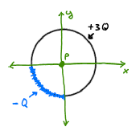
R

Problem 8 (15 pts, show work/logic to get credit):

A possible model of the helium atom is a sphere of positive charge (total charge +2e) of radius R with two electrons embedded symmetrically at radius r’(<R) as shown in the figure. Suppose, in this model, that the positive charge is distributed out to radius R with a charge density going as ρ(r)=Cr. Find r’ in terms of R for the situation when the electrons are at equilibrium.
r’’
R
-e
-e
+2e, ρ(r)=Cr for r≤R, =0 for r>R
Problem 9 (15 pts, show work/logic to get credit):

A non-conducting wire is placed along the x-axis with one end at x = -d and the other end at x = d. An electric charge is placed on the wire with a charge density distribution, λ=Cx, where C is a positive constant. (Note that λ becomes negative for negative x.) Calculate the electric field at any point on the y-axis. Given your answer, demonstrate the behavior of your solution makes sense for large y.

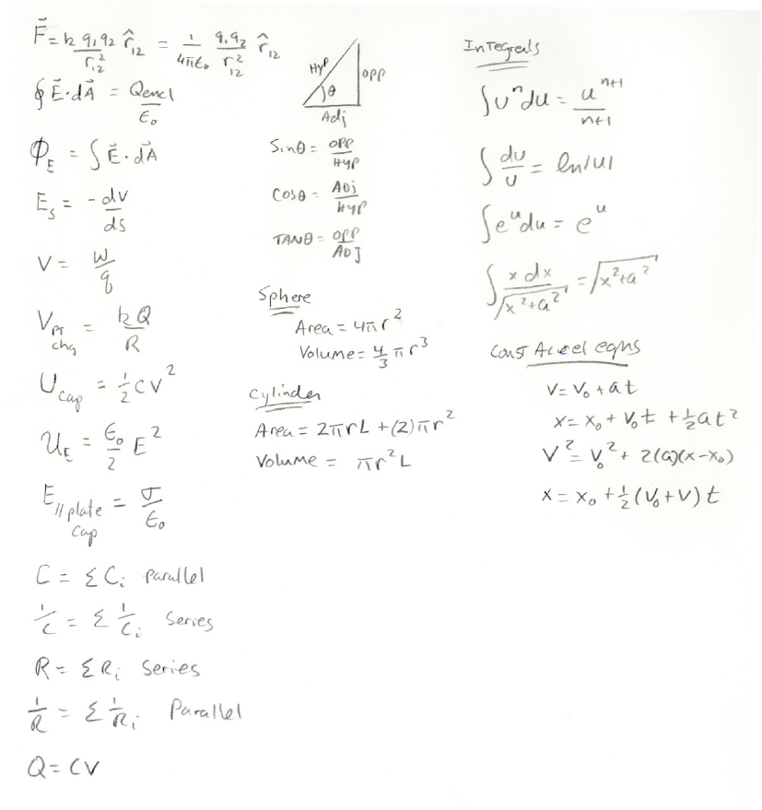

Potentially useful formulas (ask if you need an integral or series expansion)

