Exam 2 (November 15, 2005)
Please read the problems carefully and answer them in the space provided. Write on the back of the page, if necessary. Show all your work. Partial credit will be given.

Problem 1 (10 pts, show work/logic to get credit):

Two bar magnets are dropped from the same height. Magnet A is dropped over bare earth. Magnet B is dropped over a metal plate. Which magnet hits the ground first?

- Magnet A
- Magnet B
- They hit the ground at the same time
- Whichever magnet has its north pole oriented toward the ground
- Whichever magnet has its south pole oriented toward the ground

Problem 2 (10 pts, show work/logic to get credit):

Two parallel wires carry current in the same direction. Wire 1 carries a current I₁. Wire 2 carries a current I₂=2I₁. What is the relationship of the magnitudes of the forces on the two wires?

- F₁=F₂
- F₁=2F₂
- 2F₁=F₂
- F₁=4F₂
- 4F₁=F₂

Problem 3 (10 pts, show work/logic to get credit):

Two infinite solenoids (circular cross section), each with radius R and n turns per unit length, are placed parallel to each other with their central axes a distance 3R apart. Find an expression for the mutual inductance of these two solenoids.

Problem 4 (12 pts, show work/logic to get credit):

After graduation, you take a job at Ed’s Transmorgorizer Emporium. Ed comes in one day asking for help in the design of a circuit for a new and improved model of transmorgorizer.
Ed shows you three circuits containing two resistors and one capacitor. They are each connected in turn across the same battery via a switch. The resistors are all identical and the capacitors are all identical. Rank the circuits in terms of the time required for the capacitor to reach 50% of its final charge.
- /10
- /10
- /10
- /12
- /10
- /10
- /12
- /13
- /13
____________

tot /100

Problem 5 (10 pts, show work/logic to get credit):

Below there are two conducting wire loops, I and II, in the plane of the paper. A constant B field in the region shown is oriented into the paper. Loop I is stationary and loop II is moving to the right as shown in the figure. Which statement is true?

- The induced current in loop II is clockwise and the induced current in loop I is counter-clockwise.
- The induced current in loop II is counter-clockwise and the induced current in loop I is clockwise.
- The induced current in loop II is clockwise and the induced current in loop I is clockwise.
- The induced current in loop II is counter-clockwise and the induced current in loop I is counter-clockwise.
- The induced current in loop II is clockwise and there is no induced current in loop I.
- The induced current in loop II is counter-clockwise and there is no induced current in loop I.
Problem 6 (10 pts, show work/logic to get credit):

Sweet Sally stands by the road waiting for a bus to take her to the Eastman School of Music for her drum lesson. She holds her snare drum in front of her in a square box with sides of length “A”. Sally holds the box so that one side is oriented parallel to the road in front of her. Smooth Sid, fraternity brother extraordinaire, zooms by in his ultra sleek sports car at a speed of 0.93c. As he zooms by, Sid carefully observes Sally and her box and ponders whether he has room in his car to give her a ride. He measures the volume of Sally’s box to be how large as compared to what Sally would measure?

Problem 7 (12 pts, show work/logic to get credit):

After ascending to the Vice-Presidency of Ed’s Transmorgarizer Emporium, you poke around one of the research laboratories and discover a little test circuit hooked up to a battery. You make the observation that the insulated positive and negative wires leading to and from the battery powering the circuit are tightly twisted together forming a “twisted pair”. Briefly explain why Ed’s engineers have done this to the wires (besides the fact that it looks cool).

Problem 8 (13 pts, show work/logic to get credit):

In the typical transmorgarizer, two currents are configured as shown in the sketch below. Both ends of each wire extend to infinity. Determine the magnetic field at point P in terms of i₁, i₂, R and d.

Problem 9 (13 pts, show work/logic to get credit):

An infinite wire of radius R has a current density, J(r)=Cr, where C is a constant. Find the magnetic field for the regions of space r<R and r>R.
R
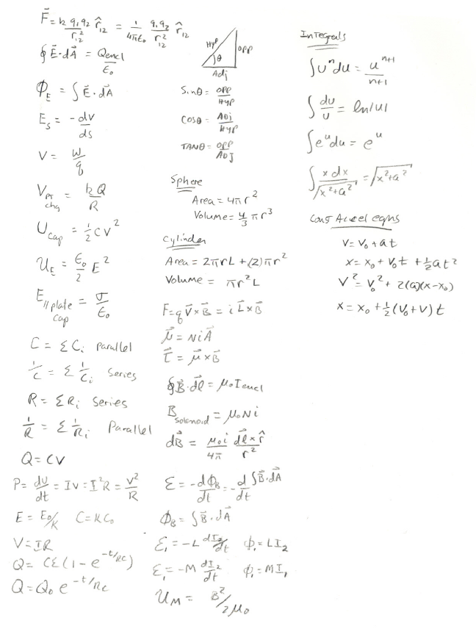

Potentially useful formulas (ask if you need an integral or series expansion)

