Exam 4 (April 20, 2000)
Please read the problems carefully and answer them in the space provided. Write on the back of the page, if necessary. Show all your work. Partial credit will be given unless noted otherwise. Try to be neat. TA's are known to be less generous with partial credit if they have to work hard to decipher the paper!

Problem 1 (20 pts) :

A 2.0-meter-long vertical stick in air casts a shadow 1.0-meter long. If the same stick is placed (at the same time of day) in a flat bottomed pool of salt water half the height of the stick, how long is the shadow on the floor of the pool? (Assume n=1.72 for this pool.)

Problem 2 (20 pts) :

A source of light exists at the bottom of a bucket that is slowly being filled with an unidentified, transparent liquid. Floating on top of the liquid, centered over the light, is an opaque circle 12 cm in diameter. An observer looking down at the surface of the liquid in the bucket does not see any light from the source until the height of the liquid reaches 7.5 cm. Determine the index of refraction of the unknown liquid. You must show your work to receive credit.

Problem 3 (20 pts :
Scores
- ___/20
- ___/20
- ___/20
- ___/20
- ___/20
- ___/20
EC ___/3

Total ___/123

Light is incident at an angle φ with the normal to a plane containing two slits of separation d. Select the expression that correctly describes the positions of the interference maxima in terms of the incoming angle φ and outgoing angle θ. You must derive the correct expression in the space below to receive credit.

- (b) (c)
$d\text{sin}ϑ=mλ$$\text{sin}φ+\text{sin}ϑ=(m+2)\frac{λ}{d}$
$\text{sin}φ+\text{sin}ϑ=(m+\frac{1}{2})\frac{λ}{d}$
(d) (e) (f)
$\text{sin}φ+\text{sin}ϑ=m\frac{λ}{d}$$\text{cos}φ+\text{cos}ϑ=m\frac{λ}{d}$$d\text{sin}ϑ=(m+\frac{1}{2})λ$
φ
θ

Problem 4 (20 pts, 10 pts for each part) :

(a) Why do stars appear to twinkle?

(b) A binary star system is visible from earth. (A binary system is a solar system with two suns … from earth it would appear to be two stars very close together.) Assume the stars shine brightly in all portions of the visible spectrum. Your ability to resolve these two stars is better if you look at them through a blue filter than it is if you look at them through a red filter or with no filter. Explain why this is so.

Problem 5 (20 pts) :

A birefringent material is one that has different indices of refraction for different directions of polarization. Calcite (CaCO3) is an example of a material that exhibits birefringence. A slab of calcite is oriented such that the index of refraction for light polarized parallel to the y-axis is 1.553 and that polarized parallel to the x-axis is 1.544. For an incident light with λ= 589 nm, plane-polarized at an angle of 45 degrees to both the positive x and y axes (as shown in the figure), what is the minimum thickness of the calcite (along z) that will produce circularly polarized light coming out the other side of the calcite? (hint: Such a device is called a quarter-wave plate.)

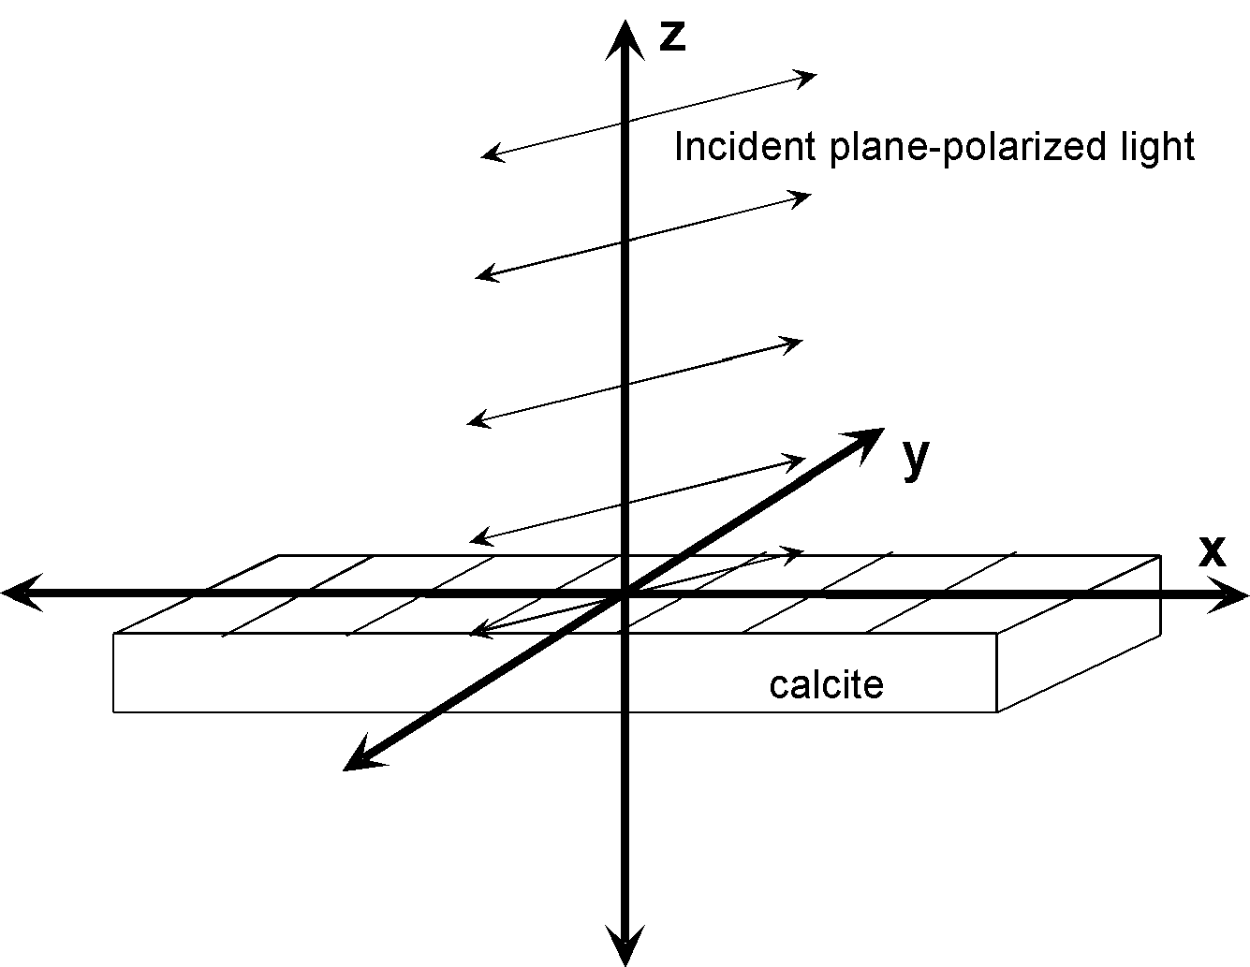

Problem 6 (20 pts) :

If it were possible to closely investigate the space in the vicinity of a star, one would find no ice particles any larger than a certain radius, even in regions far enough away that the ice would never melt. Consider the sun, for example. Given the power output of the sun ( 3.8x10²⁶ Watts), the mass of the sun (1.99x10³⁰ kg), and the density of ice (1 g/cm³) explain (briefly) this phenomenon and quantitatively determine the minimum radius of ice particles found in interplanetary space. (hint: Assume all ice particles have spherical symmetry and that the projected area of such a particle, with radius r, is πr².)

