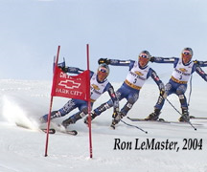
Wanted: Group members for physics project on skiing!
-Interested in flex pattern/design of modern skis; center of mass; centripetal motion/turn radius
-Ultimate goal: to provide computational evidence for modern technique/ski design

Contact: nnacca@mail.rochester.edu

