Laboratory Section: Grade:
Last Revised on July 20, 2020

EXPERIMENT 10

Electronic Circuits
Before Lab:
- Read and follow the Lab General Notes instructions,
especially about cleaning and disinfecting equipment before starting the lab and at the end.
- Read the lab manual and watch two videos: (1) Using digital scope (14:58 min)
- https://rochester.hosted.panopto.com/Panopto/Pages/Viewer.aspx?id=00a7b093-db11-4023-8e94-ac050098cac8
- Watch prelab video for Lab 10. (17:43 min) TURN CC ON FOR CAPTIONS.
https://rochester.hosted.panopto.com/Panopto/Pages/Viewer.aspx?id=dfcec750-a88e-4688-80bf-ac0100de3e52
Note: We use the Rigolna DS1102e digital scope Below is the web site
https://www.rigolna.com/products/digital-oscilloscopes/1000/
Also, his additional video may be useful. https://www.rigolna.com/scopebasics/
READ IN ADVANCE all the Questions in the postlab section and make notes as to how to answer them. If you need clarification ask the TA in lab. MAKE SURE THAT YOU ARE FULLY PREPARED or you may not be able to complete the lab.

Bring a printed copy of the lab manual, completed prelab assignment, the Brief-Notes and a copy of the General brief notes to lab. Bring a laptop: You may want to replay parts of the video in lab.

Pre-Laboratory Work [2 pts]

- How are you going to determine the capacitance of the unknown capacitor using the oscilloscope in the first part of the experiment? Explain. (1 pt)

- In theory, what should be the slope of the graph you will make of your data when you plot 1/Q versus Resistance in the second part of the experiment? What value should the y-intercept have? (1 pt)

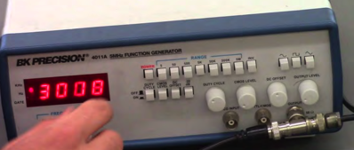
Experiment #10: Electronic Circuits
PHY 122/142/114
Digital Oscilloscope

Variable Resistor

``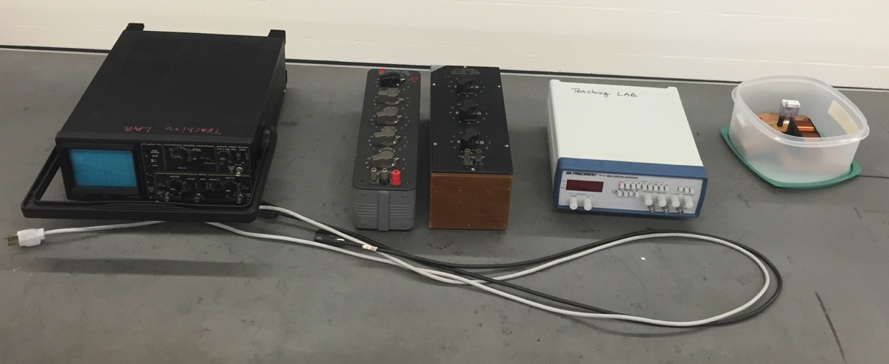
Box with 1 resistor,
1 capacitor & 1 inductor

Variable Capacitor

Function Generator

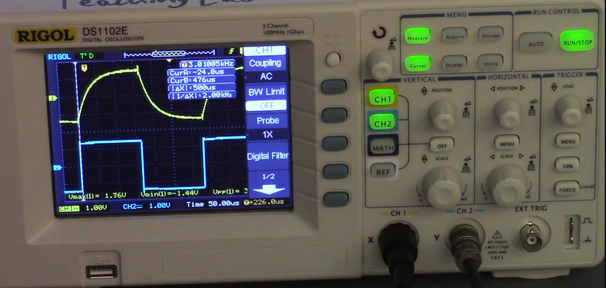
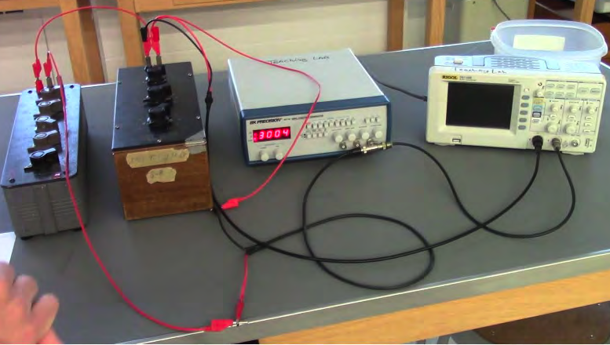
Materials List:
RC setup
- Digital oscilloscope
- Variable resistor
- Variable capacitor
- Function generator
- Box with: 1 resistor, 1 capacitor & 1 inductor

Setup Notes:
- Place power cords on lab table,
do not plug in
- Box in metal cabinet far corner (B&L 268)
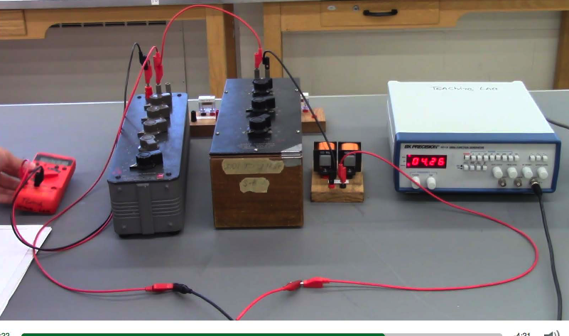
(Box: resistor, inductor, capacitor

RLC setup

Last Revised on July 17, 2020

EXPERIMENT 10

Electronic Circuits
- Watch prelab video for Lab 10. TURN CC ON FOR CAPTIONS.
https://rochester.hosted.panopto.com/Panopto/Pages/Viewer.aspx?id=dfcec750-a88e-4688-80bf-ac0100de3e52

Purpose

To learn about the concept of capacitance, resistance and inductance; to learn about the phenomenon of electrical resonance in a real circuit; to learn how to use the oscilloscope.

Watch two videos (1) Digital scope (2) Prelab video for lab 10

Introduction

You will be first studying RC circuits and then resonant RLC circuits. To do this, you will first review the use of an oscilloscope, the most versatile electronic measuring instrument. Then you will use this tool to investigate the characteristics of capacitors and resonant circuits.

Review of the Oscilloscope
An oscilloscope is an instrument principally used to display signals as a function of time. With an oscilloscope it is possible to see and measure the details of wave shape, as well as qualities like frequency, period and amplitude. While these signals are primarily voltages, all manner of signals can be converted into voltages for observation.
The heart of an oscilloscope is a cathode ray tube (CRT), similar to that in a TV set, in which an electron beam excites a spot on a phosphor screen (Figure 10.1). The resulting visible spot of light is usually made to draw a graph where the y-axis is the measured signal and the x-axis is time. An "electrostatic deflection tube", in which the electron beam is
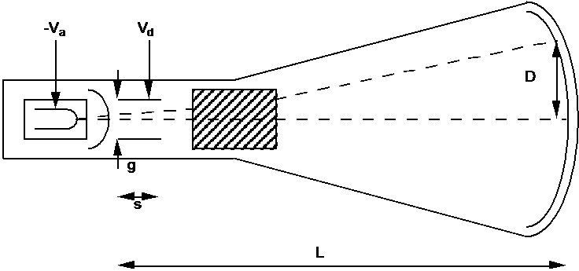
Figure 10. 1

steered by two sets of plates that apply electric fields is used to deflect the electron beam in both the horizontal and vertical directions.
The voltage applied between the vertical or Y input and ground is amplified and applied to the vertical plates in the CRT to deflect the electron beam in the vertical direction. The deflection of the beam, and the corresponding deflection of the light spot, are proportional to the applied voltage. It is usually calibrated so that input voltage differences can be read directly from the vertical divisions on the screen according to the scale (amplification or gain) selected by the front panel control (Volts/Division). This scale should be selected so that the height of the screen represents an amplitude a bit larger than the that of the input signal.
In a similar manner the spot is deflected in the horizontal direction by a voltage applied to the horizontal plates. Usually this voltage is a "ramp" (that is a signal which increases linearly with time) generated internally by the oscilloscope's "time base" or "sweep generator." This sweeps the spot at a uniform, measured rate from the left side to the right side of the screen and then rapidly returns it to the left side to start over. In this way the horizontal position on the screen is proportional to time. The sweep rate is also usually calibrated so that time intervals can be read directly from the horizontal divisions on the screen according to the sweep rate selected by the (horizontal) front panel control (Time/Division). This rate should be selected so that the width of the screen represents a time interval a bit larger than the duration of the features being investigated.
The result is that the oscilloscope plots out a graph of the input voltage as a function of time on the screen of the CRT. Digital oscilloscopes produce a similar plot. However, there are some practical details which must be understood in order to get satisfactory results. Familiarize yourself with your oscilloscope. Make sure it is plugged in. Find the controls discussed above. Disconnect any input cables and turn it on. You should see a horizontal line (the graph of a constant zero volts input). Make sure the vertical and horizontal positions are on the screen. If necessary, ask your instructor for assistance in getting started. Try adjusting the horizontal sweep control (Time/Division) through its range to observe its effect.
If the voltage changes are slow enough then on a very slow sweep speed you directly see the signal on the screen. Electronic signals are often too fast to see this way. With an analog oscilloscope, it is hard to see signals slower than the persistence of the phosphor because, as the beam moves on, the illuminated trace fades from view. This prevents you from seeing the whole wave form at once.
So, for reasons of practicality and convenience, the signal will usually be changing too rapidly for your eye to follow. What you actually see will be the superposition of multiple successive tracks across the screen. Only if the tracks exactly coincide will the image you see be a single sharp line. Otherwise, it will be rather unintelligible.
This will not be possible unless the input signal is periodic. Even then it will not occur if the period of the signal does not happen to be exactly the same as that of the sweep (called synchronization). This situation is illustrated in the Figure 10.2.

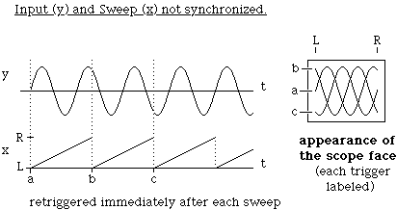
Figure 10. 2
One way to accomplish synchronization is to adjust either the frequency of the input signal or of the sweep so that they match. This is often hard to do satisfactorily because things tend to drift; besides it may be experimentally inconvenient.
Connect a function generator to the channel 1 input of the oscilloscope (check that the input channel is turned on). Set the function generator for sine wave output with a frequency of 1000Hz and set the amplitude control at mid-range. Find the appropriate setting for the time base and the vertical gain. With the digital oscilloscopes in this lab, the vertical gain knob adjusts the channel that was selected last. To simulate the free-running mode of an analog oscilloscope, open the trigger menu using the “menu” button in the “trigger” button group, select the “Source” submenu, and set the trigger “Source” to channel 2 by scrolling through the possible sources with the “Source” button or the knob at the top left corner of the oscilloscope’s controls. Exit the trigger menu when done by pressing the “Menu On/Off” button twice. You should observe the situation described above.
A more satisfactory solution to the synchronization problem is provided by "triggered" operation of the oscilloscope. In this mode, rather than having the ramp start over as soon as the previous sweep is finished (called "free-running"), the time base waits to restart the ramp until the input crosses a certain voltage level or satisfies some other condition selected in the trigger menu("triggers"). As long as this is the same point of the input wave form each time, the sweep across the screen will be synchronized with the repeating signal. This is illustrated in the Figure 10.3.
To use triggered operation, open the trigger menu. Set the trigger “mode” to “Norm” to update the screen only when a new trigger has been acquired. Select channel 1 as the trigger “Source”. Adjust the trigger level to stabilize the display. Observe what happens to the display as you vary the trigger level and change the sign of the trigger selection. Change the amplitude of the generator and note how the display changes. Measure the amplitude and frequency of the signal. Also, observe the square and triangle outputs of the signal generator.

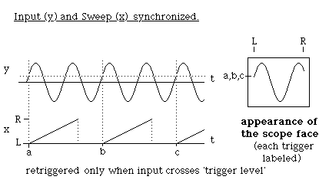
Figure 10. 3

Cautions:
- Don't let the trace exist as a dot on the screen of an analog oscilloscope; it can damage the phosphor.
- Don't look at big (>50V) voltages (i.e., the AC line).
- All signals, both input and output, are with respect to a common ground. This is a real earth ground through the chassis and the third prong of the AC plug. The shields of all the BNC connectors are connected together and to this ground and the input signals are applied between it and the center terminal of their BNC connectors.

Laboratory Work

3.1 RC Circuits Introduction
A capacitor stores electric charge. Typically, a capacitor is made of two parallel plates. Each plate will have a charge of the same magnitude, Q, but of opposite sign between which there will be an electric field. The work (per unit charge) this field would do on a test charge moved between the plates is the potential difference or voltage, V, across the plates of the capacitor.

The charge and voltage are linearly related by a constant C, the capacitance. Consider the situation in which a capacitor is charged by a battery through a resistance as shown in Figure
  - (with the switch in the “Charge” position). The charge stored on the capacitor (and therefore the voltage across it) increases with time because of the current, which is a flow of charge through the resistance. This current, by Ohm's law, is proportional to the voltage across the resistor,

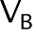
Equation 10.1

This current will decrease as VC rises toward VB so the rate at which the capacitor is charging up will fall. When there is no further flow of charge the capacitor will be fully charged to its final value,

Figure 10.4

Qfinal = CVB

Equation 10.2

The charge on the capacitor and the voltage across the capacitor do not grow linearly with time. Rather, they follow an exponential law. If the capacitor is initially (at t = 0) discharged, this takes the form,

Equation 10.3

After a time t = RC, the capacitor is charged to within 1/e (0.37) of its final value. The value RC is known as the time constant of the circuit. If the resistance R is in Ohms and the capacitance C is in Farads then the time constant RC is in seconds. Figure 10.5 displays voltage as a function of time for a charging capacitor.

VC
VB
0.63 VB

t=RC time
Figure 10. 5

Similarly, if a fully charged capacitor is discharged through a resistance (e.g. by moving the switch in Figure 10.4 to the discharge position) the voltage across the capacitor (and the charge on it) will fall to zero exponentially with time, as shown in Figure 10.6,

Equation 10.4

Again, after a time t = RC the capacitor will discharge to 0.37 of its initial value.

V C
V B
0 .63 VB

t=RC time
Figure 10. 6
In the first part of this experiment you will investigate the charging and discharging of a capacitor for different values of the time constant. By observing the voltage across the capacitor with an oscilloscope you can measure the voltage as a function of time.
Although for purposes of illustration it is convenient to discuss charging and discharging the capacitor with a switch, it is experimentally more practical to apply a square wave which duplicates the switching action using a signal generator, as shown in Figure 10.7. This is a way of regularly switching the applied voltage between two values so that the capacitor can charge and discharge between them. The charging and discharging traces will be accurately reproducible from cycle to cycle. Then if the oscilloscope is triggered off the periodic input these successive traces will overlay each other on the screen. The "switching" can occur at a fast enough rate that the result will be a bright, stable display from which you can make measurements. If the period of the square wave is greater than several times the time constant, then the capacitor will very closely approach its final value before the square wave switches.

R

C

Signal Generator
(Square Wave)

To Oscilloscope

Figure 10. 7
Hook up the function generator, set it to produce square waves, and build the circuit shown in Figure 10.7 using (variable) resistor and capacitor decade boxes. Find a convenient amplitude and frequency and then look at and trigger on the output of the signal generator. Connect the other channel to observe the capacitor voltage at the same time. You should obtain a display similar to that shown in Figure 10.8.

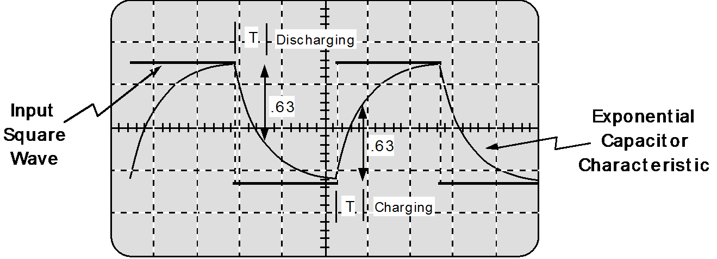
Figure 10. 8

Procedure

    - Set the decade boxes to the values R = 3,000 Ω ; C = 0.01 μF and the signal generator to a square wave with a frequency of 3000Hz and an amplitude of 3 Volts. Adjust the oscilloscope so the whole display is used (see figure 10.8) and trace it on a data sheet. Determine both the charging and discharging time constant by measuring the time taken for the voltage to change from its initial value to within 1/e of its final value, as discussed previously.

    - Average the charging time constant and the discharging time constant and compare with the theoretical value of RC.

    - Change the value of R or C by 30% and repeat Steps 1-2.

    - Get an unknown capacitor from the TA and substitute it for the capacitance decade box. Adjust the oscilloscope for a convenient display and measure the time constant as above. Use the result to obtain an experimental value for the capacitor.

5. Get an unknown resistor from the TA and determine its value in a manner similar to Step 4

6. Turn off the oscilloscope and disconnect all cabling.

3.2 Forced Damped Oscillator – RLC Circuits Introduction
In this section you will study the electrical version of a mechanical system that you have studied in your mechanics course. There is much similarity between the two cases as Figure
10.9 indicates.

On the right we have a mass, m, on a spring of constant, k and with damping b. It is being driven by an oscillating force of constant amplitude at an angular frequency ω (which can be varied). This system has a resonant frequency,
Figure 10. 9

k
m

ωo = 2πfo =
Equation 10.5

for which the response is a maximum when the driving frequency ω is equal to ωo. In the vicinity
of ωo the response curve looks like Figure 10.10, where the width of the curve, Δf , (measured
2

from the point where
A = Amax
) is given by Δω = ωo/b.

Figure 10. 10

In this experiment you will investigate the general phenomenon of resonance in the form of the particular example of an RLC (resistor, inductor and capacitor) circuit. You will be able to determine steady state behavior as well as the Q (quality) factor. In the process you will gain some experience with electronic circuits and components. You will set up the circuit shown in Figure 10.11. Be sure that the ground to the signal generator is the same as the voltmeter.
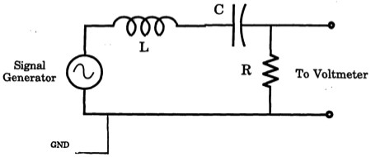
To Oscilloscope
Figure 10. 11
The basic equation that describes the phenomenon of resonance is that of a driven, damped, harmonic oscillator. In the case of the above RLC circuit, this takes the form,
Equation 10.6

where q is the charge on the capacitor and V is the peak amplitude of the signal generator and
ω(= 2πf ) is the angular frequency.
It is important to understand that the phenomena are characteristic of the mathematics and not peculiar to its electrical realization. For instance, if it were a mechanical oscillator the phenomena of resonance would be the same.

The general solution of Equation 10.6 (written in terms of
I = dq , which is more practical
dt

to measure) has two parts, I = Is + It, a steady state and a transient term.

Theory on Steady State RLC
The steady state term is,

Equation 10.7

where the quantity Z, impedance is,
Equation 10.8

and the phase offset is,
Eq Equation 10.9

You are going to measure the RMS voltage across the resistor, so VS = IS R . The steady state current, Is is the term caused by the driving voltage; it is all that is left after initial transients have died away. The physical significance of these quantities can be made more apparent by expressing them in terms of the more universal quantities: resonant angular frequency, ωo , and the quality factor, Q.

and
1
LC
ωo = 2πfo =

Equation 10.10

Q = Equation 10.11
1 L
R C

The quality factor Q is roughly the number of oscillations it takes for the transient to die down.

Thus in terms of ωo
and Q we have,

and

Equation 10.12

Equation 10.13

In the steady state it is apparent that at the resonant frequency the phase angle will be zero and the circuit will act just like a resistance R and the current will be maximum. Away from the resonant frequency, the amplitude of the current will decrease. The "full width at half maximum (half power = .707 of maximum current)" of the resonance curve will be about,

Equation 10.14

that is it will be narrower, in terms of a fraction of the resonant frequency, as Q increases.

Procedure
The object in this part of the experiment is to identify the resonant frequency of an RLC circuit and measure the response curve similar to the one in Figure 10.10.

- Assemble the experimental circuit shown in Figure 10.11 using the values:

R=400Ω :C=0.01μF :L = 22.5 mH

- Calculate the resonant frequency (not the angular frequency), fo, in Hz. Set the signal generator frequency near the value calculated with an voltage amplitude of about 3 Volts. You can set the signal generator output precisely by unhooking the RLC circuit from the generator and directing the output only to the oscilloscope. Set the oscilloscope to the AC Volts setting, with the sensitivity set to the 20V setting. The AC Volts setting is the one with a symbol like so: V~.

- With the RLC circuit set up, measure the voltage across the resistor. Now vary the frequency f to find the maximum voltage (it will likely not be the full 3V). This frequency will probably be a little different from your calculation.

- Take many (at least 4 on each side of fo ) measurements of V in the vicinity of the resonant frequency ensuring that you tune the signal generator through a broad range of frequencies so you see the voltage drop off by at least one-third on each side of the peak voltage. Record your data in the tables provide in Section 4.2.

- Now change R to 200 Ω and repeat the measurements.

- Now change R to 100 Ω and repeat the measurements.

Last Revised on July 22, 2020
Laboratory Section: Partners’ Names:

EXPERIMENT 10

Electronic Circuits

Post-Laboratory Work [20 pts]

4.1 RC Circuit [9 pts] e=2.718, 1/e=0.3679
Data [5pts] (2pts for raw data)
  - Known Values Data: use R = 3,000 Ω ; C = 0.01 μF
Sketch the pattern you see on your oscilloscope, as in Figure 10.8. You will want to note what value one division on the x-axis is equal to in seconds.

R = : C = : RC =

Time of Charging (to within 1/e of final value) :

Time of Discharging (to within 1/e of final value) :

Average :

****TA STAMP_______________

30% Values Data (change the value of R or C by 30%)
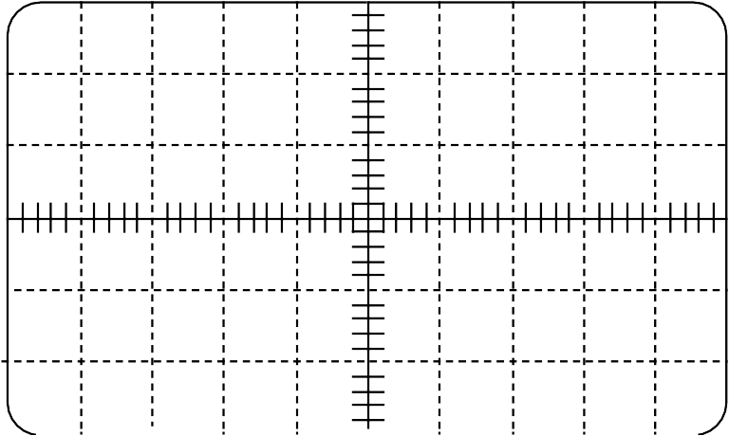
Sketch the pattern you see on your oscilloscope, as in Figure 10.8

R = : C = : RC =

Time of Charging (to within 1/e of final value) :

Time of Discharging (to within 1/e of final value) :

Average :

Unknown Capacitance Data
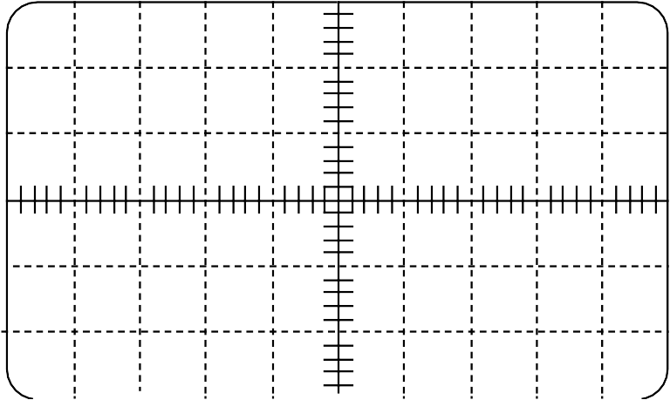
Sketch the pattern you see on your oscilloscope, as in Figure 10.8.

R = : C = Unknown : RC = Unknown

Time of Charging (to within 1/e of final value) :

Time of Discharging (to within 1/e of final value) :

Average :

*** TA STAMP:_______.

- Calculate the unknown capacitance value from your measured average for RC (1pt):

Unknown Resistance Data
Sketch the pattern you see on your oscilloscope, as in Figure 10.8

R = Unknown : C = : RC = Unknown

Time of Charging (to within 1/e of final value) :

Time of Discharging (to within 1/e of final value) :

Average :

- Calculate your unknown Resistance from your measured average of RC (1pt):

TA STAMP:_______.

Analysis [4 pts]

- What systematic or random errors can you think of which might account for differences between the measured and calculated values of the time constant? List at least two.(2 pts).

- How accurately do you think you can measure a time constant from your traces of the oscilloscope pattern? Justify your answer. (2 pts)

4.2 RLC Circuit [10 pts] Data [3 pts]
L:

C:

f o :

R = 400 Ω
Frequency (Hz) | Voltage (V)

R = 200 Ω
Frequency (Hz) | Voltage (V)

R = 100 Ω
Frequency (Hz) | Voltage (V)

TA STAMP:_______.

Analysis [8 pts]
- Plot Voltage vs. Frequency ( y vs. x!) for all 3 data sets on a single grid, plotting the data for R = 400 Ω first as it should be broadest. Use 3 different markers: solid circles for 400 Ω, hollow squares for 200 Ω, and small x’s for 100 Ω. Connect each different data set with a smooth line forming a bell-shape curve. (3 pts)

TA STAMP:_______.

- How do the resonant frequencies compare in the 3 plots? Is this expected? Explain. (1 pt)

- From your plots, measure the Quality factor, Q, of each of the 3 curves. Show your work for at least one value. Use this variant of Equation 10.14. (Hint: See Figure 10.10) (1 pt)

Q = fo
Δf

- Calculate Q for each of the three resistances: 100, 200, and 400 ohms. Show work for at least one of the calculations. Use Equation 10.11. (1 pt)

- Plot 1/Q (measured from your plots) versus R on the small grid below. Is this a straight line, as expected? Draw a best-fit line and measure its slope. How close is your measured slope to what it should be? Hint : Remember Equation 10.11 (2 pts)

TA STAMP:_______.

