Laboratory Section: ____________ TABLE# ______ Partners’ Names: ___________

Last Revised on February 2, 2021 DATE _____________ Grade: ___________

EXPERIMENT 15

The Franck Hertz Experiment
You should watch Lab 15 video (Turn CC on for Captions) Experiment 15: https://rochester.hosted.panopto.com/Panopto/Pages/Sessions/List.aspx?folderID=96ec3da2-4ace-4d81-a981-acc20100dd2a There is also a short and older less extensive video: https://www.youtube.com/watch?v=t2zTQGirjjo
Read the lab manual and the Lab Brief-Notes which includes photos of apparatus and sample data. Do the prelab assignment and upload to blackboard. READ IN ADVANCE all the Questions in the postlab section and take notes as to how to answer them. This way, you will take less time to complete the postlab after you do the Lab. If you need clarification ask the TA in lab.

Pre-Laboratory Work [2 pts]

- Why should mercury pressure in vacuum tube in Frank-Hertz experiment be low? (0.5 pt)

- Draw atomic model of ground state argon atom. (0.5 pt)

- Calculate the binding energy of outermost electron in Ar atom. According to Bohr's model, energy of electron in n^{th} orbital of an atom of atomic number Z is $E= \frac{-13.6 ×Z^{2}}{n^{2}} eV$ . [ 1pt]

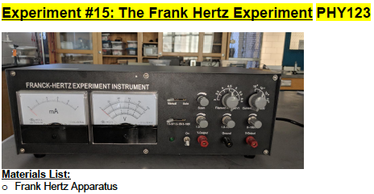
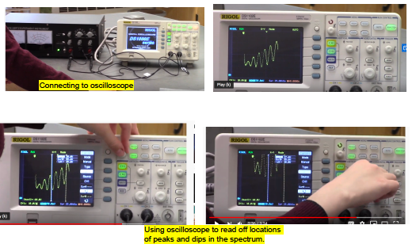

EXPERIMENT 15

The Franck Hertz Experiment

Purpose

In this lab, you will find the energy required to excite an Argon atom from its ground state to its first excited state.

Introduction

Frank-Hertz experiment, reported by James Frank and Gustav Hertz in 1914, is the very first direct demonstration of existence of discrete energy of electrons in atom. Schematic of vacuum tube used in their experiment is shown in Figure 1.
Note: They used mercury vapor (Hg) and we will be using argon (Ar)).
Figure 1

Figure-1: Schematic of the original Frank Hertz tube (with mercury). Hot filament emits electrons, positive bias on metal grid G accelerates them and when they land to anode plate A current flows from filament (cathode) to anode.

The vacuum tube has three electrodes: hot cathode as electron emitter, a metal grid-G to accelerate electrons, and an anode. Tube contains small amount of mercury which vaporizes when tube is heated, creating low pressure mercury vapor. Grid-G is held at positive potential compared to cathode. Electrons emitted from cathode get attracted towards grid-G and acquire kinetic energy. Electrons that pass-through grid-G contribute to the cathode-anode current. The Anode is at slightly negative potential compared to grid-G. This screens very slow – diffusive electron from reaching anode (A). They found that when accelerating potential (grid-G potential) is increased, the Anode current (I) gradually increases first and then abruptly dips down at around 4.9 V. With further increase in grid-G potential the current again goes up. The current dips down at regular interval of 4.9V.

For example, when grid-G potential is set to 1V, an electron acquires 1 eV of energy when reaching grid-G. On the way to grid-G the electron collides with a mercury atoms. At such a low energy, the collision of an electron with a Hg atom is elastic. Electrons just bounce off the atoms and no energy is transferred. With the increase in voltage the speed of the electrons increase gradually and hence the anode current (I) increases.

When grid-G voltage reaches 4.9V, an electron acquires 4.9 eV of energy. This energy is the same as the difference between the energy of the electron which is bound in the outermost orbit of the Hg atom and the energy of an electron in the first unoccupied orbit. In the inelastic collision, the accelerated electron transfers energy to Hg atom and comes to rest. The number of electrons reaching the anode decreases and hence the current (I) suddenly decreases dramatically. On further increase of grid-G potential beyond 4.9 eV, when an electron on its way to grid-G acquires an energy of 4.9 eV, the electron collision between the electron and the Hg atom can be inelastic, and the electron energy is transferred it to the Hg atom. After coming to rest, the electron is then accelerated again during the rest of the way to grid-G. Therefore, more electrons can reach anode and the current increases again.

At grid-G voltage is 9.8 eV, an electron excites one atom the first time when it acquires an energy of 4.9 eV and comes to rest. It then accelerates again and when it acquires an energy of 4.9 eV again, it excites another atom and then comes to rest again. Therefore, the node current dips again.
In this way current dips appear in regular intervals of 4.9 V of grid-G voltage. An excited Hg atom emits a UV photon when it drops back to ground state. The energy of the UV photon exactly matches the electron’s energy corresponding to grid potential interval at which current suddenly decreases.

In this lab you will do a similar experiment with Argon. The vacuum tube used here is slightly different from that of the original Frank-Hertz setup (compare figure 1 and figure 3). The use of Argon is preferred because mercury is toxic. In addition, heat is required to vaporize the mercury, but no heat is required for Argon gas.

The general working principles of the device and procedures are explained in next section. In this lab you will find the energy required to excite an Argon atom from its ground state to its first excited state.

- Laboratory Materials Information
  - Apparatus Description – Working Principle of Setup Used in Lab

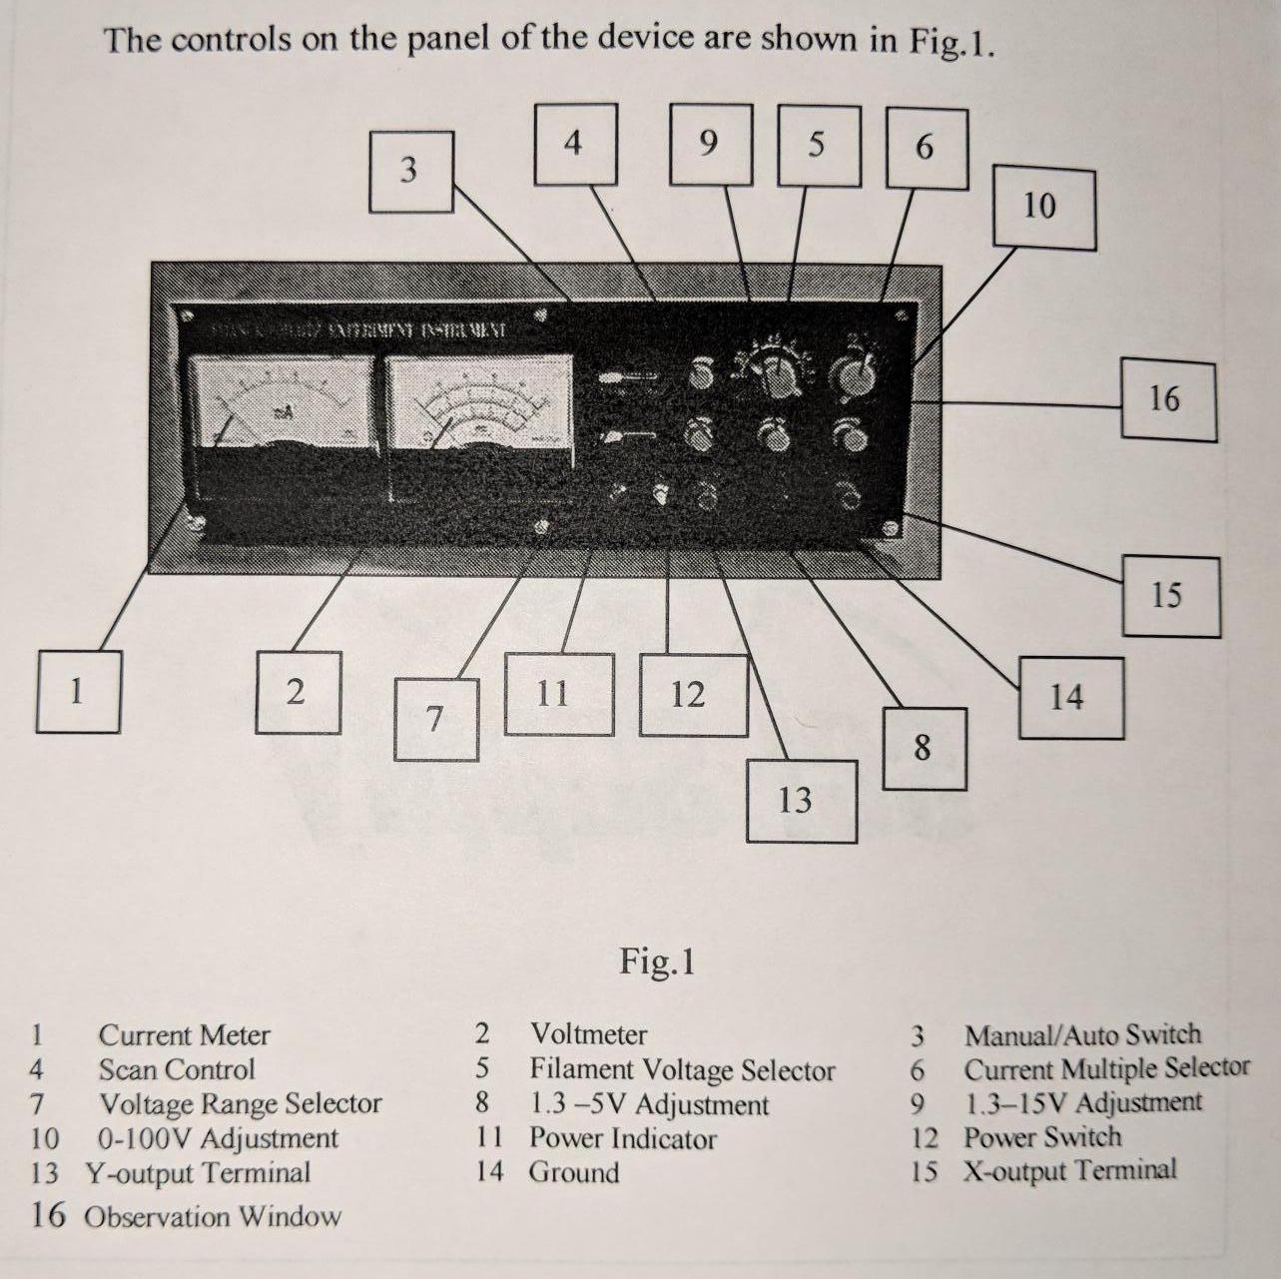

Figure 2 – Experiment 15 voltage controls

The Frank-Hertz tube used in this lab is a tetrode filled with Argon. The electrodes and applied voltages are shown in Figure-3. A voltage U_{G1}K of about 1.5V is added between the first grid (G1) and the cathode (K) to reduce the effect of space charges on cathode scattering electrons. When the filament is heated, the electrons emitted by the cathode are accelerated in the potential U_{G2}K between the cathode (K), and the second grid (G2) thus gaining additional energy.

At the beginning, because the voltage U_{G2}K between the second grid and cathode is low, the electron energy is low. Thus, there is no energy transfer in the elastic collision of an electron with an Argon atom. Therefore, the anode plate current I_{A} formed by electrons penetrating the second grid will increase with the increase of U_{G2}K (See Figure 3).
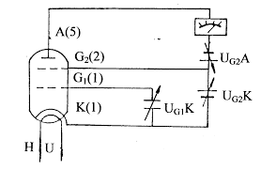
Fig 3: Schematics of Frank Hertz setup used in lab.

When U_{G2}K reaches the first excitation potential of Argon, the electron collides with Argon atoms near the second grid (it is an inelastic collision), and transfers the total energy obtained in the accelerating field to the Argon atom, exciting it from its ground state to the first excited state.
The electron, after transferring all its energy to the Argon atom, can’t overcome the reverse field U_{G2}A between G2 and anode plate (A). They are drawn back to the second grid even if some of them penetrated the second grid. Therefore, the anode plate current I_{A} decreased. Then, with further increase of U_{G2}K, the electron energy increases since it is accelerated after the collision with the Argon atom.
Thus, an electron can overcome the reverse field U_{G2}A and reach anode plate (A). And the anode plate current IA can increase again, until U_{G2}K is equal to twice the voltage of Argon atoms first excited potential. Now the electrons between G2 and K can undergo a second inelastic collision which results in a decrease in the energy of electron.
We now plot the results. Let U_{G2}K be the horizontal axis and I_{A} the vertical axis. We can plot the spectrum amplitude curve. The voltage difference between two consecutive valley points is the first excitation potential of argon atom.
This experiment illustrates the fact that the slow electrons in the Frank-hertz tube collide with Argon atoms, excite the atoms from the ground state to the first excited state. By measuring Argon first excitation potential (somewhere between 10 and 10V, which is constant) we verify that energy absorbed and emitted by the atom is discrete (not continuous).
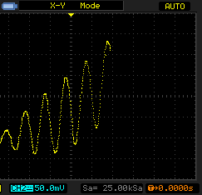
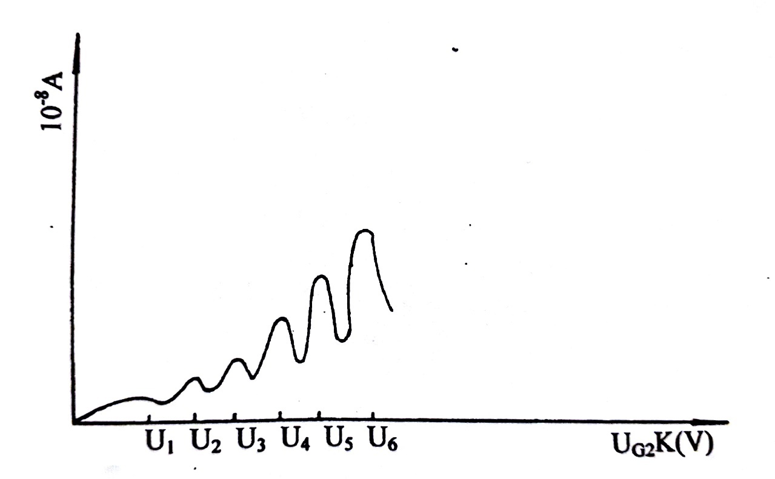

Figure 3

Figure 3: Typical plot of the anode plate current IA (vertical axis) vs accelerating voltage UG2K (the horizontal axis). Dips in the current correspond to the excitation of Argon atoms to first excited state in electron- atom inelastic collisions.

WARNINGS:

- During the experiment, pay close attention to the output current indicator when voltage is over 60V. This is especially important at the higher voltage (filament voltage) and sensitivity (current multiple) settings. If the current meter reading increases suddenly, decrease the voltage at once to avoid the damage to the tube.

- If you want to change the value of U_{G1}K, U_{G2}A and U_{H} during the experiment, rotate “0-100V” adjust know counter-clockwise to end, before making the changes.

- The filament voltage of this instrument is 3V, 3.5V, 4V, 5V, 5.5v, 6.3V. You can do the experiment with these filament voltages. Use of too high filament voltage can cause current distortion. In such condition filament voltage should be decreased.

ADJUST OPERATING VOLTAGES:

- Make yourself familiar with the control knobs and read warning carefully before starting the experiment. Use of filament voltage exceeding 5 volts is discoursed except under direct supervision of TA/TI.

- Make sure the setup has vacuum tube installed (ask TA if unsure) and covered prior to use.

- The 0-100 V knob is continuously adjustable with a soft stop. Use care to slowly rotate this knob during use and when zeroing. Turn all voltage adjustment knobs fully counterclockwise (make all zero). Turn the “Manual -Auto” switch to “Manual” and rotate the “Scan Knob” counter-clockwise to end.

- Set the filament voltage U_{H} to 4 V and the “current Multiple” selector to 10^-8. Turn on the device – the green power indicator will glow. Preheat the bulb for 2 minutes prior to experiment.
Note: NEVER change the “Current Multiple” selector with the instrument powered on. When turning the unit off, the current meter will dip and hold under zero momentarily while the device is powering down.

- Set UG1K to 1.5 V:
Move the “Voltage Stepper” switch to 1.3 – 5 V, and rotate the 1.3 – 5 V adjustment knob until the voltmeter reads 1.5 V.

- Set UG2A to 7.5V:
Move the “Voltage Stepper” switch to 1.3 – 15 V, and rotate 1.3 – 15 V adjustment knob until the voltmeter reads 7.5 V (rejecting voltage).

OPERATION IN MANUAL MODE (AN OPTIONAL ALTERNATIVE):

Complete section 1-6 in previous section. Move the “Voltage Stepper” switch to 0 -100 V, and rotate the 0- 100 V adjustment knob until the voltmeter reads 0V to set UG2K = 7.5 V (accelerating voltage. Normally this is fully counterclockwise. Remember that this knob is continuously adjustable with a soft zero. Now you can gradually increase UG2K and record measurement in ammeter and voltmeter.

OPERATION IN AUTO-MODE:
- Complete 1-6 in section ADJUST OPERATING VOLTAGES.
- Turn on oscilloscope. Press ‘Menu’ button and set it to ‘XY’ mode by using buttons on right side of display.
- Set up marker channel using “Cursor” button. Once you set it properly, X and Y markers control could be changed using “Off” button.
- Set the trigger on X channel using ‘Trigger’ panel on right side of the scope.
- Connect oscilloscope to Frank-Hertz experiment kit properly. Connect the instrument X output to channel 1 of the oscilloscope and Y output to channel 2 of the oscilloscope. Don't forget that you also have to connect the instrument's ground to the ground of the oscilloscope. See figure-4 for reference.

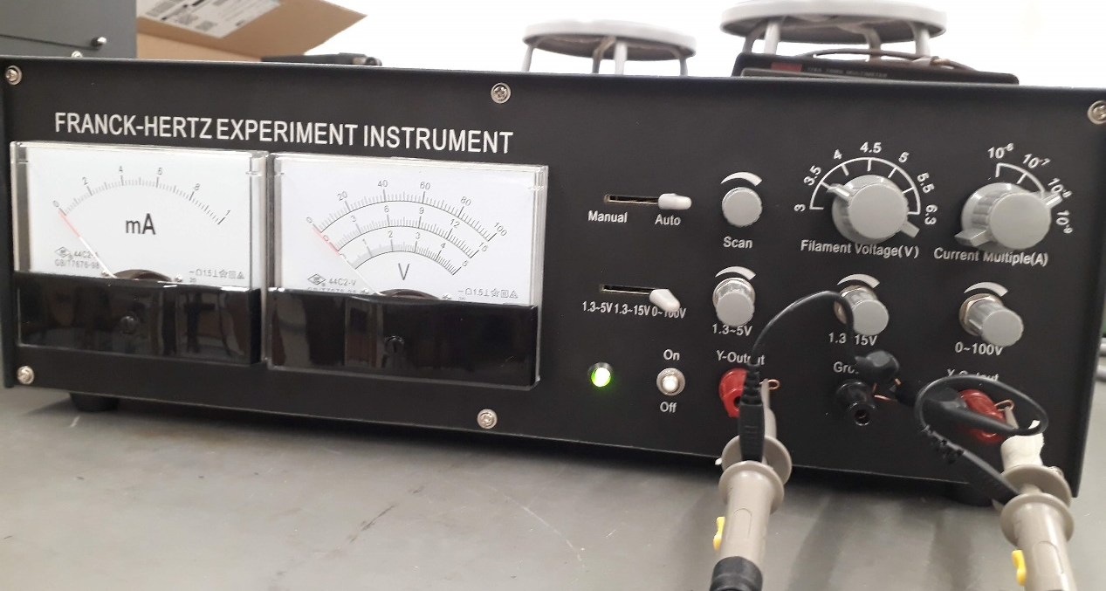

Figure-4: Oscilloscope probe connection

- Move "Voltage Stepper” on Frank Herts Kit to 0 – 100V range and operation switch to "Auto". If you have connected everything properly signal should look as shown in figure-5.
- Measure the peak to peak voltage difference using Cursors and fill in table.

- You can also save in flash drive in different format. For that use “Acquire” button on top panel.

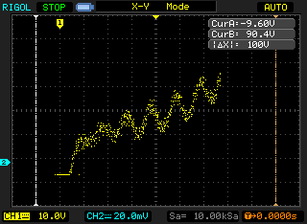

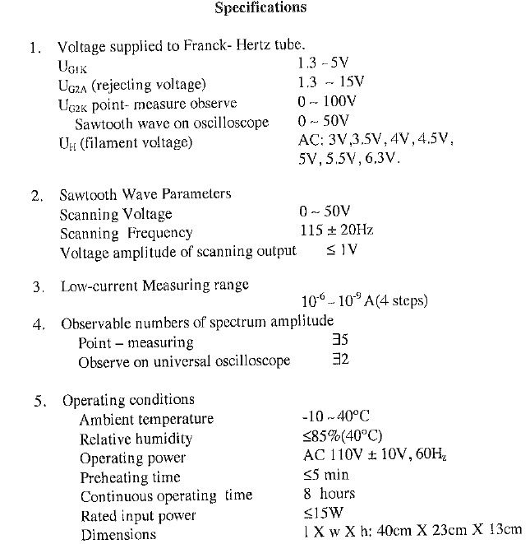

Laboratory Section: ____________ TABLE# ______ Partners’ Names: ___________

Last Revised on February 2, 2021 DATE _____________ Grade: ___________

EXPERIMENT 15

The Franck-Hertz Experiment

DATA ACQUISION [10pt]

FOR AUTO-MODE OF OPERATION: (Use auto-mode unless otherwise instructed by TA)
- Using vertical cursor measure the spacing between adjacent dips: [7 pt].

Location of first dip = ………………V TA STAMP:________
Pair of Dips | $∆$V =  Voltage of (i+1)^{th} dip – voltage of i^{th} dip (V) | Average Voltage Spacing
1-2
2-3
3-4
4-5
5-6
6-7
7-8

- Calculate the standard deviation in average voltage spacing. What does average voltage spacing physically correspond to? [0.5+0.5 pts]

- Sketch the current versus grid voltage as seen in oscilloscope. (You can also save oscilloscope window in picture format and attach). [2pts]

FOR MANUAL MODE OF OPERATION: (SKIP this if you worked in AUTO mode, Only complete if instructed by TA)
- Complete step 1 through 7 in previous section. Now increase U_{G2K} gradually by rotating the 0 – 100V adjustment knob and record current. Try to get at least three dips in current vs U_{G2K} plot. Increase U_{G2K} in small steps for high resolution data. You may use excel or similar data handling program to make plot. (6 pts)

S.N. | U_{G2K} (V) | Current I_{A}
1
2
3
4
5
6
7
8
9
10
11
12
13
14
15
16
17
18
19
20
21

- Make plot of I_{A} vs U_{G2K} recorded in above table: (2 pts)

- Find the spacing between adjacent dips. Find average voltage spacing and standard deviation. What does average voltage spacing physically correspond to? [1+ 0.5 + 0.5 pt]

DATA ANALYSIS [10 pt]

- How much energy is required to excite electron on valence shell of Argon to its first excited state? [1 pt]

- Atoms could not stay at excited state for long. After some time Argon at excited state returns to ground state by releasing excess of energy in the form of electromagnetic radiation. If you were to measure frequency of radiation from your Frank-Hertz experiment what would be the frequency? [2 pts]

- Now suppose you want to excite Argon to first excited state by shining electromagnetic radiation on it. What should be the wavelength of the radiation? [2 pts]

- If everything went correctly, you should have seen higher order dip current does not reach that of the first few. What could be the reason? [1 pt]

- How would contamination of other gas in tube affect your result? [ 1 pt]

- What is the overall conclusion about energy levels in atom/atomic model from this experiment? Describe its connection to Bohr’s atomic model. (3 pts)

