Experiment 2
Acceleration Due to Gravity
Watch the prelab video for Lab 2 (20.53 min) TURN CC ON FOR CAPTIONS), https://rochester.hosted.panopto.com/Panopto/Pages/Viewer.aspx?id=576777fd-42ed-4ea7-bbf1-ac0500499e9c
Read the Lab manual and then read the brief notes.. (Also go over the general brief note for all lab). Do the prelab, upload to blackboard. READ IN ADVANCE all the Questions in the postlab section and make notes as to how to answer them. If you need clarification ask the TA in lab.
Bring the printed manual, a copy of the completed prelab assignment and these Brief Notes to lab. Bring a laptop: You may want to replay parts of the video in lab.
- Pre-Laboratory Work [2 pts]
  - You have just completed the first part of this lab and have five time values for a particular height: 1.8, 1.7, 1.9, 0.8, and 1.9 seconds.

- Give one quantitative reason why you think that 0.8 sec is or is not consistent with the other measurements. (0.5 pts)

- If we assume that 0.8 sec is in fact an outlier, what is one explanation for what could have gone wrong in that trial (use details of the experiment)? (0.5 pts)

  - In this lab you will be using Atwood’s Machine to measure the acceleration due to gravity, g. The machine works by hanging two masses on a pulley, with each mass being acted upon by gravity. Since the masses are on opposite sides of the pulley, their weights oppose each other, and the net acceleration is less than g. To see this, please draw in all of the relevant forces in the diagram below. Be sure to indicate which direction friction in the pulley is acting. Assume m₁ > m₂. (1 pt)

Fig. 0.1
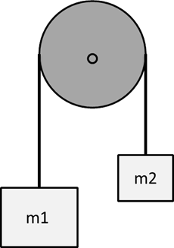
Experiment 2
Acceleration Due to Gravity

- Purpose
The purpose of this lab is to demonstrate how imperfections in an experimental apparatus can play a large role in the final results. You will be measuring the acceleration of an object attached to a pulley system known as an Atwood machine (see prelab Fig. 0.1). As opposed to an object freely falling under the influence of gravity alone, there are other forces in an Atwood machine that slow the object down. These forces include friction in the experimental apparatus, and rotational inertia (the pulley needs to rotate for the object to fall). These extra forces mean that the acceleration of the masses is not actually given by equation 2.1. In this lab you will investigate and quantify the effects of these forces have on the acceleration of the masses.
Additionally, you will compare two different experimental techniques to see which gives more accurate, and which gives more precise, measurements of the acceleration due to gravity, $g=9.8039$ m/s². In one version of the experiment two digital photogate timers will be used to measure how quickly the masses accelerate, and in the other you will use hand timers. Then we will see who is better: you, or the machines.

- Introduction
Atwood’s machine was originally designed by George Atwood in 1784 as an experiment demonstrating the effects of uniform acceleration. Atwood’s machine reduces the acceleration of the masses to a fraction of the value of gravitational acceleration, and the lower acceleration is measured to greater precision than the unchanged acceleration of gravity with the same timing device. The smaller value of the acceleration is:

$$\begin{aligned}a=\frac{M_{1}-M_{2}}{M_{1}+M_{2}}g, \#\left(2.1\right)\end{aligned}$$
Inverting this for $g$ we get,

$$\begin{aligned}g=\frac{M_{1}+M_{2}}{M_{1}-M_{2}}a,\#\left(2.2\right)\end{aligned}$$

In the next section we will show how to calculate the acceleration, $a$, of the masses used in Atwood’s machine. Then, with Eq. 2.2, you will be able to estimate the acceleration due to gravity on the Earth’s surface (or at least Rochester’s surface, which is almost as good).

Throughout this lab, and in future ones, you will be asked to estimate the uncertainty in the measurements you perform. Unless are you are given further instructions, you should calculate the standard deviation of a set of data, Δx, using

$${}_{x}=\sqrt{\frac{1}{N-1}\sum_{i=1}^{N}{{\left(x_{i}-\overline{x}\right)}^{2}}}, \left(2.3\right)$$

where $x_{i}$ are the data points, $\overline{x}$ is the mean of the data, and N is the number of data points.
For instance, if you performed 10 trials where you timed how long it took an object to drop to the floor, you would report that the object’s fall time was the mean of your 10 data points, and the uncertainty of this fall time is the standard deviation, t.

You could then be asked whether one of the 10 data points was consistent with others, or whether the accepted value is consistent with your findings. One way to test this is to check if the number in question lies within one (or two) standard deviation of the mean (i.e. does it lie in the range ± t or ± 2t ). We use this test because, for a Gaussian (or normal) distribution, about 68% of the data points should lie within one standard deviation of the mean and 95% of the data points should lie within two standard deviations of the mean. Thus, if a number lies outside of this range, then there is a fair chance that it is an outlier.

- Laboratory Work [20 pts]

3.1 The Equation of Motion for the Atwood Machine
To find the equation of motion for Atwood’s machine we calculate the sum of the forces acting on the system. There are three separate forces in our system: the force of gravity on each mass ($M_{1}$, $M_{2})$, and the force due to friction in the pulley. The force due to friction is the sum of the tension in the strings on either side of the pulley ($T_{1}$ and $T_{2}$) and the weight of the pulley ($M_{p}g$) multiplied by $μ$, the coefficient of friction.

$$\begin{aligned}ΣF=M_{1}g-M_{2}g-μ\left(T_{1}+T_{2}+M_{p}g\right)=M_{T}a, \#\left(3.1\right)\end{aligned}$$

Note that we have defined the direction that the larger mass ($M_{1}$) moves to be the positive direction, $M_{T}$ the total mass of the system, and $a$ the acceleration. The total mass of Atwood’s machine is made up of three separate masses: $M_{1}$, $M_{2}$ and $M_{p}$. Plugging in for $M_{T}$ on the righthand side of Eq. 3.1, we get:

$$\begin{aligned}M_{1}g-M_{2}g-μ\left(T_{1}+T_{2}+M_{p}g\right)=\left(M_{1}+M_{2}+\frac{1}{2}M_{p}\right)a, \#\left(3.2\right)\end{aligned}$$

$M_{p}$ is multiplied by a factor of ½ because the pulley is being angularly accelerated rather than linearly accelerated like $M_{1}$ and $M_{2}$ (which just means that the pulley is being rotated rather than pushed along a line). Why this means we put a ½ in front of $M_{p}$ you will see later in the course.

3.2 Measuring the Acceleration (a)

Digital Timer Setup
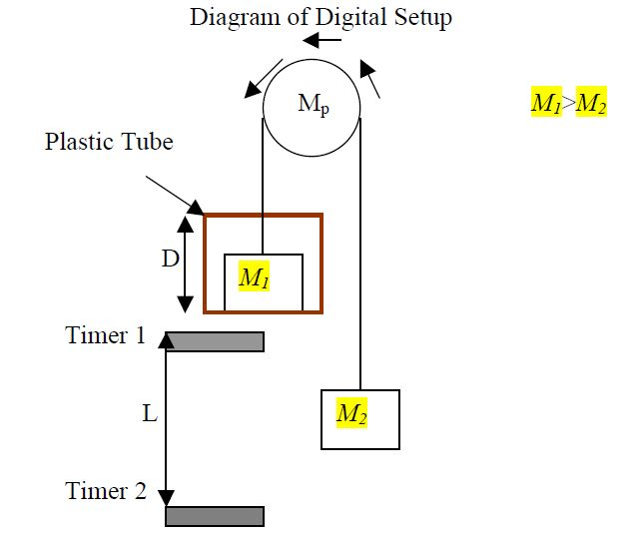
Fig. 3.1

There are four variables that need to be measured to find the acceleration of gravity from this setup: $D$, the length of the plastic tube, $L$, the distance between the two photogate timers and $t_{1}$ and $t_{2}$, the times recorded by the timers. The timers measure how long it takes an object to pass through them, so $t_{1}$ and $t_{2}$ tell us how long it takes $M_{1}$ to pass through the first and second timers respectively. $M_{1}$ has a length of $D$, so we can find the velocity at the location of each timer by taking the distance it needed to travel and dividing by the time it took to travel that distance:
$$\begin{aligned}v_{1}=\frac{D}{t_{1}},\#\left(3.3a\right)\end{aligned}$$
The speed of $M_{1}$ at the second timer is
$$\begin{aligned}v_{2}=\frac{D}{t_{2}},\#\left(3.3b\right)\end{aligned}$$
The change in the velocities is due to acceleration $a$. Using the kinematic equations, the acceleration $a$ can be determined:
$$\begin{aligned}v_{2}=v_{1}+at,\#\left(3.4a\right)\end{aligned}$$
where $t$ is the time it takes $M_{1}$ to travel from the first timer to the second one. Although this would be difficult to measure directly, the distance ($L$) is easily measured. We can relate this to $t$ using another kinematic equation,
$$\begin{aligned}L=v_{1}t+\frac{1}{2}at^{2},\#\left(3.4b\right)\end{aligned}$$

From Eq. 3.4a we can solve for $t$ in terms of $a$:
$$\begin{aligned}t=\frac{v_{2}-v_{1}}{a},\#\left(3.5\right)\end{aligned}$$
Combing Eqs. 3.4b and 3.5 to get rid of the unknown, $t$, we are left with,
$$\begin{aligned}\frac{v_{1}\left(v_{2}-v_{1}\right)}{a}+\frac{{\left(v_{2}-v_{1}\right)}^{2}}{2a}=L,\#\left(3.6\right)\end{aligned}$$
Solving for the acceleration $a$, we find,
$$\begin{aligned}a=\frac{D^{2}}{2L}\left(\frac{1}{t_{2}^{2}}-\frac{1}{t_{1}^{2}}\right),\#\left(3.7\right)\end{aligned}$$
And with that, we have found what we were looking for! By measuring a couple of lengths, and using the photogate timers, we will be able to measure how quickly the masses are accelerating. Next, we do the same for a slightly different setup.

Analog (Hand) Timer Setup
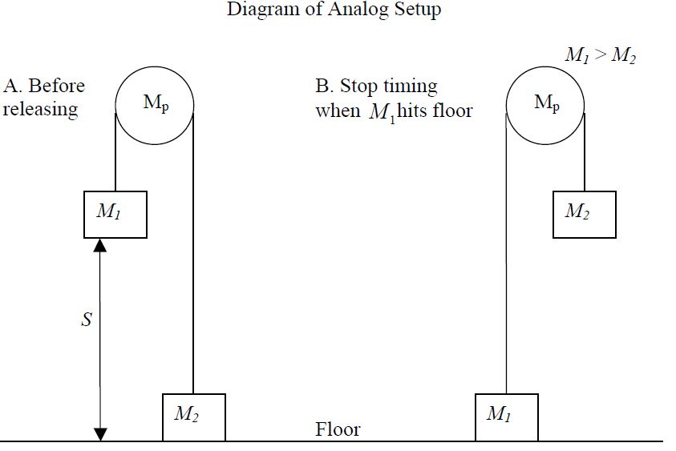
Fig. 3.2
In this section $M_{1}$ starts at rest, which makes the kinematics equations much simpler. Now, only two variables must be measured to find the acceleration of gravity. First, there is the distance from the bottom of $M_{1}$ to the floor, $S$. Second, we must measure the time, $t$, it takes for $M_{1}$ to reach the floor. $t$ will be measured with the hand timer.
The kinematic equations for this section are similar to those in the previous one:
$$\begin{aligned}v_{final}=at,\#\left(3.8a\right)\end{aligned}$$
$$\begin{aligned}S=\frac{1}{2}at^{2},\#\left(3.8b\right)\end{aligned}$$
Notice that these are just Eqs. 3.4a and 3.4b with the initial velocity, $v_{1}$, set equal to 0. Solving Eq. 3.8b for the acceleration, $a$, we find:
$$\begin{aligned}a=\frac{2S}{t^{2}},\#\left(3.9\right)\end{aligned}$$
- Measuring Acceleration Using Photogates and Hand Timers
In this section of the lab, photogate and hand timers are used to time the falling mass. In both methods, the acceleration of gravity will be measured using Atwood’s Machine. The accuracy and the precision of these two methods will then be compared. Equations developed in the introduction for finding the acceleration will be used in this section, as will the statistical techniques from the previous lab. Before doing the experiment, read the operating instructions on the back of the photogate. For this experiment, you will be using the timer in gate mode.

4.1 Procedure for the Photogate Timers (see Fig. 3.1)
- Measure the mass of the plastic tube, $M_{D}$, its length, $D$, and enter these below in Data Table 1:
MM₁=260g
MM₂=240g

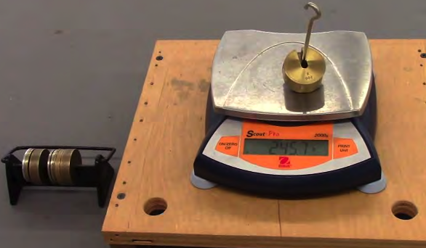
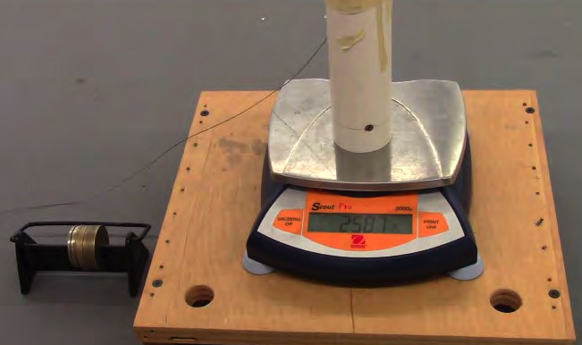

- Set the photogates successively along the path of the mass. Make sure that the plastic tube will not hit them on its way down

- Measure the distance, $L$, from the top of one of the photogates to the top of the other photogate. Enter this below in Data Table 1.

- For $M_{1}$, add masses to the plastic tube so that the total mass (including $M_{D}$) comes out to $M_{1}=260$g. For $M_{2}$, add masses to one of the metal holders such that the total is $M_{2}=240$g. You may use tape to help keep the masses on the holder.

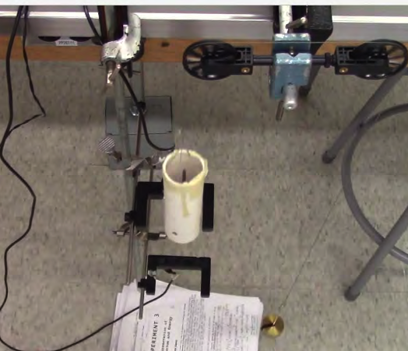
- Once everything is set up you can begin the experiment by starting the lighter mass ($M_{2}$) on the floor, and after making sure that the photogate timers are reset, letting go of the masses. Try not to push the masses when you let them go: you will only be able to measure the acceleration due to gravity if they start from rest. Hold the pulley and not the masses to keep them steady for the fall.
M2 pulley system

- Record the time from the top timer as $t_{1}$, and the time from the bottom timer as $t_{2}$. $t_{1}$ is the time that the photogate initially displays. After you have recorded $t_{1}$, in Data Table 2 (next page), find $t_{2}$ by flipping the MEMORY switch on the photogate to READ. The new number displayed is $t_{1}$ + $t_{2}$. Subtract $t_{1}$ from this to get $t_{2}$. To check that you’re recording reasonable times, remember that $t_{2}$ should be less than $t_{1}$, Why should we expect this?
MM₂=240g
MM₁=260g

- Repeat steps ‎5 and 6 a total of ten times to get a good estimate of the average value of $g$ and the standard deviation (uncertainty) involved with this timing method.

Data Table 1: ** TA Stamp:_____________
$D$ = _____ $M_{2}=240$g
$L$ = _____
$M_{D}$ = _____
$M_{1}=M_{D}+ ______=260$g

Data Table 2 * TA Stamp:____________________
Trial # | $t_{1}$(sec) | $t_{2}$(sec) | Trial # | $t_{1}$(sec) | $t_{2}$(sec)
1 |  |  | 6
2 |  |  | 7
3 |  |  | 8
4 |  |  | 9
5 |  |  | 10

4.2 Procedure for Using Hand Timers (see Fig. 3.2)

- The setup is the same as in section 4.1 minus the photogate timers. Move them out of the way to ensure that the mass doesn’t knock into them while it is falling.

- Let $M_{1}$ (the plastic tube) lie on the floor and measure the distance, $S$, from the floor to the bottom of the lighter mass ($M_{2})$. Record in Data Table 3. Do not hold the masses or the string when measuring; otherwise, you will not get an accurate measurement.

- Familiarize yourself with the hand timer and plug it in when you’re ready to use it. Or, if you prefer, use a phone or any other device that can be used as a stopwatch (like an actual stopwatch, for instance).

- The experiment is the same as before. Hold $M_{2}$ on the floor and then release it and time how long it takes $M_{1}$ to reach the floor.

- Use your chosen timing apparatus and make 10 measurements of how long it takes $M_{1}$ to travel the distance $S$. Record the times in Data table 4. You should release the masses and start the timer at the same time.

Data Table 3: ** TA Stamp:_________________

$M_{1}=260$g
$M_{2}=240$g
$S=$ _____

Data Table 4: ** TA Stamp_____________________

Trial # | Time (sec) | Trial # | Time (sec)
1 |  | 6
2 |  | 7
3 |  | 8
4 |  | 9
5 |  | 10

Questions [10 pts]
Answer questions 1-3 using the photogate timer data:
- Calculate averages of your time data: ${\overline{t}}_{1}$ and ${\overline{t}}_{2}$, as well as the standard deviations, $∆t_{1}$ and $∆t_{2}$. Remember to include units next to your answers! (1 pt)

${\overline{t}}_{1}=$ _____

${\overline{t}}_{2}=$ _____

$∆t_{1}=$ _____

$∆t_{2}=$ _____

- Find the average acceleration using Eq. 3.7. For $t_{1}$ and $t_{2}$, plug in the average times computed in question ‎1. Don’t forget to show your work! (1 pt)

$\overline{a}=$ _____

- Base your uncertainties in $L$ ($∆L$) and $D$ ($∆D$) on how accurately you think you read the ruler, and fill these numbers in below. Then, using the provided error propagation equation, estimate the uncertainty in the acceleration, $∆a$. (0.5 pts)
$$∆a=\overline{a}\sqrt{{\left(\frac{∆L}{L}\right)}^{2}+{{\left(\frac{2∆D}{D}\right)}^{2}+\left(\frac{2∆t_{1}}{{\overline{t}}_{1}}\right)}^{2}+{\left(\frac{2∆t_{2}}{{\overline{t}}_{2}}\right)}^{2}}$$

$∆L=$ _____

$∆D=$ _____

$∆a=$ _____

- Which of the four terms in the square root of the error propagation equation in part (a) contributed the most to the uncertainty $∆a$? (0.25 pts)

- What is one possible reason that this term added the most uncertainty? Use details of the experiment. (0.25 pts)

Answer questions 4-6 using the hand timer data:
- Calculate the mean and standard deviation of your hand timer data (1 pt)

$\overline{t}=$ _____

$∆t=$ _____

- Find the average acceleration $\overline{a}$ using Eq. 3.9. For $t$, plug in the average time computed in question ‎4. (1 pt)

$\overline{a}=$ _____

- Base your uncertainty in $S$ ($∆S$) on how accurately you think you read the ruler and fill this quantity in below. Then, using the provided error propagation equation, estimate the uncertainty in the acceleration, $∆a$. (0.75 pts)
$$∆a=\overline{a}\sqrt{{\left(\frac{∆S}{S}\right)}^{2}+{\left(\frac{2∆t}{\overline{t}}\right)}^{2}}$$

$∆S=$ _____

$∆a=$ _____

- Which quantity, $S$, or $t$, adds the most uncertainty to our estimate for the acceleration of the masses? (0.25 pts)

- Use Eq. 2.1 to calculate your estimates for $g$ from the photogate and hand timer data. Also, calculate the uncertainty in each estimate using the error propagation equation provided below. Report your results in the form $g±∆g$. (1 pt)
$$∆g=\frac{M_{1}+M_{2}}{M_{1}-M_{2}}∆a$$

$g_{photogate}=$ _____ $±$ _____

$g_{hand timer}=$ _____ $±$ _____

- Compare the accuracy and precision of the hand timers to those of the photogate timers. Remember that the accepted value of $g$ is $g=9.8039$ m/s².
- Which method was more precise? How can you tell? (1 pt)

- Which method was more accurate? How can you tell? (1 pt)

- How many standard deviations away from each other (N) are your two estimates for $g , using the eqation provided below$? (1 pt)

Correcting for the Mass of the Pulley

When you try to move an object in a straight line it is clear that the higher the mass of the object the harder you have to push in order to get the same acceleration. A similar rule applies to spinning objects. A car wheel is harder to spin than a bike wheel because the car wheel is much heavier. Spinning objects are more complicated because their motion depends not only on their mass, but also on how the mass is distributed around the axis of rotation. You will deal with this complication formally later in the course; for now, we will confine ourselves to relatively simple objects.
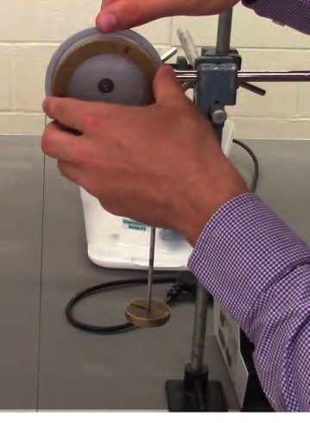
In the previous section, we calculated the acceleration of the masses by assuming that the pulley was massless. However, the pulley does have mass, and is accelerated as the masses fall. Does the extra force required to spin the pulley affect the experiment? In this section you will determine the effect of the pulley’s mass on your measurement of g (if any).

  - Procedure for Measuring Rotational Inertia

- Replace the current pulley system with the large disk pulley.

- Attach two metal mass holders to the pulley and add masses to the holders so that they match the first combination of $M_{1}$ and $M_{2}$ given in the table below.

- As in the first part of the lab, measure the distance, $S$, from the floor to the bottom of the lighter mass while the heavier one sits on the floor. Fill in the result below in Data Table 5.

- For each combination of $M_{1}$ and $M_{2}$ listed below, measure the drop time once using the hand timers. Record these times in column 1 ($M_{R}=0$) of the table.

- Measure the mass of one of the metal rings ($M_{R}$) and add this to the pulley, then repeat step ‎4 and record $M_{R}$ and the times in column 2 of Data table 5 below.

- Measure the mass of another metal ring and add it to the pulley as well (so that there are now two metal rings on the pulley). Repeat step ‎4 and fill in column 3.

$Data Table 5: S=$ _____ ** TA Stamp ____________________

$$M_{1}$$ | $$M_{2}$$ | Fall Times
$$M_{1}$$ | $$M_{2}$$ | - $M_{R}=0$ | - $M_{R}=$ | - $2M_{R}=$
105g | 100g
110g | 100g
115g | 100g

Questions [6 pts]

- Calculate $\frac{M_{1}-M_{2}}{M_{1}+M_{2}}$ for each combination and place your answers in the first column of Data table 6 below. Also, calculate the acceleration for each trial using Eq. 3.9. Don’t forget to include units! (1 pt)

Data Table 6: ** TA Stamp:____________

$$\frac{M_{1}-M_{2}}{M_{1}+M_{2}}$$ | Acceleration
$$\frac{M_{1}-M_{2}}{M_{1}+M_{2}}$$ | 0 rings | 1 ring | 2 rings

If the pulley is massless then Eq. 2.1 holds, and we have
$$\begin{aligned}a=\frac{M_{1}-M_{2}}{M_{1}+M_{2}}g,\#\left(5.1\right)\end{aligned}$$
Thus, a plot of $a$ vs. $\frac{M_{1}-M_{2}}{M_{1}+M_{2}}$ should result in a straight line with a slope of $g$. To see how the mass of the pulley affects our estimates for $g$, we can plot $a$ vs. $\frac{M_{1}-M_{2}}{M_{1}+M_{2}}$ and see how far off the slopes are from the accepted value $g=9.8039$ m/s².

- Plot $a$ vs. the mass ratio $\frac{M_{1}-M_{2}}{M_{1}+M_{2}}$ (y vs. x) for the 0 rings data, and draw a linear best-fit line to these three data points. Then, do the same for the 1 ring data, and then the 2 rings data. Make sure to include the usual axes labels, units, and title for your plot. Finally, add a legend or otherwise indicate which data points belong to which case: 0 rings, 1 ring, or 2 rings. (2 pts)

Check your graph to make sure you included axes labels, units, a title, and a legend!

- How does your measurement for $g$ change as the mass of the pulley increases? Hint: remember that $g$ should be equal to the slope of your data. (1 pt)

- Given your answer to question 11, do you think the effect of the pulley’s mass on measurements of g can be used to explain the differences between your estimates for g in question 7, and the accepted value of 9.80839 m/s² ? (2 pts)

- Summary Questions [4 pts]

- What is another significant source of error in Atwood’s machine that is not explored in this lab? How might this affect your results? (1 pt)

- What is one improvement that you could make to Atwood’s machine to make your results more accurate? (1 pt)

- What is one improvement that would make the results more precise? (1 pt)

- Clearly, Atwood’s machine has a lot of systematic error that would not be present if we were to simplify the experiment. What is one reason we might expect to get better results using Atwood’s machine rather than following Galileo’s example and just dropping objects off of tall buildings? (1 pt)

