Experiment 3
Conservation of Momentum and Energy
Watch the two-part Prelab video for Lab 3 (27.39min) (TURN CC ON FOR CAPTIONS),
https://rochester.hosted.panopto.com/Panopto/Pages/Viewer.aspx?id=dd8e6cbc-48de-4f25-8f64-ac05005034e7
Read the Lab manual and then read the brief notes.. (Also go over the general brief note
for all lab). Do the prelab, upload to blackboard.
READ IN ADVANCE all the Questions in the postlab section and make notes as to how to answer them. If you need clarification ask the TA in lab.
Bring the printed manual, a copy of the completed prelab assignment and these Brief Notes to lab. Bring a laptop: You may want to replay parts of the video in lab.
- Pre-Laboratory Work [2 pts]
  - In Sections 3.1 & 4.1, The Linear Track, what is the purpose of measuring the Average Fraction Lost for the Momentum and Energy? (1 pt)

  - In Sections 3.2.1 & 3.2.2, two different methods are used to estimate the initial velocity of the ball, $v_{b}$, after it has been launched out of the spring cannon.
- Briefly describe both methods. (0.5 pts)

- Why might we want to use two independent methods to measure $v_{b}$? (0.5 pts)

Mechanics Experiment #3: part 1: Friction Carts room B266

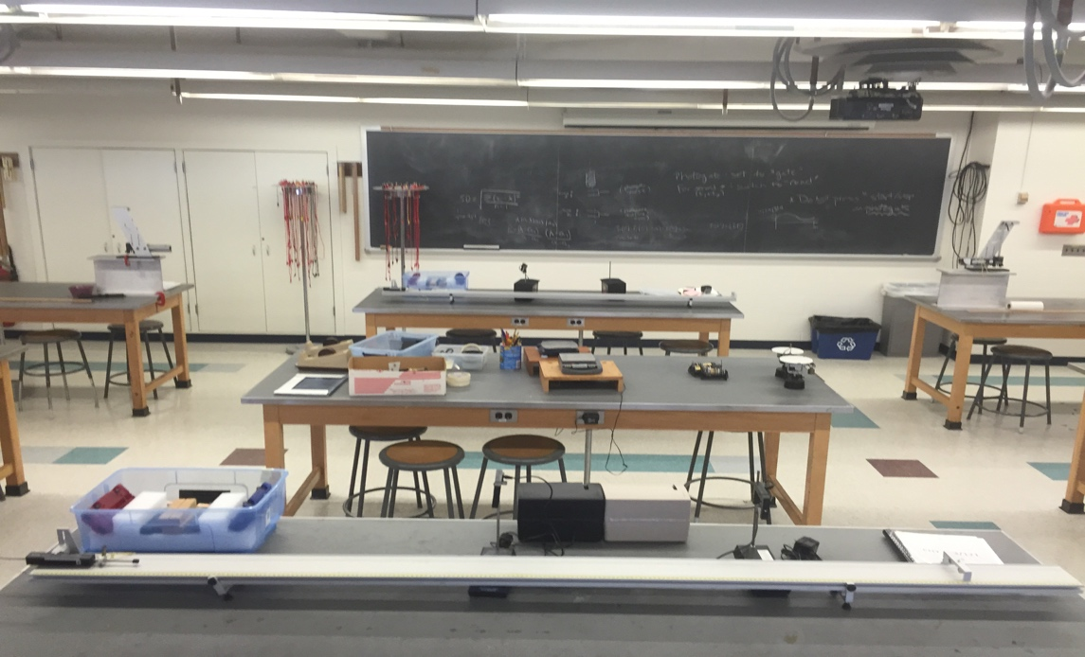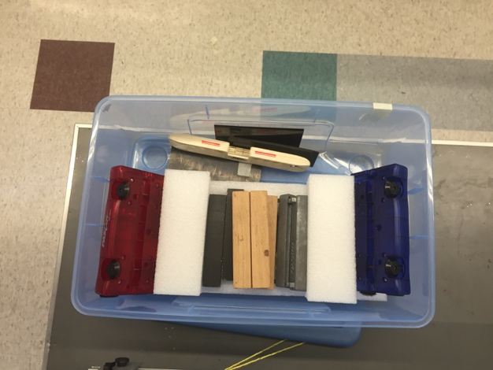
Photogates

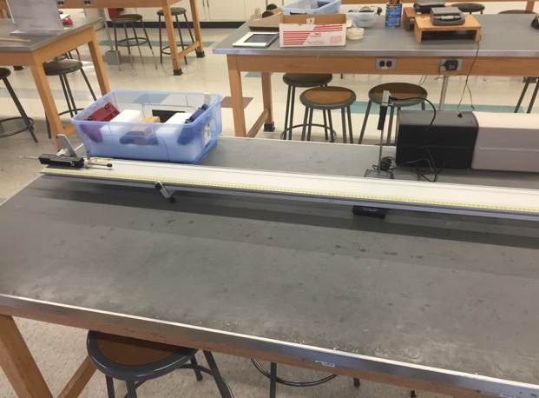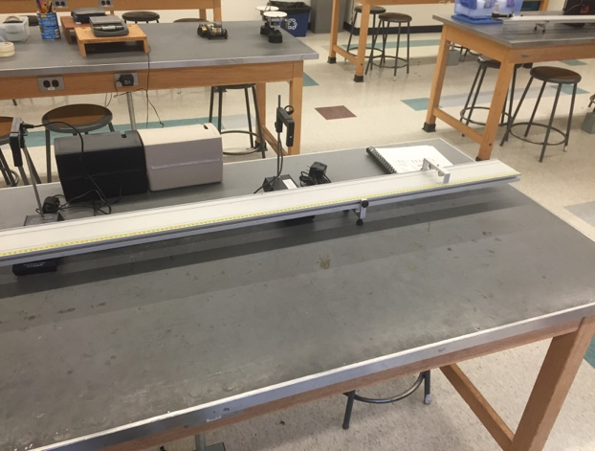

Materials List:
- Aluminum I-beam
- Ballistic Pendulum/Projectile Launcher
- Pail with Metal Ball
- Ball loader stick
- 2 Plastic Carts
- Masses
- Wooden Blocks
- Level
- Photogates
Items in room available to be shared by all students for all labs

- Scale
- Additional rulers

Experiment #3(b): Conservation of Momentum & Energy PHY 113, 121

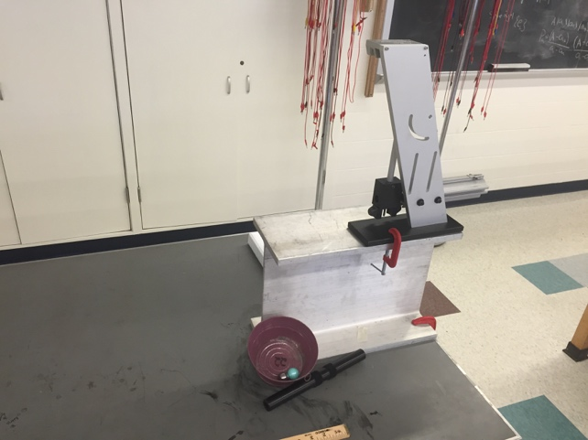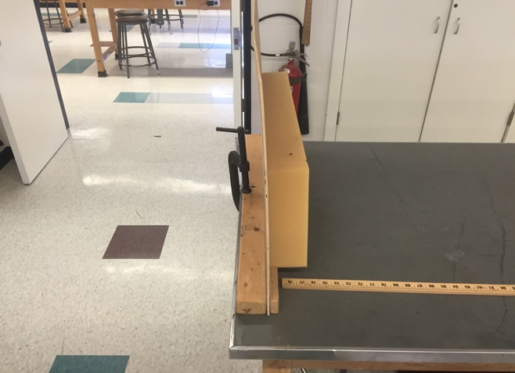
Pail with metal ball

Ballistic Pendulum/
Projectile Launcher

Aluminum I-beam

Ball Loader Stick

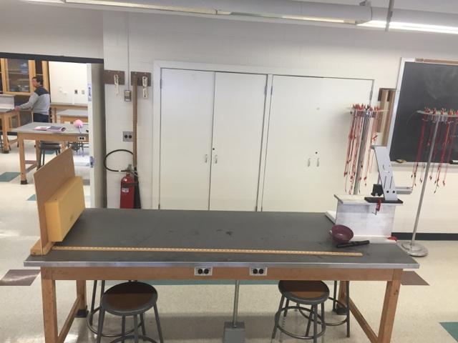
Materials List (all in B&L 266 back glass cabinet):
- Aluminum I-beam
- Ballistic Pendulum/Projectile Launcher
- Pail with Metal Ball
- Ball loader stick
- 2 Plastic Carts
- Masses
- 2 Wooden Blocks
- Level
- Photogates
Setup Notes:
- Setup #3A on outside lab tables ONLY (projectiles)
- 1 large clamp (in storage room), 1 small clamp (B&L 266 near back glass cabinet)
Items in room available to be shared by all students for all labs

- Scale
- Additional rulers

Experiment 3
Conservation of Momentum and Energy

Watch the two-part Prelab video for Lab 3 (27.39min) (TURN CC ON FOR CAPTIONS),
https://rochester.hosted.panopto.com/Panopto/Pages/Viewer.aspx?id=dd8e6cbc-48de-4f25-8f64-ac05005034e7

- Purpose
The purpose is to experimentally verify the laws of conservation of momentum and energy by performing the following experiments:
- The Linear Track
- Newton’s First Law
- Elastic Collisions
- Inelastic Collisions
- Velocity of a Projectile
- Ballistic Pendulum
- Projectile Motion

- Introduction

The laws of conservation of energy and momentum are among the most fundamental and useful laws of physics. They aid in the solution of many mechanics problems and come up frequently in many fields of science. These laws say that if there are no net forces on a system, then that system will have the same momentum,
$$\begin{aligned}\vec{p}=m\vec{v},\#\left(2.1\right)\end{aligned}$$
at all times (note that the symbol denotes a vector). In addition, if there are no external or internal forces acting in or on a system, then the energy of that system will remain constant. Newton’s First Law is hidden in these conservation laws. Newton’s First Law states that bodies at rest will remain at rest as long as no forces act upon them, and bodies in constant motion will remain in constant motion as long as no forces act upon them. As one can see, Newton’s First Law is a statement about conservation of momentum and energy. Objects stay the same, as long as they are left alone.
Despite their fundamental nature, the conservation laws are often difficult to observe in ordinary experience, primarily because of the presence of friction. Friction between moving bodies and their surroundings means that there are external forces acting on the system, therefore, the conservation laws do not apply. To observe the conservation laws, friction must be eliminated as much as possible.
This lab will deal primarily with the conservation laws as they apply to collisions between objects. Collisions can be divided into two different classes: elastic and inelastic. If the kinetic energy,
$$\begin{aligned}K=\frac{1}{2}mv^{2},\#\left(2.2\right)\end{aligned}$$
Of the colliding bodies is conserved before and after the collision, then the collision is said to be elastic. On the other hand, if the kinetic energy is not conserved, then the collision is said to be inelastic. Notice the repeated references to the phrase “kinetic energy.” In determining whether the collision is elastic or inelastic, one considers only the kinetic energy of the system, not the total energy. The kinetic energy of a system may not be conserved depending on the collision type⎯ elastic or inelastic. However, the total energy, which is the kinetic energy plus potential energy plus heat energy (plus any other type of energy in the system) is always conserved regardless of the collision type. The total energy is always conserved in all cases.
In this experiment, we take the liberty of assuming that only kinetic and heat energies are present. Also, we make the approximation that the internal structure of the solid bodies used in the experiment are unchanged by the collision. When this is valid we can treat the solid bodies as point particles (as though all their mass were concentrated at a single point). This simplifies the calculations because no energy is wasted changing the internal structure of the bodies. Therefore, if we ignore friction and small changes to the internal structure of the colliding bodies, momentum will be conserved in both elastic and inelastic collisions.
In a one-dimensional collision between two bodies, setting the initial and final momenta equal using Eq. 2.1 gives us,
$$\begin{aligned}m_{1}v_{1i}+m_{2}v_{2i}=m_{1}v_{1f}+m_{2}v_{2f},\#\left(2.3\right)\end{aligned}$$
where the two bodies have masses $m_{1}$ and $m_{2}$, initial velocities $v_{1i}$ and $v_{2i}$, and final velocities $v_{1f}$ and $v_{2f}$. Eq. 2.3 holds for both elastic and inelastic collisions.
For elastic collisions only, setting the initial and final kinetic energies of the two bodies equal with Eq. 2.2 yields,
$$\begin{aligned}\frac{1}{2}m_{1}v_{1i}^{2}+\frac{1}{2}m_{2}v_{2i}^{2}=\frac{1}{2}m_{1}v_{1f}^{2}+\frac{1}{2}m_{2}v_{2f}^{2},\#\left(2.4\right)\end{aligned}$$
Using Eqs. 2.3 and 2.4, we will be able to experimentally study elastic and inelastic collisions between two bodies and verify whether these conservation laws are correct.

- Laboratory Work

3.1 The Linear Track

Introduction
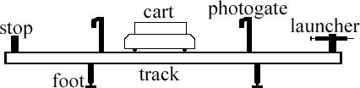
Fig. 3.1

For these experiments you will be using a track with carts that have very low friction wheels. The track setup with a cart used in the experiments is shown in Fig. 3.1. You will be able to measure the time intervals of a cart using the photogate, from which you can calculate the velocity of the cart. The photogate timer is an electronic timer controlled by the interruption of an invisible infrared light beam when the cart passes the gate. If an object of length $L$ interrupts the beam for a time interval $Δt$ while passing through the gate, then the average speed of the object during that time is given by
$$\begin{aligned}v=\frac{L}{Δt},\#\left(3.1\right)\end{aligned}$$
This is the basic measurement that you will make in this experiment. By measuring the velocity of the carts before and after various collisions, you will be able to calculate their energy and momenta to test the conservation laws.

Instructions on Equipment Operation
Timers
Please note that, although you are usually using the two timers on the track at the same time, the timers work independently. In order to calculate the speed at a point on the track, use only the measurement from the timer at that position.
Track
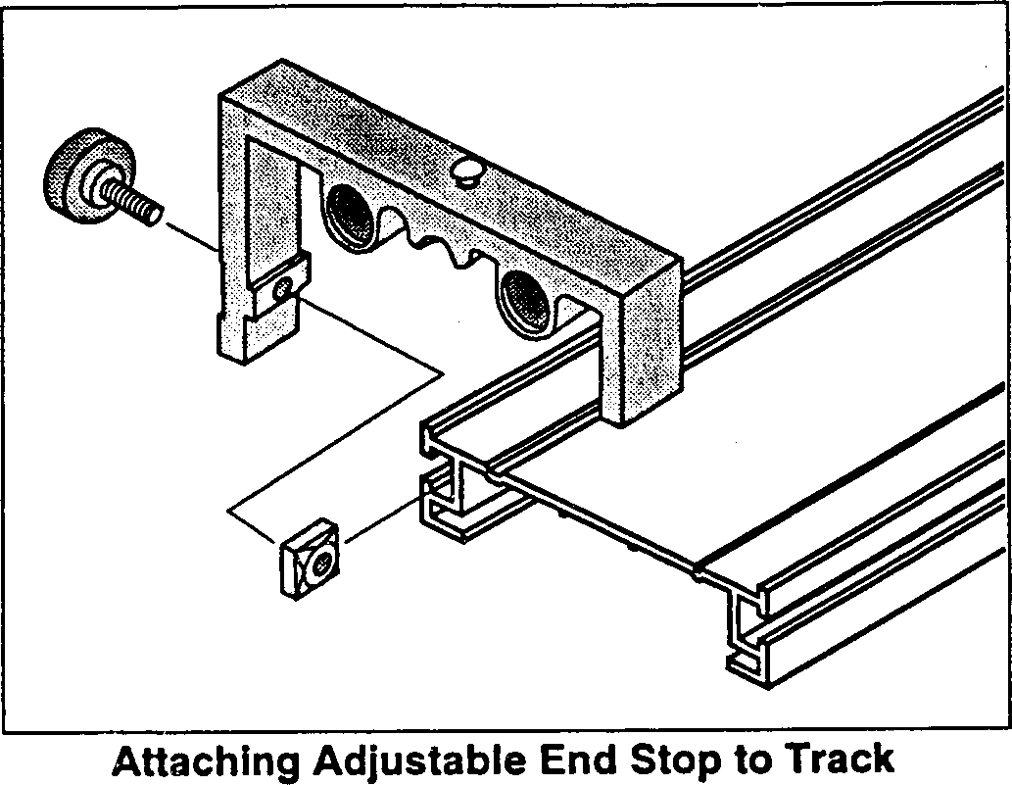
Fig. 3.2

There are several things that must be done in preparation for the experiments ahead. Most importantly is to check if the track is level. Levels are provided for this purpose. Take one and place it over the track’s feet at one end of the track. First, place it along the length of the track and observe the level’s “bubble.” You want this bubble to be as close as possible to the middle. To move the bubble, adjust the feet of the track by turning the screws at the base of the feet. When the bubble is in the middle of the level, repeat this procedure at the opposite end of the track with the level again length-wise.
Once both ends have been adjusted, repeat this again at both ends with the level along the width of the track. Make sure that there is an end stop at one end of the track, and the launcher on the other end. To move the end stop and launcher, loosen the screws on the side and slide them into position (see Fig. 3.2). Lastly, align the two photogates so that they are about two and a half cart-lengths apart.
Carts
One end of the cart has a magnet inside. The other end has a plunger and Velcro pads as labeled in Fig. 3.3. You will use the magnetic bumpers for the elastic collisions and the Velcro for inelastic collisions. The Velcro may not stick together well. To test this, push the plunger in all the way on both carts. Put the two carts together by their Velcro ends. If they are not sticking well, you can roughen the Velcro by repeatedly putting the carts together and pulling them apart (or by using the tape provided).
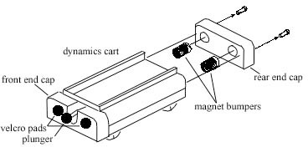
Fig. 3.3

Check that the carts have no irregularities by testing them on the track. Place each cart on the track, making sure that the wheels are in the grooves. Give each cart a small push and see how well it moves on the track. There should be minimal loss in speed as it rolls along the track. If there is a noticeable loss in speed, check the level of the track again. If the level is fine, check the wheels of the cart and then ask your TA for assistance.
The track will be used to create various collisions between the carts. The collisions will be arranged so that an initially moving cart will pass through a photogate timer (so you can measure its initial velocity). Then, it will hit the other cart, and one or both will pass through the photogate timers, allowing you to measure both final velocities. With these measured velocities, as well as the measured masses, the momentum and kinetic energy of the carts before and after the collisions can be calculated and compared.
To deal with systematic errors in this experiment, the approximate effects of friction will be measured, and launchers will be used so that the initial conditions of consecutive trials can be reproduced.

3.1.1 Newton’s First Law
In this part of the experiment, one cart at a time will be rolled down the track, past the two timers. The time for the cart to roll past each timer will be recorded. Newton’s First Law states that an object will remain in its state of motion so long as no forces act upon it. In this case, a cart moving with no friction would not change its velocity as it moves along the track.
We are not testing the conservation laws here. The data from this section of the experiment will be used to estimate the systemic error due to friction so that we can account for it in the next part when we do test the validity of the conservation laws.
The goal in all the trials is to compare the initial and final momenta and kinetic energies of the carts to make a judgment about the conservation laws. This will be done by dividing the final value of the quantity by the initial value in each trial, yielding the fraction of the quantity that is conserved,

$$\begin{aligned}The Fraction of Momentum Conserved: \frac{p_{f}}{p_{i}},\#\left(3.2\right)\end{aligned}$$
$$\begin{aligned}The Fraction of Kinetic Energy Conserved: \frac{K_{f}}{K_{i}},\#\left(3.3\right)\end{aligned}$$

If there was no friction or other forces acting on the two carts, then both The Fraction of Momentum Conserved and The Fraction of Kinetic Energy Conserved would be equal to 1. Since there is friction acting on the carts they will lose speed as they move along the track. As a result, the fractions conserved you measure in the experiment will be slightly less than 1. Results much less than 1 indicate that momentum and/or kinetic energy were lost in the collision (see KEY IDEA below).
The purpose of this section is to measure how much momentum and energy are lost because of external forces like friction. The magnitude of this systematic error can be estimated by calculating the Average Fractions Lost of both momentum and energy, and then taking the difference with what the value would be if there were no external forces:
$$\begin{aligned}Average Fraction of Momentum Lost: \frac{\overline{Δp}}{p}=1-\left(\overline{\frac{p_{f}}{p_{i}}}\right),\#\left(3.4\right)\end{aligned}$$
$$\begin{aligned}Average Fraction of Kinetic Energy Lost: \frac{\overline{ΔK}}{K}=1-\left(\overline{\frac{K_{f}}{K_{i}}}\right),\#\left(3.5\right)\end{aligned}$$
KEY IDEA: The Average Fractions Lost give rough estimates of the amount of momentum and energy lost due to friction. If the average fractions lost when a collision occurs differ by less than 3 times the Average Fractions Lost without a collision (found from Post lab work section 4.1.1), then we will assume that no momentum or energy were lost in the collision. And therefore, that the conservation laws are valid since momentum and energy were only lost to friction.

Procedure
- Answer question 1 in Post lab work section 4.1.1.

- Check that the track is level along both its length and width using the level provided. Test each direction at a few locations along the length of the track.

- Place a wooden block on top of one of the cars. Stick a plastic board into the wood block so that it fits firmly (this is what the photogate timers will detect).

- Fix the heights of the photogates so that the board cuts the beam (a red LED on the side of the photogate lights up when the beam is cut). You can adjust the height of the photogates by loosening the screw on the post and moving the bracket up or down. Make sure that you adjust both photogates and place them about 2.5 cart-lengths apart.

- Adjust the cart launcher so that the scale reads around 1 to 2 cm when it is cocked. You can adjust the compression by loosening the screw on the latching clamp and sliding it into position.

- Take the cart that you’ve set up and place it in front of the launcher. Make sure that the launcher is aimed at the center of the cart and that the cart’s wheels are in the grooves of the track.

- Launch the cart by pulling the string on the launcher. Once it has passed through both photogates, stop the cart and record the two photogate times in Table 3.1.

- Repeat steps 6 and 7 again for a total of 2 trials.

3.1.2 Elastic Collisions
Now, you will be testing the conservation laws. During this part of the experiment, you will use two carts to create elastic collisions. Place two carts on the track with their magnetic ends facing each other.
Note that the launcher setting, and the positions of the timers, are recommendations only. Feel free to make any changes so long as they are consistent across all the trials. When positioning the timers, keep in mind that we want a measurement of the speed and direction of each of the two carts, both before and after the collisions.
Also, remember that energy and momentum are lost continuously (mainly to friction) as the carts travel. Therefore, it is advisable to position the timers so that the measurements are taken just before and after the collision.
You will perform the following experiments:

- Carts of Equal Mass: (use data in Table 3.2)
Place the wooden masses on each cart. Set the launcher scale to around 1 cm and the photogates about 2.5 cart lengths apart.

- Lighter Mass Colliding with Heavier Mass
Place a wooden mass on the cart being launched and heavier, metal masses on the stationary cart. Again, set the launcher scale to around 1 cm and the photogates about 2.5 cart lengths apart.

Procedure
- Answer question 3 in Post lab work section 4.1.2.

- Follow the instructions under I. Carts of Equal Mass above for the correct cart combination and advised launcher and photogate settings.

- Launch one of the carts into the other (stationary) one. Set it up so that the collision occurs in between the photogate timers. The launched cart should pass through the first timer before the collision, and this time should be recorded in Table 3.2 as $t_{1i}$. The final times of both carts can be read off the photogate timers after the collision and entered in Table 3.2 as well.

- Both timers should be set to gate mode. If one of the timers reads two times, then the individual times need to be found. The displayed time is the first time, $t_{I}$. To get the second time, $t_{II}$, flip the memory switch to get the total time, $t_{I}+t_{II}$, and subtract the first time from this to get the second time, $t_{II}$.

- Post lab work Section 4.1.3 (which is worth 0 points and does not require that you collect data) is identical to the above situation but with the stationary cart carrying more mass.

3.1.3 Inelastic Collisions
Post lab work Section 4.1.4 (Equal Mass Inelastic Collisions) is worth 0 points and does not require you to collect any data (so you may remove the photogates if you like). Use the same technique as in section 3.1.2 Elastic Collisions to test conservation laws in inelastic collisions. However, here the Velcro ends of the two carts face each other. If the two carts have trouble sticking together after the collision, you may want to add tape to the Velcro.

Post lab work Section 4.1.5 (Inelastic Collisions – Other situations) is worth 3 points. Follow the instructions given in section 4.1.5 with the launcher scale set to 2 cm.

3.2 Velocity of a Projectile

Introduction
In this experiment, the velocity of a projectile as it leaves a spring gun will be measured using two different methods. First, the conservation laws will be used to determine the initial velocity. For comparison, the velocity will also be measured using projectile motion. The results of these two methods are then compared to see if they agree.

Instructions on Equipment Operation
Ballistic Pendulum
Ensure that the apparatus is firmly fastened down so that it will not move during the experiment. Make sure the base is level and adjust it if necessary. The ball mounts on the gun’s push rod via a hole through its diameter. Also ensure that this fits smoothly on your apparatus, and that the ball catcher is aligned with the spring gun.
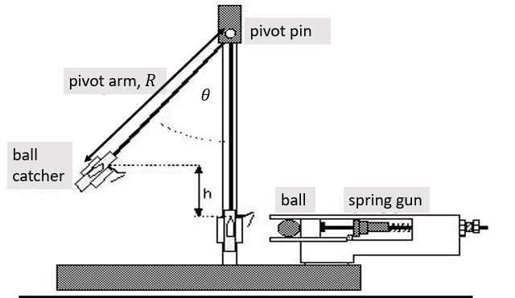
Fig. 3.4
To remove the ball from the catcher, lift the latch spring with your finger while pushing out from the rear. The ball should come out easily.
To weigh the pendulum, carefully unscrew the pivot pin (at the top of the pendulum there is a small knob that allows it to be unscrewed), slide out the pin and remove the pendulum. Place the pin in a safe place, so that it is not lost while you are weighing the pendulum. Replace the pendulum by reversing the disassembly sequence.
To cock the gun, first place a ball in the launcher’s barrel. Then push the ball down the barrel with the ramrod until the trigger catches the piston at the desired point. There are three range settings: short, medium and long. We recommend using the long-range setting, but feel free to use any of them. Just make sure that it is the same for each trial.
Never look into the barrel of the launcher or put your fingers into the barrel. To launch the ball, pull lightly upward on the trigger assembly.

3.2.1 Ballistic Pendulum
Introduction
A ball is fired by a spring gun into a catcher arranged to swing as a pendulum (see Fig. 3.4). When the ball is caught, the combination of the ball and catcher becomes the bob of the pendulum. Although the collision between ball and catcher is inelastic and energy is not conserved, momentum is. With the catcher at rest, the initial momentum of the system is provided by the ball shot with velocity, $v_{b}$. Just after the ball is caught, the momentum is due to motion of the center of mass of the pendulum assembled from the catcher and ball, having velocity, $v_{p}$. Conservation of momentum requires that the momentum before and after the collision be the same:
$$\begin{aligned}mv_{b}=\left(M+m\right)v_{p},\#\left(3.6\right)\end{aligned}$$
where $m$ and $M$ are the masses of the ball and pendulum respectively.
After the ball is caught, the energy of the combined ball and catcher system is conserved. Initially, the center of mass is at the lowest possible point with velocity, $v_{p}$. As it moves upward against the force of gravity, the kinetic energy is converted into potential energy. At its highest point all the initial kinetic energy of the pendulum has been used to produce a change in the potential energy,
$$\begin{aligned}\left(M+m\right)gh=\frac{1}{2}\left(M+m\right)v_{p}^{2},\#\left(3.7\right)\end{aligned}$$
This change in potential energy (from height $0$ to height $h$) can be directly measured by measuring the change (increase) in height of the pendulum bob/ball, $h$. In this lab you will measure $h$ indirectly by measuring the length of the pendulum arm, $R$, and the angle it swings, $θ$:
$$\begin{aligned}h=R\left(1-cos\left(θ\right)\right),\#\left(3.8\right)\end{aligned}$$
Plugging Eq. 3.7 into Eq. 3.6, the initial velocity of the ball can be found:
$$\begin{aligned}v_{b}=\left(1+\frac{M}{m}\right)\sqrt{2gh},\#\left(3.9\right)\end{aligned}$$
Fig. 3.5
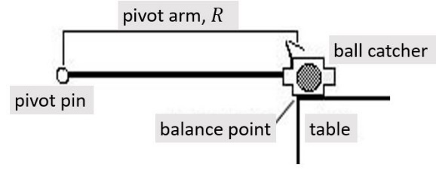

Procedure
- Measure the mass of your ball (use the metal one) and the mass of the
pendulum+ball catcher. Record these in Post lab work section 4.2.1.

- To find the distance from the pivot pin to the center of mass of the ball-pendulum system, $R$, place the ball in the catcher, and balance the entire assembly on the edge of the table. Move it until the assembly is just barely balanced and moving it any farther out would cause it to fall over. The balance point will be directly under the center of mass of the assembly, so $R$ can easily be measured as the distance from the pivot to the balance point/edge of the table. (See Fig, 3.5)

- Starting with the pendulum at rest and the angle indicator set to zero, fire the ball into the catcher five times and measure the maximum angle to which the pendulum swings each time. Make sure the spring gun is at the same setting for each trial and record your data in Table 3.3. Be careful not to get your hand caught in the gun.

- Make sure that you reset the angle indicator to zero before each trial.

3.2.2 Projectile Motion
Introduction
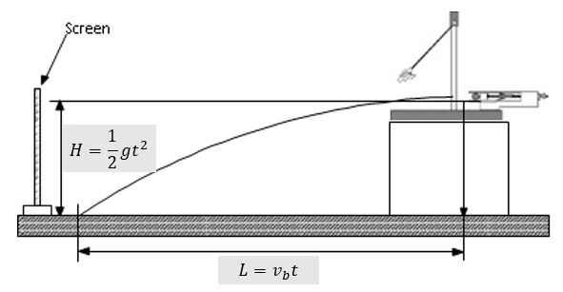
Fig. 3.6

Make sure that the apparatus is securely fastened and leveled on a block on the table. Latch the pendulum bob out of the way and practice firing the ball from the gun out onto the floor. Be careful of wild shots.
With the catcher removed from its path, the ball will fall freely after it leaves the gun. It will follow a parabolic arc until it hits the table, traveling a horizontal distance, $L$, while falling a vertical distance, $H$. The equations of projectile motion can be used to analyze the motion in these directions, as shown in Fig. 3.6. Solving one of the equations for the time the ball spends in the air, $t$:
$$\begin{aligned}t=\frac{L}{v_{b}},\#\left(3.10\right)\end{aligned}$$
Plugging Eq. 3.10 into the other projectile motion equation shown in Fig. 3.6 allows us to eliminate $t$ as a variable:
$$\begin{aligned}H=\frac{1}{2}g{\left(\frac{L}{v_{b}}\right)}^{2},\#\left(3.11\right)\end{aligned}$$
Solving first for the initial velocity of the ball, $v_{b}$:
$$\begin{aligned}v_{b}=L\sqrt{\frac{g}{2H}},\#\left(3.12\right)\end{aligned}$$
And then for the horizontal distance travelled, $L$:
$$\begin{aligned}L=v_{b}\sqrt{\frac{2H}{g}},\#\left(3.13\right)\end{aligned}$$
Procedure
- Measure the height, $H$, from the table to the bottom of the ball when it is sitting in the launcher. Record this in Post lab work section 4.2.2.

- Answer question 1 in Post lab work section 4.2.2.

- With the ball in the gun (and the spring uncompressed so the ball sits at the front of the cannon), find the position on the table directly below the center of the ball and mark it with a piece of tape.

- With the ball in place, compress the spring to whatever range you prefer and then pull up on the string to release the spring and launch the ball. Tape a piece of white paper over the area where the ball landed and cover it with carbon paper, carbon side down. Do not tape the carbon paper!

- Re-load the gun and fire the ball five more times using the same range setting. The ball should leave carbon marks on the paper so that you can measure the horizontal distance the ball travelled. Record each distance, $L$, in Table 3.4.

Experiment 3
Conservation of Momentum and Energy
- Post-Laboratory Work [20 pts]
4.1 The Linear Track [11 pts]
4.1.1 Newton’s First Law (from Section 3.1.1) [3 pts]

- What values do you expect for the Fractions of Momentum and Kinetic Energy Lost when friction is infinitely large? Why? (1 pt)
$$\overline{\frac{∆p}{p}}= \overline{\frac{∆K}{K}}=$$

- What about when there is absolutely no friction? Why? (1 pt)
$$\overline{\frac{∆p}{p}}= \overline{\frac{∆K}{K}}=$$

Launch the cart down the track and fill in the table below. $t_{i}$ is the time it took the cart to pass through the first timer, $t_{f}$ is the time for the second timer, $L$ is the length of the black board on the cart, and $p_{f}/p_{i}$ and $K_{f}/K_{i}$ can be calculated using the equations given below.
The average velocity, $v$, of a cart as it passes through a timer is given by Eq. 3.1, its momentum, $p$, is given by Eq. 2.1, and the kinetic energy, $K$, by Eq. 2.2. Combining these, we get: $\frac{p_{f}}{p_{i}}=\frac{m\left(L/{t_{f}}\right)}{m\left(L/{t_{i}}\right)}=\frac{t_{i}}{t_{f}}$, and $\frac{K_{f}}{K_{i}}=\frac{\frac{1}{2}m{\left(L/{t_{f}}\right)}^{2}}{\frac{1}{2}m{\left(L/{t_{i}}\right)}^{2}}=\frac{t_{i}^{2}}{t_{f}^{2}}$. You can see that because the mass and lengths of the cart do not change they cancel in the above equations, and we end up with simplified expressions for the fractions conserved.

Trial | $$t_{i}$$ | $$t_{f}$$ | $$p_{f}/p_{i}$$ | $$K_{f}/K_{i}$$
A
B
Average, $\overline{\frac{p_{f}}{p_{i}}}$: __________
Average, $\overline{\frac{K_{f}}{K_{i}}}$: __________

Table 3.1 (wooden block) $L$: __________
*** TA Stamp:__________________

- Fill in Table 3.1 and then, using the Average Fractions Conserved found above, calculate the Fractions Lost below using Eqs. 3.4 and 3.5. Show your work. (1 pt)
$$\overline{\frac{∆p}{p}}= \overline{\frac{∆K}{K}}=$$

4.1.2 Elastic Collisions- Equal Masses (from Section 3.1.2) [5 pts]

- For a perfectly elastic collision, what values do you expect for the Fractions Lost given the effect of friction that you just measured? (0.25 pts)
$$\overline{\frac{∆p}{p}}= \overline{\frac{∆K}{K}}=$$

- Why do you think that these values would be the same or different than the ones you calculated in question 2? (0.75 pts)

- If we assume that the lengths and masses of the two carts are equal, will the simplified equations for the Fractions Conserved that you used before still hold? Why? (0.75 pts)

- Based on your answer to part (a), what equation (simplified or not) will you use to calculate the Fractions Lost, $\overline{\frac{∆p}{p}}$ and $\overline{\frac{∆K}{K}}$? (0.25 pts)

In Table 3.2 below, $M_{1}$, and $M_{2}$ are the masses of each cart (cart 1 is the cart being launched). $t_{1i}$ is the time it takes cart 1 to pass through the first timer before the collision, and $t_{2f}$ is how long it takes cart 2 to pass through the second timer after the collision.

Trial | $$M_{1}$$ | $$M_{2}$$ | $$t_{1i}$$ | $$t_{1f}$$ | $$t_{2i}$$ | $$t_{2f}$$
A |  |  |  | N/A | N/A
Table 3.2 (Equal Mass Elastic Collision) *** TA Stamp:__________________

$L_{1}$: __________ $L_{2}$: __________
Note: The time interval $t_{2i}$ is entered as N/A because the second cart should be at rest before the collision, so it has no initial time (its initial velocity is zero). $t_{1f}$ is also entered as N/A, because for an elastic collision the first cart should not move after it collides with the second cart since both carts have the same mass.

- Using your answer to question 4(b) and the data in Table 3.2, find the Fractions of Momentum and Kinetic Energy Lost. (1 pt)
$$\overline{\frac{∆p}{p}}= \overline{\frac{∆K}{K}}=$$

- Following the KEY IDEA (page 8), check if your data supports the conservation laws by testing whether your data satisfies the two inequalities given below (2 pts)

4.1.3 Elastic Collisions- Small Mass into Heavy Mass (from Section 3.1.2) [0 pts]
If the wooden cart derails after the collision, turn down the launcher power until it does not. Think about what happens in this collision, and how it is different from the Equal Mass Elastic Collision. It may be useful to look back at the simplified equations for the Fractions Conserved and consider whether they still apply in this case.

4.1.4 Inelastic Collisions- Equal masses (from Section 3.1.3) [0 pts]
Think about this situation as well, and how it is different from the Equal Mass Elastic Collision before. Do the simplified equations for the Fractions Conserved apply here?

4.1.5 Inelastic Collisions- Other situations of your own choosing (from Section 3.1.3) [3 pts]

Here we study inelastic collisions between the carts. In an inelastic collision, the two carts should stick together after the collision (so you should have the Velcro ends of the carts facing each other). We’ll be using the same setup as before, one cart with mass $M_{1}$ should be in front of the launcher and one cart with mass $M_{2}$ should be at rest on the track. Our goal is to find what combination of masses causes the least kinetic energy to be lost in the collision. Here the Launcher scale is set to ~ 2cm.
Start by making $M_{1}<M_{2}$ and then launching the two carts together. You don’t necessarily need the photogates for this part, just try to remember qualitatively about how much the carts slowed down after the collision. If you’re having trouble getting the carts to stick together, try putting tape on one of the carts so that it will stick more when the two carts collide.
Next, make $M_{1}=M_{2}$ and launch the carts into each other again. Finally, make $M_{1}>M_{2}$ and collide the two carts together one last time.

- Which of the combinations that you tested led to the smallest change in speed of the two carts after the collision? (weigh the carts from your best trial ($M_{1}<M_{2}$ , $M_{1}=M_{2}$ , $M_{1}>M_{2}$ ) (0.5 pts) Table 3.2 B

$M_{1}=$ __________ $M_{2}=$ __________ **TA Stamp_____________

- Why do you think that this combination worked best? Remember that for an inelastic collision momentum conservation tells us that $M_{1}v_{initial}=(M_{1}+M_{2})v_{final}$. (1.5 pts)

- What is one factor that limits the final velocity of the two carts, $v_{final}$? (1 pt)

4.2 Velocity of a Projectile [9 pts]
4.2.1 Ballistic Pendulum (from Section 3.2.1) [3 pts]

*** TA Stamp:__________________

Trial | 1 | 2 | 3 | 4 | 5 | Average, $\overline{h}$
Angle, $θ$ |  |  |  |  |  | N/A
$$h=R\left(1-cos\left(θ\right)\right)$$
Table 3.3 (Ballistic Pendulum Data)

Pendulum Length, $R$: _______ Mass of ball, $m$: _______ Mass of pendulum, $M$: _______

- Calculate the average height of the center of mass of the ball, $\overline{h}$, and its standard deviation, $∆h$. Show your work and don’t forget units! (1 pt)

- Using the results of your above calculation, find the initial velocity of the ball, $v_{b}$, from Eq. 3.9. Show your work and remember to include units next to your answer! (1 pt)

- Now find the error in the ball’s velocity, $∆v_{b}$, using the error propagation equation given below (which treats the mass measurement as being errorless). Show your work. (1 pt)
$$\frac{∆v_{b}}{v_{b}}=\frac{∆h}{2\overline{h}}$$

4.2.2 Projectile Motion (from Section 3.2.2) [6 pts]

$H=$ __________ *** TA Stamp:__________________
Make and record a reasonable estimate of $∆H$, the error in the height measurement: _________

- Use Eq. 3.13 to predict the length, $L$, that the ball will travel. Show your work and mark the expected location on the table with a piece of tape. Remember to include units! (1 pt)

Expected L = __________
Trial | 1 | 2 | 3 | 4 | 5 | Average, $\overline{L}$
Distance, $L$
Table 3.4 (Projectile Motion) *** TA Stamp:__________________

- Calculate the average range that the ball travels, $\overline{L}$, and its error, $∆L$ (i.e. the standard deviation). Show your work. (1 pt)

- Calculate $v_{b}$ from your measurements of $H$ and $\overline{L}$ using Eq. 3.12. Show your work. (1 pt)

- Calculate the error in the initial velocity, $∆v_{b}$ using the error propagation equation given below. Show your work and remember to include units next to your answer! (1 pt)
$$\frac{∆v_{b}}{v_{b}}=\sqrt{{\left(\frac{∆L}{\overline{L}}\right)}^{2}+{\left(\frac{∆H}{2H}\right)}^{2}}$$

- Was the initial velocity of the ball, $v_{b}$, with standard deviation $∆v_{b}$, calculated using the laws of projectile motion (in questions 6 & 7) consistent with the $v_{b}$ and $∆v_{b}$ calculated using the conservation laws (in questions 2 & 3)? (i.e. do the uncertainty ranges overlap?) (1 pt)

- If not, what is one factor that could have caused this discrepancy? (1 pt)

