Name:
Laboratory Section: Date:

Grade:

EXPERIMENT 5

Equivalence of Energy: Heat, Mechanical
Watch the Two-Part Prelab video for Lab 5 (6:41 min). (TURN CC ON FOR CAPTIONS)
https://rochester.hosted.panopto.com/Panopto/Pages/Viewer.aspx?id=0dc4dd14-4b16-49da-a81e-ac05008ab0f8
Read the lab manual and the Lab 4 Brief-Notes which includes photos of apparatus and sample data.
Do the prelab assignment and upload to blackboard. READ IN ADVANCE all the Questions in the postlab section and make notes as to how to answer them. If you need clarification ask the TA in lab. MAKE SURE THAT YOU ARE FULLY PREPARED or you may not be able to complete the lab.

This lab manual needs to be edited using MS word 11 with MathType.
- Pre-Laboratory Work [2 pts]
- A 90kg person jumps from a 30m tower into a tub of water with a volume of 5m3 initially at 20°C. Assuming that all of the work done by the person is converted into heat to the water, what is the final temperature of the water? It’s helpful to first find the work done by the person to the water tub and then the amount of heat equivalent to that work. Make sure you have the correct value for the mass of the water. Include units. [1pt]

- In Section 3.1 you are asked to continue taking temperature measurements even after the heat source has been turned off. What effect are we trying to observe and how do we use this effect in our data analysis? [1pt]

Mechanics experiment #5: Mechanical Equivalent of Heat
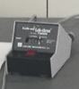
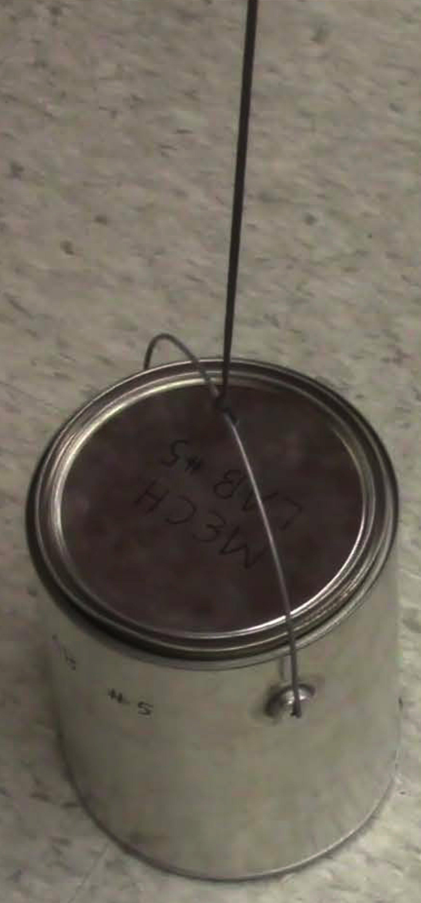
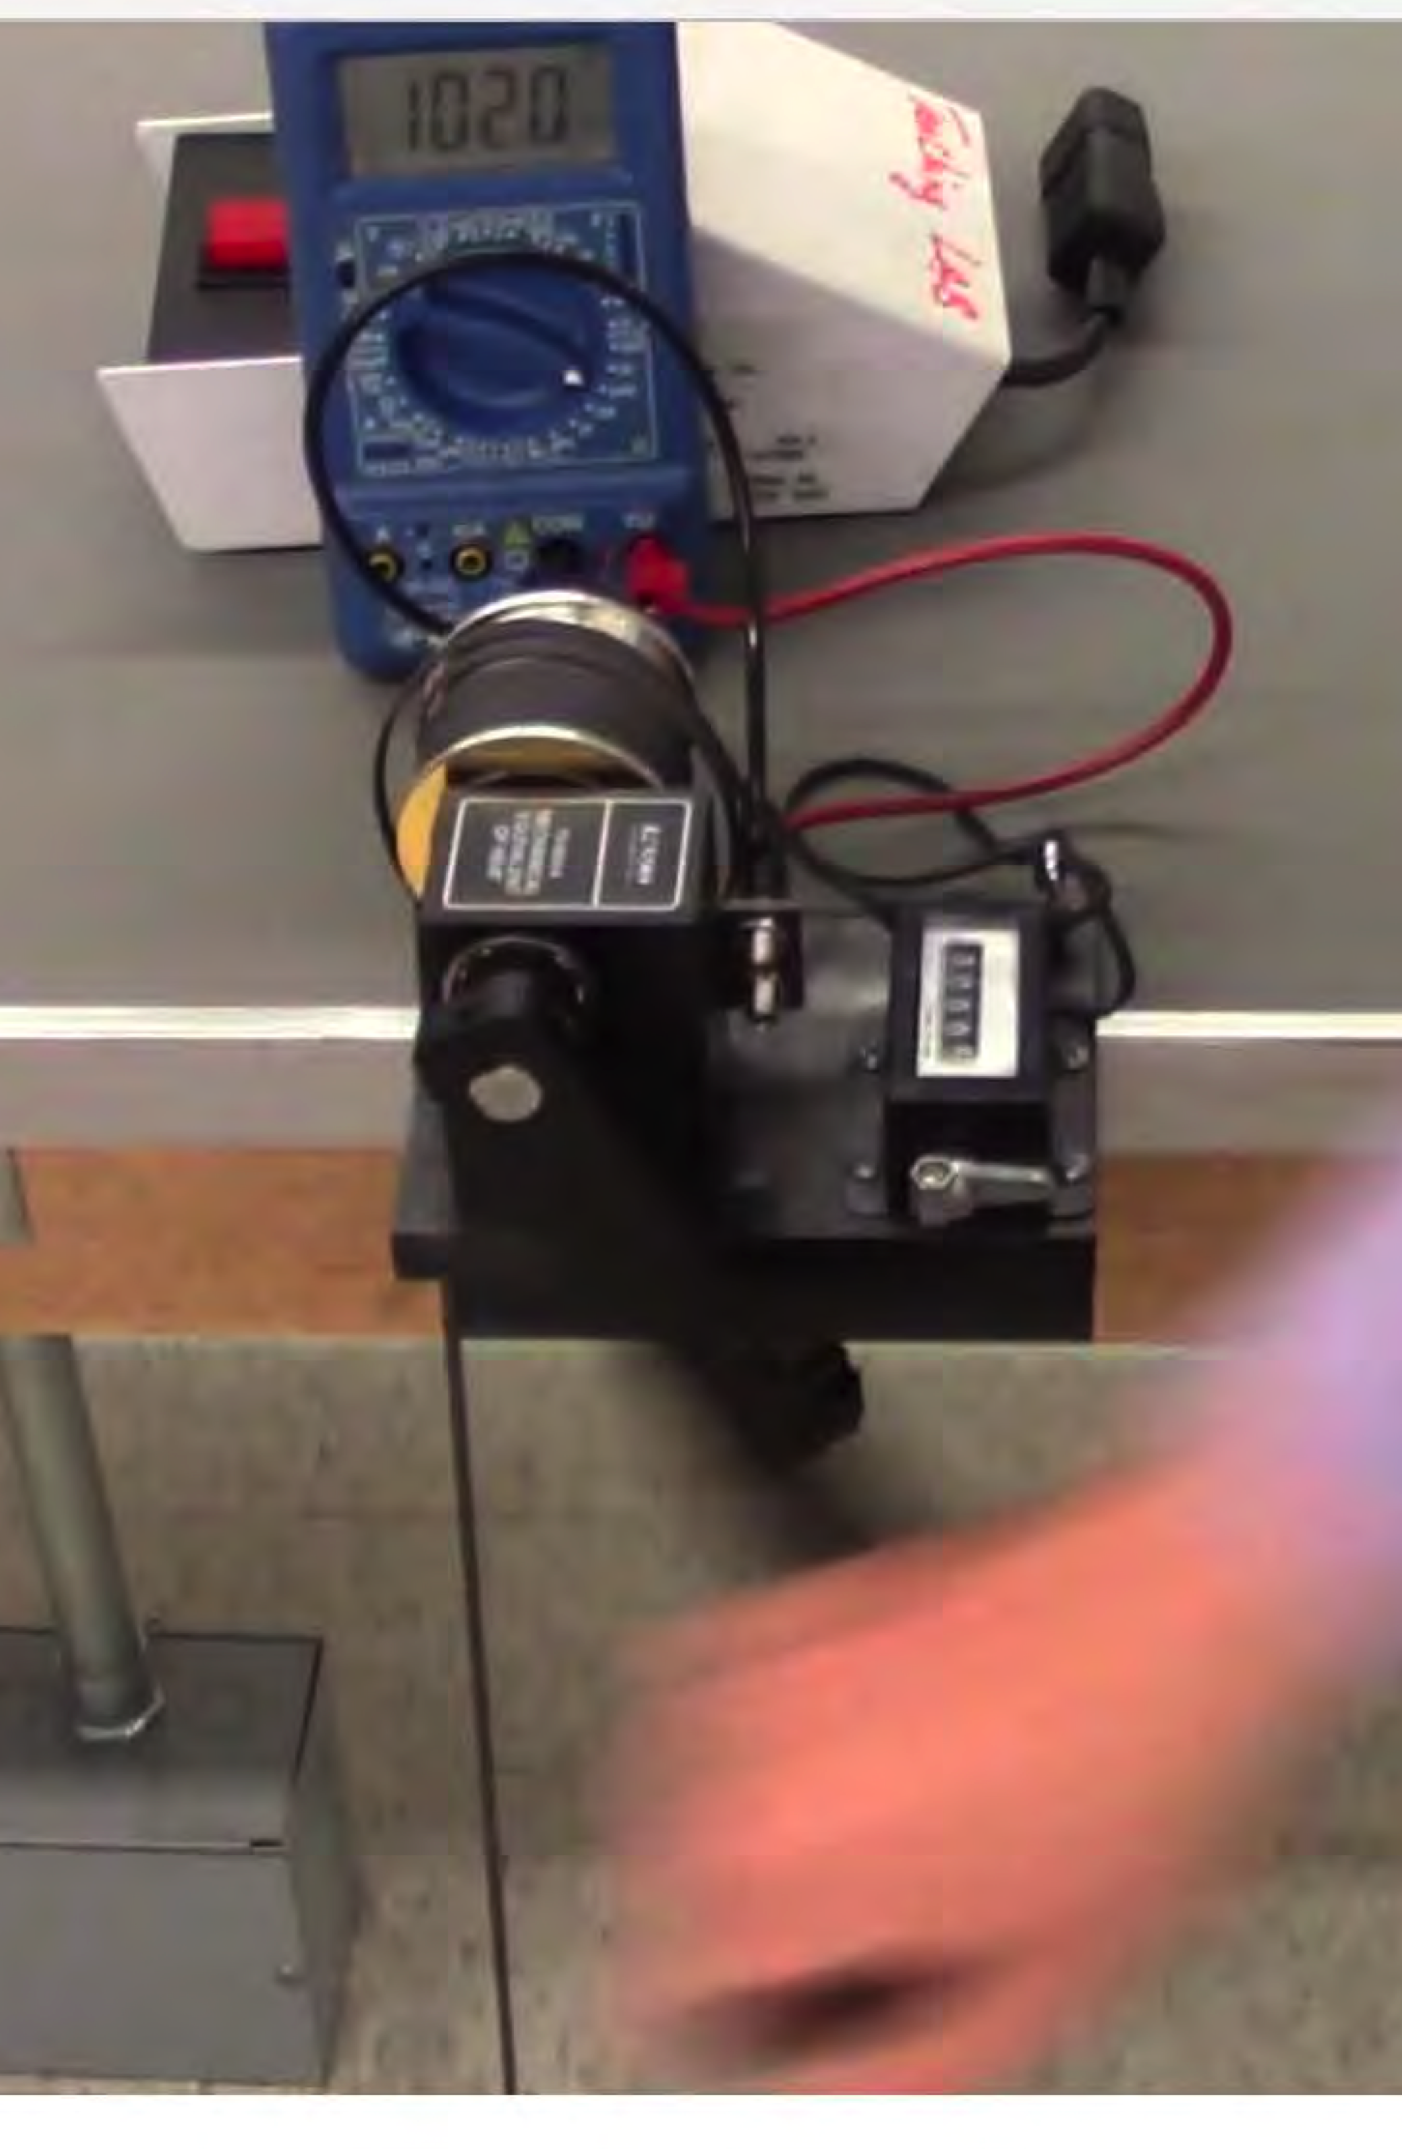
In this laboratory, a Thermistor will be used to measure temperature. This Thermistor is an NTC type (negative temperature coefficient) whose resistance DECREASES with temperature
Mass slightly lifter off ground by cranking
thermistor inside
Blue Multimeter to measure resistance of thermistor to convert to temperature
Timer to Measure time
Counter to count turns

:

EXPERIMENT 5

Equivalence of Energy: Heat, Mechanical

Watch the Two-Part Prelab video for Lab 5 (6:41 min). (TURN CC ON FOR CAPTIONS)

https://rochester.hosted.panopto.com/Panopto/Pages/Viewer.aspx?id=0dc4dd14-4b16-49da-a81e-ac05008ab0f8

In lab:
Bring the printed manual, a copy of the completed prelab assignment and these Brief Notes to lab. Bring a laptop: You may want to replay parts of the video in lab.

THIS EXPERIMENT REQUIRES COLLABORATION WITH A PAIRED PARTNER
THERE NEEDS TO BE A LONG CABLES BETWEEN TWO PAIRED LAB BENCHES.
- Introduction and Purpose

Conservation of Energy is one of the foundational principles in Physics. As a consequence of this principle, we expect that when energy changes forms, there should be the same amount of energy before and after that change. Different forms of energy relevant in this experiment include mechanical work, electrical work, heat (thermal energy), and light. The purpose of this experiment is to observe the conversion of energy from one form to another. Mechanical and electrical work are generally measured in Joules, whereas thermal energy (heat) is usually measured in Calories. Calories and Joules should be proportional to one another, since they are just different units of measure for the same physical quantity (energy). You will measure that proportionality constant between Joules and Calories (i.e. the proportionality between mechanical work and heat), known as Joule’s constant. The accepted value of Joule's constant is 4.19 J/cal.

In this laboratory, a Thermistor will be used to measure temperature. This Thermistor is an NTC type (negative temperature coefficient) whose resistance DECREASES with temperature.

In summary, you will do the following:

Conversion of Mechanical Energy into Heat

- Theory
  - Conversion of Mechanical Energy into Heat
In this experiment, a measurable amount of work is performed by turning a crank. The crank drives the rotation of an aluminum cylinder, which is subject to friction from a rope looped around the cylinder several times, supporting a mass. When the system is set up correctly, turning the crank will just lift that supported mass off the ground—when this occurs, we know that the force of friction between the aluminum cylinder and the rope is equal to the gravitational force F = Mg on the mass. If we know the average force, and we know the number of turns of the crank (there is a counter on the hardware), then we can compute how much work we have put into the system. We assume that all of this work is converted to heat through friction, and that we should subsequently be able to make a connection between the amount of work put into the system and the temperature of the aluminum cylinder over time. Specifically, we expect that the mechanical work performed and the thermal energy gained by the cylinder will be proportional.
There is a thermistor embedded in the aluminum. By measuring the resistance of the thermistor using a multimeter, we can monitor the temperature change of the cylinder (and thus compute the thermal energy transferred to the cylinder). Finally we calculate the ratio of mechanical work performed (in Joules) to heat gained by the cylinder (in Calories), in order to compute Joule's Constant Jmechanical = 4.19 J/Cal, or the mechanical equivalence of heat. (Note that we notate Jmechanical = Jm throughout the manual, in order to contrast this result with the corresponding one in the second half of the lab, which will be notated Jelectrical = Je).
We go through the process for computing the amount of mechanical work performed by turning the crank. The torque required to support a mass M is given by
τ =MgR Equation 5.1
where g is the gravitational accelerating near Earth's surface, and R is the radius of the aluminum cylinder being cranked. The work performed by this torque is given by W = τθ, where θ is the angle through which the cylinder has been rotated. Each complete turn of the crank adds 2π to θ. It then follows that if we have performed a total of N turns of the crank in the experiment, the
total mechanical work must equal to:
W =τθ =(2πN)MgR Equation 5.2
This completes the calculation of the mechanical work we put into the system.
Next we consider how to compute the heat Q imparted to the cylinder from the measured temperature change. The general formula to compute the heat required to change the temperature of an object by a certain amount is given by:
Q = mcΔT Equation 5.3
The mass of the object being heated is m, and c is the specific heat of the material. For us, the object being heated is the aluminum cylinder. Its mass m can be measured (it should be about 200 g), and the specific heat of aluminum is 0.220 (cal/g oC). ⊗T is the change in temperature experienced by the object being heated, and is a measured quantity. We will calculate this a few different ways, discussed in the post-lab.
We can then finally find Joule's Constant:
J = W ( J / cal ) Equation 5.4
m
Q
Any remaining details in the calculations are discussed in section 3.1.

Laboratory Work

Conversion of Mechanical Energy
Preparing the Apparatus
The apparatus for this lab must be set up carefully in order to obtain a good result. The overall apparatus is shown in Fig. 5.1. A multimeter (ohmmeter) will be used to determine the temperature of the cylinder as shown in Fig. 5.2 and described below. We convert mechanical work into heat through friction between a nylon rope and aluminum cylinder, as described in section 2.1. The source of mechanical energy will be provided by you—the aluminum cylinder will be turned by a crank. You should do the following to ensure your hardware is set up correctly.

- You should have the crank apparatus set up on the table top as shown in Fig. 5.3. Measure the mass of the aluminum cylinder, and replace it by screwing in the knob (see Fig 5.3). There are two brushes on the crank apparatus—make sure that they in contact with the side of the aluminum cylinder with the brass slip rings exposed, as shown in Fig.
5.4. The brushes establish an electrical contact with the thermistor inside the cylinder, which is used to monitor the cylinder's temperature.
- Spray some powdered graphite on the cylinder. This acts as a lubricant. The graphite is harmless so long as it is not inhaled (so avoid spraying it near your face).
- Mass the bucket and whatever masses have been placed in it. The total M = Mbucket + Min is taken to be the mass supported by the rope. We neglect the rope's mass. A total M of 2- 3 kg is recommended.
- Tie the nylon rope to the bucket, leaving relatively little extra rope hanging down below the bucket. (You will need as much of the rope's length above as possible.)
- Align the bucket with the slot on the edge of the table-top crank apparatus, such that the nylon rope passes vertically through the slot. Wrap the rope several times around the aluminum cylinder (4-5 turns recommended), keeping some tension in the rope as it is wrapped. (It should be wrapped tightly).
- Tie the rope to rubber band anchored to the base-plate of the crank, as shown in Fig. 5.1. The rubber band should be through the hook in such a way that it creates two loops. (One loop is not strong enough to maintain proper tension in the rope for most rubber bands— loop it through so that it is doubled up. Ask you TA/TI for help if needed.) Pull the rubber band's loops towards the aluminum cylinder before tying that end of the rope off, so that when you are not cranking the rubber band maintains some tension in the rope. Make sure the rope does not cross over itself anywhere on the cylinder.
- Turn the crank a few times. How much does the mass rise off the floor? The amount of friction between the rope and cylinder is determined by the tension in the rope, and the number of turns of the rope around the cylinder. If the mass rises more than 3cm from the floor, there is too much friction between the rope and aluminum cylinder. In this case
either re-tie the string to the rubber band such that it is looser, or unwind one turn of the rope around the cylinder. If the mass does not entirely leave floor, there is not enough friction, and you should either add a turn or re-tie the rope to the rubber band to make it tighter. To correctly calculate the force of the hanging mass, all of the mass must leave the floor when you are cranking.

- Ideally the mass will just leave the floor when you crank, and fall back to the floor if you stop cranking but hold on to the crank handle. Keep playing with step 7 until this happens.
- Use the banana-plug connectors to attach the ohmmeter (see Figs. 5.2 and 5.4), and set it to the 200 k∧ setting or similar resistive range. Your apparatus is ready to go! Some tips about setting up multimeters are provided at the end of the instructions.

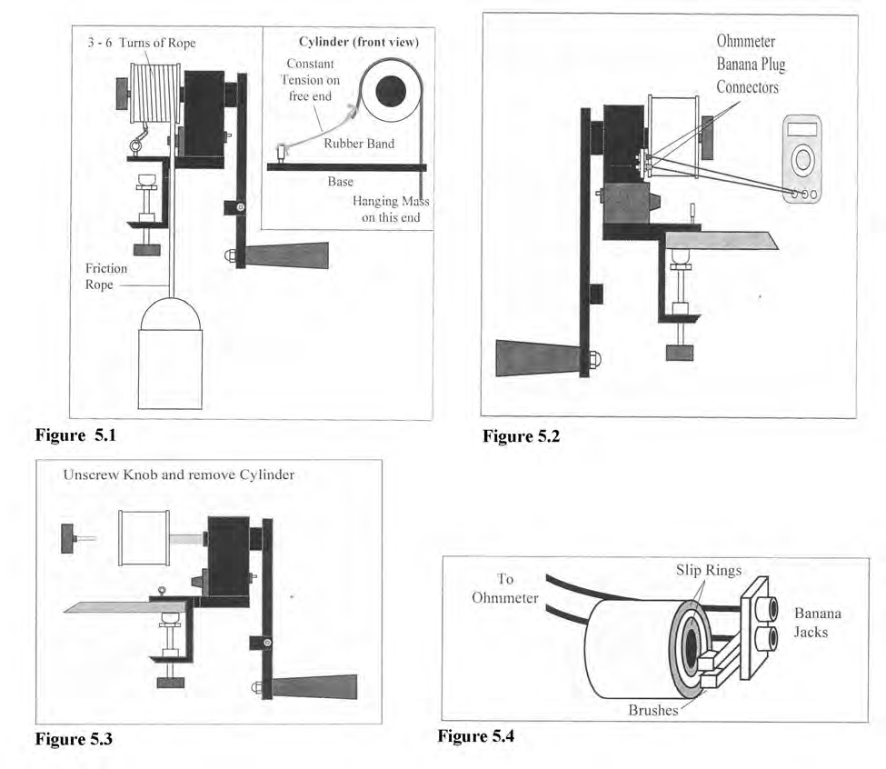

Using the Apparatus (Data Collection)
We now describe the experimental procedure which uses the apparatus described above.
- Make sure the turn counter for the crank is reset to zero. (Turn the knob of the counter to reset it.)
- Make sure your Ohmmeter is on, and record your starting resistance R for time t = 0, in table 5.1. Note that a table and function for converting the resistance measured across the thermistor to a temperature can be found below. It is most efficient to record all of the
resistances in the experiment and then make conversions at the end.

- Start your hand timer, and begin cranking the apparatus. Every thirty seconds you should briefly stop cranking in order to record the resistance and number of revolutions in table
5.1. (Note that the thermistor's reading will vary while the apparatus is being cranked, but will quickly settle to a steady value when it is not being cranked. The person cranking should stop for less than five seconds at each thirty second interval, just long enough for a lab partner to record N and R, and then resume.)
- Continue performing step three for thirty second intervals until your recorded temperature has risen 10-12 oC. You can eyeball this from the table above (or the reduced table on the apparatus itself) while doing the experiment, and then do more careful temperature calculations once data collection is over. A total cranking time of about 5 minutes (300 seconds), in which 500-700 revolutions of the crank are performed would be typical.
- At a thirty second interval at which you have achieved the temperature change of approximately 10-12 oC, stop cranking. Mark this time as tstop.
- However long you were cranking the system, continue to monitor it for that long again every thirty seconds. (Continue taking data without cranking until the time reaches 2tstop.. Clearly N no longer changes, but the resistance should rise slowly as the temperature of the aluminum cylinder decreases as it gradually tries to return to equilibrium with the environment.) This step is in place in order to make a rough estimate of how much energy was lost as heat dissipating into the environment. A change of 1-4 oC in this step would be typical. Talk to your TA if you observe something outside of this range.
- Convert all of your resistance data to temperatures using the table and/or function below. The table will allow you to convert to temperatures with an acceptable degree of precision in the absence of a good calculator for evaluating the function. If you are able to use the functional form to get data however, your results will be much nicer. The function is:
T (R) = (67.03) − (0.7136) R+(3.801∗10−3 ) R2 − (8.680 ∗10−6 ) R3 Equation 5.11
This function requires input of R in kΩ in order to obtain a result in degrees Celsius.
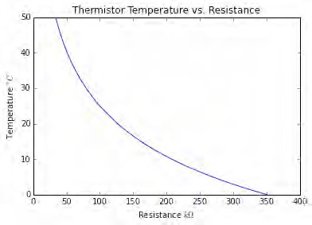
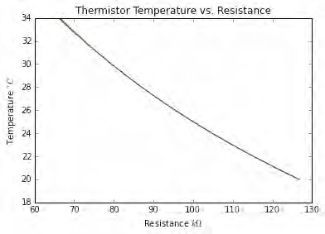
Figure 5.1 (plot from Table) Figure 5.2 (plot from function)

Figures 5.5 and 5.6 visualize the data from the table below. (Equation 5.11 is an approximation of the actual curve, but we see from figure 5.6 that it is a good one over the temperature range of interest. The function is shown in green, and the table data below in blue.)
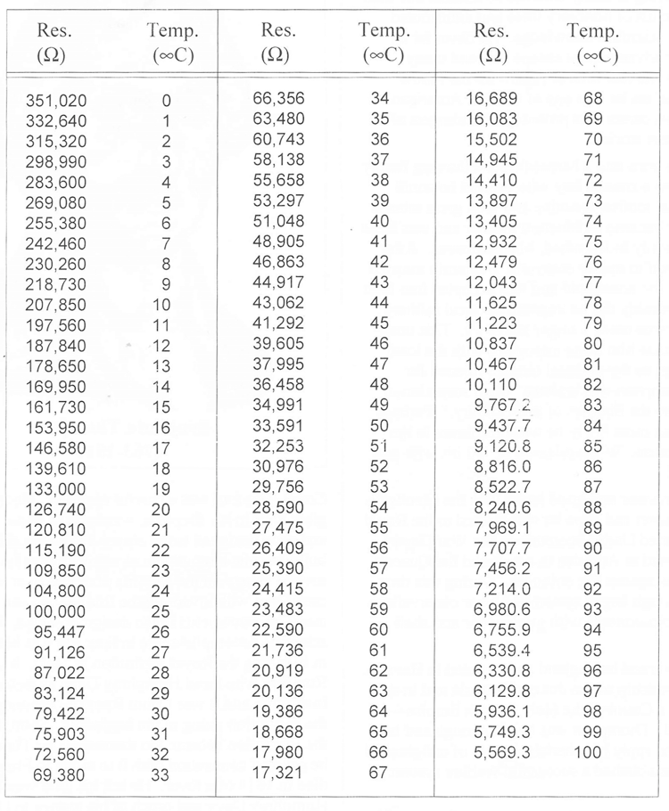
- Follow the instructions and questions in the post-lab in order to complete the analysis of
the data.

Partners’ Names: Grade

EXPERIMENT 5

Equivalence of Energy: Heat, Mechanical
THIS EXPERIMENT REQUIRES COLLABORATION WITH A PAIRED PARTNER. THERE NEEDS TO BE A LONG CABLE BETWEEN TWO PAIRED LAB BENCHES.

For social distancing, we have set up each student with own equipment. Student A (Lab bench A) rotates his/her crank. There is long cable and the ohmmeter for student A is set up at lab Bench B of paired student partner B, who records the data in the Table 5.1 Duplicate. Then they switch. Now student B rotates his/her crank and the student A records the data in their Table 5.1 Duplicate. The students inform each other so that the other student can record his/her data in their own Table 5.1. This is why we have two copies of Table 5.1
4. Post-Laboratory Work [20 pts]

4.1 Conversion of Mechanical Energy into Heat [10pts]

Time (sec) | 0 | 30 | 60 | 90 | 120 | 150 | 180 | 210 | 240
R (k∧)
N (Revs)
Temp (°C)
Time (sec) | 270 | 300 | 330 | 360 | 390 | 420 | 450 | 480 | 510
R (k∧)
N (Revs)
Temp (°C)
Time (sec) | 540 | 570 | 600 | 630 | 660 | 690 | 720 | 750 | 780
R (k∧)
N (Revs)
Temp (°C)
Table 5.1 First copy TA Stamp:_____________
Convert R into T using T ( R) = (67.03) − (0.7136) R+(3.801∗10−3 ) R2 − (8.680 ∗10−6 ) R3 where R
must be entered in kΩ , or use the table on page 8.

Time (sec) | 0 | 30 | 60 | 90 | 120 | 150 | 180 | 210 | 240
R (k∧)
N (Revs)
Temp (°C)
Time (sec) | 270 | 300 | 330 | 360 | 390 | 420 | 450 | 480 | 510
R (k∧)
N (Revs)
Temp (°C)
Time (sec) | 540 | 570 | 600 | 630 | 660 | 690 | 720 | 750 | 780
R (k∧)
N (Revs)
Temp (°C)

Table 5.1 DUPLICATE second copy TA Stamp:_______________
Convert R into T using T ( R) = (67.03) − (0.7136) R+(3.801∗10−3 ) R2 − (8.680 ∗10−6 ) R3 where R
must be entered in kΩ , or use the table on page 8.

- Plot temperature versus time of the data from Table 5.1 on Graph 5.1. Draw two best-fit straight lines—one for the time between 0 and tstop and the other between
tstop and 2tstop . As shown on Figure 5.7, mark on the y -axis the initial ( Tinitial ), peak ( Tpeak ) and final ( Tfinal ) temperatures.
These three temperatures must be based on the two best-fit straight lines, not the data points themselves. The initial temperature Tinitial is at the y-intercept of the first line;

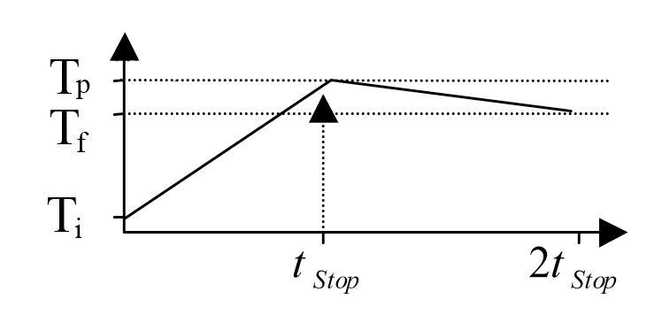
Figure 5.3: Temperature vs. Elapsed Time.

the peak temperature Tpeak is at the intersection of the two lines; the final temperature Tfinal
is when the time is 2tstop . Include title and axis labels with units. [2pts]

Graph 5.1

- The peak temperature in Graph 5.1 may not be exactly the same as the temperature when you stopped cranking. Why might it be possible to for the temperature reading to rise a bit more after you stop putting energy into the system? [1pt]

- a) Calculate the work done, 𝑊, to lift the mass while cranking using equation 5.2. [0.5 pts]

Total number of revolutions 𝑁 = _______
Mass that you lift off the ground 𝑀 = _______
Mass of the aluminum cylinder that you crank 𝑚 = _______
Radius of the aluminum cylinder 𝑅 = _______

b) Compute the change in temperature Δ𝑇 = 𝑇𝑝𝑒𝑎𝑘 − 𝑇𝑖𝑛𝑖𝑡𝑖𝑎𝑙 [0.5 pts]

c) Find the heat that you added to the system, 𝑄, to raise the temperature by Δ𝑇
using equation 5.3. [0.5 pts]

d) Finally, calculate your estimate for Joule’s constant, 𝐽𝑚, using equation 5.4. [0.5pts]

- In this experiment, the aluminum cylinder loses heat to the environment because it is hotter than its surroundings. Calculate how much heat was lost after you stopped cranking, Δ𝑇𝑙𝑜𝑠𝑡 = 𝑇𝑝𝑒𝑎𝑘 − 𝑇𝑓𝑖𝑛𝑎𝑙. [1 pt]

- While you were still cranking the cylinder, heat was also being lost to the environment because the cylinder was hotter than its surroundings (although less hot than 𝑇𝑝𝑒𝑎𝑘). If we
tried to correct for this in our calculation of Joule’s constant by saying that the total change
in temperature due to your cranking should have been Δ𝑇 + Δ𝑇𝑙𝑜𝑠𝑡, why might this overestimate the actual heat lost while cranking? [2 pts]

- Discuss one major source of error in this experiment besides the ambient/radiant cooling, and how it may have affected the measured Joule’s constant. Had that error been removed, would it have increased the measured Joule’s constant or decreased it? Explain. [2pts]

