Name: Date: Course number:
MAKE SURE TA & TI STAMPS TABLES 6.2 and 6.2 BEFORE YOU START

Lab section: Partner's name(s): Grade:

updated July Sept 24, 2020 THIS EXPERIMENT CAN BE DONE WITHOUT A LAB PARTNER

Experiment 6

Coulomb’s Law - PRELAB
Watch the prelab video for lab 6 (19:03 min) (Turn CC on for captions). https://rochester.hosted.panopto.com/Panopto/Pages/Viewer.aspx?id=132ec518-02ae-447c-aa6a-abfa0161c70d
Read Lab 6 manual , and then read the brief notes for lab 6. (Also go over the general brief note for all labs). READ IN ADVANCE all the Questions in the postlab section and make notes as to how to answer them. If you need clarification ask the TA in lab. MAKE SURE THAT YOU ARE FULLY PREPARED or you may not be able to complete the lab
.

Pre-lab Homework (2 points)

The pre-lab homework must be handed to the lab TA at the start of the lab.

- Why is it important to recharge the spheres before each measurement?

- Consider the function y = xn (for n = -2). Take the natural logarithm of both sides and plot ln(y) vs. ln(x) on the graph below. Explain or show how to obtain “n” from the graph. (Hint: Can you fit the graph below to a straight line?) (use x=1, 2, 3, 4, 5, 6)
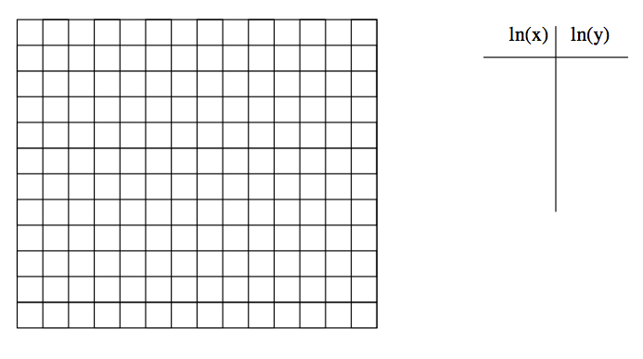

Experiment #6: Coulomb’s Law setup beginning of lab
For Lab 6 Make sure that the dehumidifiers are on.
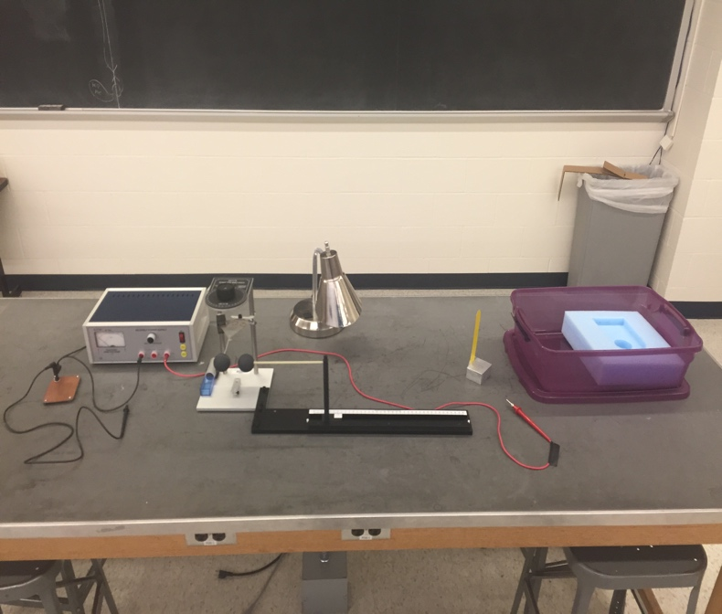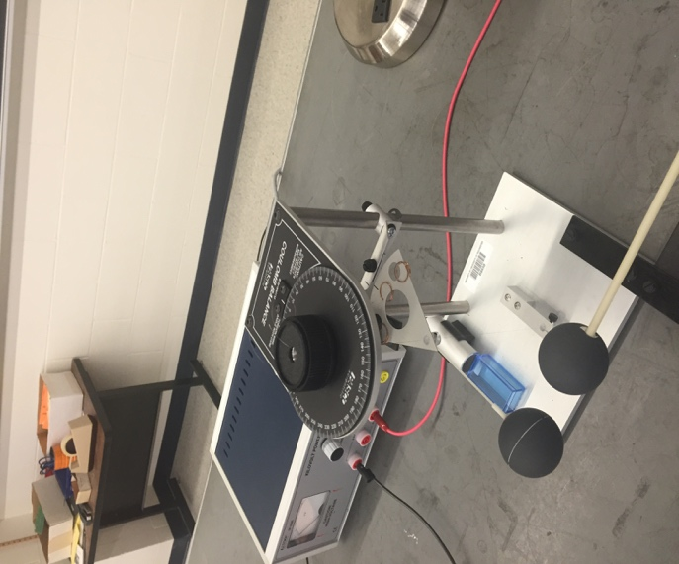
Grounding plate

Ground at wall outlet

Black wire w/ probe

Power Supply

Coulomb balance apparatus

Red wire w/ probe

Metal Block w/ flat metal

Box: Probes, metal block & black ball

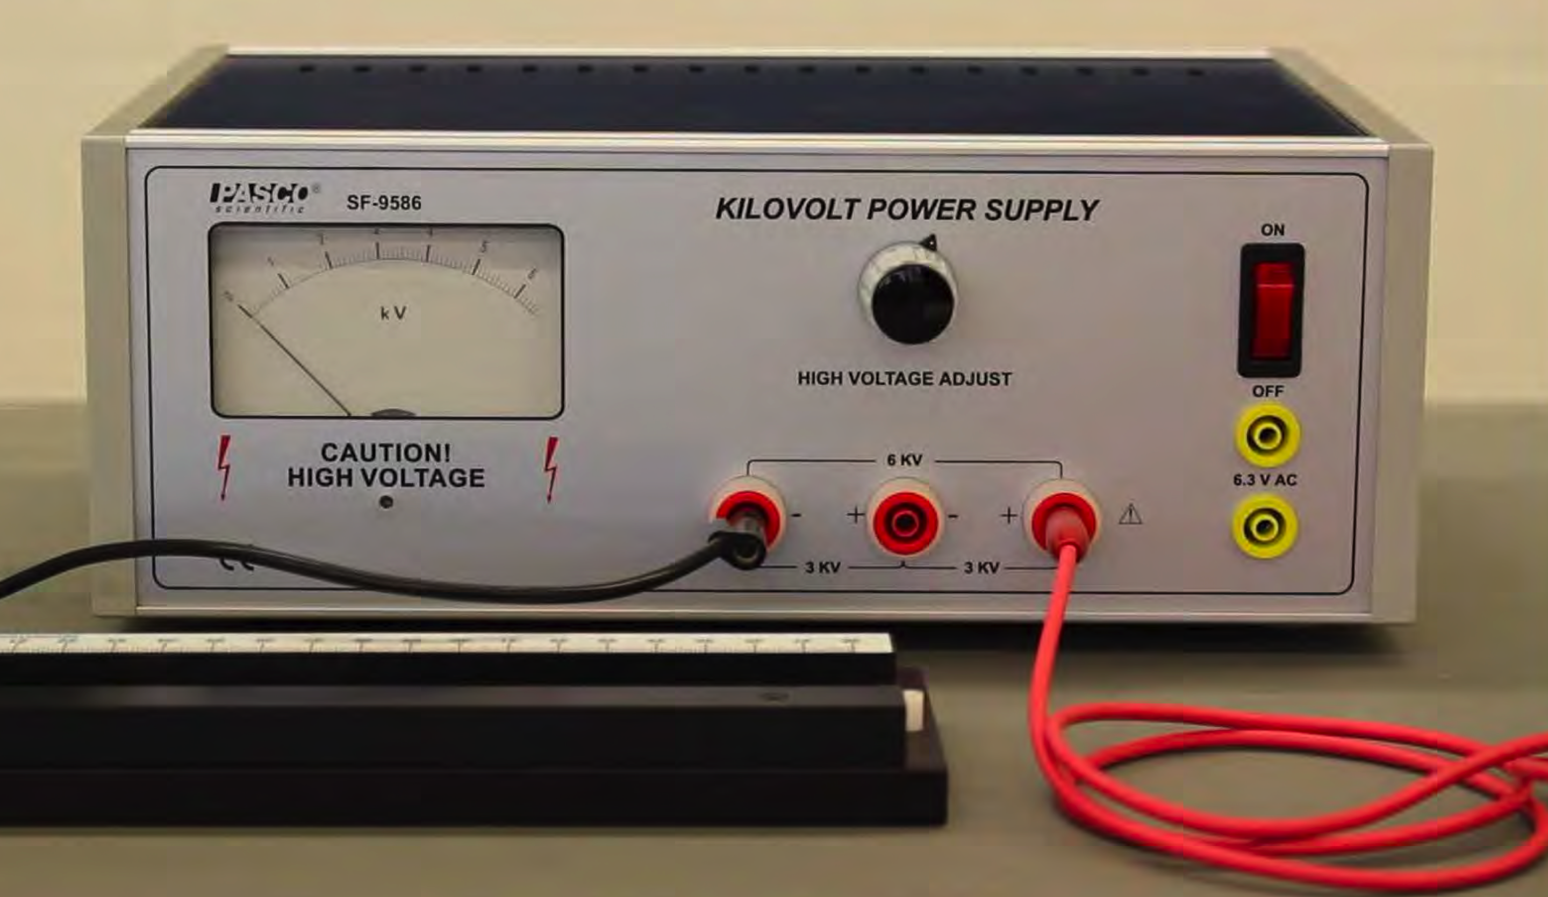
Materials List:
- Power Supply
- Box: Probes, metal block, black ball
- Metal block with flat metal attached
- Coulomb balance apparatus
- Grounding plate
- Black wire with probe
- Red wire with probe

Setup Notes:
- Purple bins (right back glass cabinet B&L 268)
- Black knobs tight when placing ball on rod, loosen after ball is attached
- Black single grounder plugs into circle hole of outlet
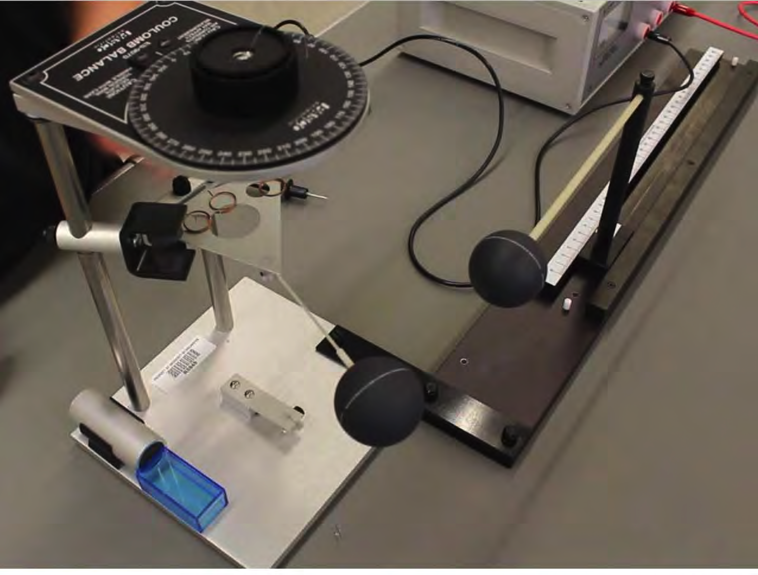
- Plug in red & black wires to power supply
- Setup 4 dehumidifiers in each corner of room.
Items in room available to be shared by all students for all labs

- Scale
- Additional rulers
- All dehumidifiers should be on

Experiment 6

Coulomb’s Law – THE EXPERIMENT
tch the prelab video for lab 6 (19:03 min) (Turn CC on for captions). https://rochester.hosted.panopto.com/Panopto/Pages/Viewer.aspx?id=132ec518-02ae-447c-aa6a-abfa0161c70d

1. Purpose THIS EXPERIMENT CAN BE DONE WITHOUT A LAB PARTNER

The purpose is to verify the proportionality of Coulomb’s Law, that is, to verify that the electric force between two point charges is directly proportional to the product of the charges and is indirectly proportional to the square of the distance between them.

Introduction
Coulomb’s Law gives us the static electrical force F, exerted by point charge Q1 on another point charge Q2 in terms of r, the distance between them:
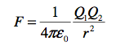

Equation 6.1

The PASCO Model ES-9070 Coulomb Balance (Figure 1) is a delicate torsion balance that can be used to investigate the force between charged objects. A conductive sphere is mounted on a rod, counterbalanced, and suspended from a thin torsion wire. An identical sphere is mounted on a slide assembly so it can be positioned at various distances from the suspended sphere.
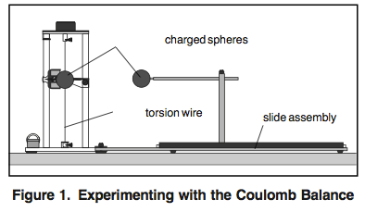
To perform the experiment, both spheres are charged, and the sphere on the slide assembly is placed at fixed distances from the equilibrium position of the suspended sphere. The electrostatic force between the spheres causes the torsion wire to twist. The experimenter then twists the torsion wire to bring the balance back to its equilibrium position. The angle

through which the torsion wire must be twisted to reestablish equilibrium is directly proportional to the electrostatic force between the spheres.

Theory

Take one gram of protons and place them one meter away from one gram of electrons. The resulting force is equal to 1.5 x 1023 Newtons-roughly the force it would take to lift an object from the surface of the Earth that had a mass about 1/5 that of the moon-not a small force.

So, if such small amounts of charge produce such enormous forces, why does it take a very delicate torsion balance to measure the force between charged objects in the laboratory? In a way, the very magnitude of the forces is half the problem. The other half is that the carriers of the electrical force-the tiny proton and the even tinier electron-are so small, and the electrons are so mobile. Once you separate them, how do you keep them separated?
The negatively charged electrons are not only drawn toward the positively charged protons; they also repel each other. Moreover, if there are any free electrons or ions between the separated charges, these free charges will move very quickly to reduce the field caused by the charge separation.

So, since electrons and protons stick together with such tenacity, only relatively small charge differentials can be sustained in the laboratory. This is so much the case that, even though the electrostatic force is more than a billion-billion-billion-billion times as strong as the gravitational force, it takes a very delicate torsion balance to measure the electrical force, whereas we can measure the gravitational force by weighing an object with a spring balance.

Laboratory Work

  - Procedural Outline

The verification of Coulomb’s Law proceeds as follows. A diagram can be found in Figure 6.1.

- Charges are placed on the spherical conductors with a high voltage power supply.
- Due to the presence of the charge, a force is induced between the two spheres.
- The force (F) between the spheres will produce a deflection (θ) of the sphere attached to the torsion fiber. These two quantities are related in the following way,

F = kθ
Equation 6.2

Where k is the torsion constant of the fiber, it is not the coulomb constant (which we call k1 )

- The charge dependence is measured by altering the charge of one sphere, keeping the spheres’ separation constant, and measuring the resulting change in θ (Thus inferring F).
- The separation (R) dependence is measured by charging the spheres and measuring the
resulting change in θ (thus inferring F) for various separations, R.

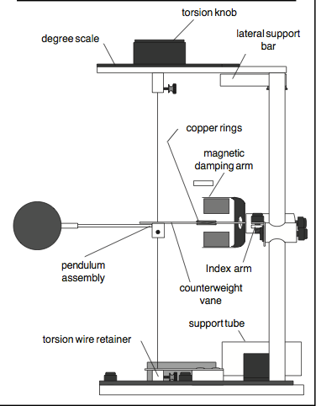

Figure 6.1
Basic Experimental Relationships:
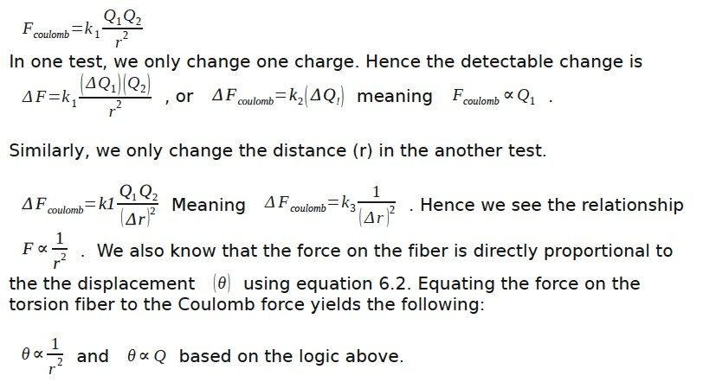

ΔF_{coulomb}=k₁ Q₁Q₂ Δ(1/r²)
ΔF_{coulomb}=k₃ Δ(1/r²)

  - Tips for Accurate Results
For Lab 6 Make sure that the dehumidifiers are on to reduce discharge.
-When performing experiments, stand directly behind the balance and at a maximum comfortable distance from it. This will minimize the effects of static charges that may collect on clothing.

- Avoid wearing synthetic fabrics, because they tend to acquire large static charges. Short sleeve cotton clothes are best, and a grounding wire connected to the experimenter is helpful.

-When charging the spheres, turn the power supply on, charge the spheres, then immediately turn the supply off. The high voltage at the terminals of the supply can cause leakage currents which will affect the torsion balance. (However if there is a lot of discharge to the air, you may try keeping the HV connected to the stationary sphere, and it will not discharge)

-When charging the spheres, hold the charging probe near the end of the handle, so your hand is as far from the sphere as possible. If your hand is too close to the sphere, it will have a capacitive effect, increasing the charge on the sphere for a given voltage. This effect should be minimized so the charge on the spheres can be accurately reproduced when recharging during the experiment.

-Surface contamination on the rods that support the charged spheres can cause charge leakage. To prevent this, avoid handling these parts as much as possible and occasionally wipe them with alcohol to remove contamination.

-There will always be some charge leakage. Perform measurements as quickly as possible after charging, to minimize the leakage effects.

-Recharge the spheres before each measurement.

Varying the separation R between the centers of the spheres

- Carefully read over the tips for accurate results.

- Be sure the spheres are fully discharged (touch them with a grounded probe) and move the sliding sphere as far as possible from the suspended sphere. Set the torsion dial to 0 C. Zero the torsion balance by appropriately rotating the bottom torsion wire retainer until the pendulum assembly is at its zero displacement position as indicated by the index marks.

- To set the sliding sphere to the proper length on its slide arm, again ground both spheres. Next, position the slide arm so that the centimeter scale reads 3.8 cm (this distance is equal to the diameter of the spheres). Position the spheres by loosening the thumbscrew on top of the rod that supports the sliding sphere and sliding the horizontal support rod through the hole in the vertical support rod until the two spheres just touch. Tighten the

thumbscrew. NOTE! Any residual charge on the spheres may cause the suspended sphere to rotate which will change the slide arm length from its proper length. To set the sliding sphere the proper distance on the sliding rod, the suspended sphere should NOT be allowed to rotate here once zeroed so you may need to hold it in position by placing an object next to the suspended sphere AFTER zeroing to prevent any rotation away from the slide sphere. Then move the slide to 3.8 cm. If the suspended sphere is held in position, you can simply extend the sphere on the slide arm until the two spheres touch. This will guarantee the proper slide arm length as any potential rotation that would change this distance is effectively prevented.

- Set the spheres at maximum separation, charge both the spheres to a potential of 6 kV, using the charging probe. (One terminal of the power supply should be grounded.) Immediately after charging the spheres, turn the power supply off to avoid high voltage leakage effects.

- Position the sliding sphere at a position of 20 cm (this will set the distance between the centers of the spheres to be 20 cm.). Adjust the torsion knob as necessary to balance the forces and bring the pendulum back to the zero position. Record the distance (R = 20 cm) and the angle (θ) in Table 6.1.
- Separate the spheres to their maximum separation, recharge them to the same voltage, then reposition the sliding sphere at a separation of 20 cm. Measure the torsion angle and record your results again. Repeat this measurement several times, until your result is repeatable to within ± 5 degree. Record all your results. You may not obtain such a tight grouping of measurements, but after a few repeats, a grouping should be noticeable. If not, keep repeating until one is noticeable. Disregard any drastic outliers from this grouping.

- Repeat steps 4-6 for R equal to 14, 10, 9, 8, 7, 6, and 5 cm.

Varying the charge Q1 (Method 1) – Use this method
IMPORTANT: IN THIS SECTION WE KEEP THE CHARGE ON Q2 FIXED
and ONLY CHANGE THE CHARGE ON Q1.
- Be sure the spheres are fully discharged (touch them with a grounded probe) and move the sliding sphere as far as possible from the suspended sphere. Set the torsion dial to 0×C. Zero the torsion balance by appropriately rotating the bottom torsion wire retainer until the pendulum assembly is at its zero displacement position as indicated by the index marks.

- With the spheres still at maximum separation, charge both the spheres to a potential of 6 kV, using the charging probe. (One terminal of the power supply should be grounded.) Immediately after charging the spheres, turn the power supply off to avoid high voltage leakage effects.

- Position the sliding sphere at a position of 8 cm. Adjust the torsion knob as necessary to balance the forces and bring the pendulum back to the zero position. Record the potential of the sliding sphere (Q1) and the angle (θ) in Table 6.2.
- Separate the spheres to their maximum separation, recharge them to the same voltages, then reposition the sliding sphere at a separation of 8 cm. Measure the torsion angle and record your results again. . Repeat this measurement several times, until your result is repeatable to within ± 5 degree. Record all your results.

5: Repeat steps 2-4 with the sliding sphere at 5, 4, 3, 2, and 1 kV, while keeping the suspended sphere at 6 kV. Recall that the charge on each sphere is proportional to the charging potential. IMPORTANT: WE KEEP THE CHARGE ON Q2 FIXED and ONLY CHANGE THE CHARGE ON Q1. DO NOT CHARGE BOTH SPHERES TO THE SAME VOLTAGE.

Varying the charge Q1 (Method 2)- skip this we will not using method 2.

- Be sure the spheres are fully discharged (touch them with a grounded probe) and move the sliding sphere as far as possible from the suspended sphere. Set the torsion dial to 0×C. Zero the torsion balance by appropriately rotating the bottom torsion wire retainer until the pendulum assembly is at its zero displacement position as indicated by the index marks.

- With the spheres still at maximum separation, charge both the spheres to a potential of 6 kV, using the charging probe. (One terminal of the power supply should be grounded.) Immediately after charging the spheres, turn the power supply off to avoid high voltage leakage effects.

- Position the sliding sphere at a position of 8 cm. Adjust the torsion knob as necessary to balance the forces and bring the pendulum back to the zero position. Record the potential of the sliding sphere (Q1) and the angle (θ) in Table 6.2.
- Separate the spheres to their maximum separation, recharge them to the same voltages, then reposition the sliding sphere at a separation of 8 cm. Measure the torsion angle and record your results again. . Repeat this measurement several times, until your result is repeatable to within ± 5 degree. Record all your results.

- Now adjust the charge on the sliding sphere. To halve the charge on the sliding sphere (Q/2), touch it with the provided conducting sphere on insulating thread. To halve the charge on the sliding sphere again (so it is at Q/4), ground the conducting sphere on the grounding plate and then touch the conducting sphere to the sliding sphere. Repeat steps 2-4 with the sliding sphere at charges Q/2, Q/4, and Q/8.

Name: Date: Course number:
MAKE SURE YOUR TA OR TI STAMPS EVERY PAGE BEFORE YOU START!

Lab section: Partner's name(s): Grade: Setup Materials Confirmation: TA/TI Signature (Return all lab materials to original state to match image reference before Post-Lab will be accepted)

Experiment 6

Coulomb’s Law – POST LAB REPORT (20 points)

The post-laboratory work must be completed and handed to the lab TA at the end of the lab.

THIS EXPERIMENT CAN BE DONE WITHOUT A LAB PARTNER.

4. Post-laboratory Report

4.1 The correction factor B:

The reason for the deviation from the inverse square relationship at short distances is that the charged spheres are not simply point charges. A charged conductive sphere, if it is isolated from other electrostatic influences, acts as a point charge. The charges distribute themselves evenly on the surface of the sphere, so that the center of the charge distribution is just at the center of the sphere. However, when two charged spheres are separated by a distance that is not large compared to the size of the spheres, the charges will redistribute themselves on the spheres so as to minimize the electro- static energy. The force between the spheres will therefore be less than it would be if the charged spheres were actual point charges.
A correction factor B, can be used to correct for his deviation. Simply multiply each value of
θ by 1/ B, where
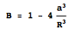

where a equals the radius of the spheres (1.9 cm) and R is the separation between the centers of the spheres.

4. 2 Analysis of Force vs. Separation (10 points)
Record the data from section 3.3 in Table 6.1. Find your average θ value, θavg, for each R value. Now calculate the correction factor for each R using the above equation. Now using the equation θcorrected = θ / B, calculate your corrected θ average.

Table 6.1 (Section 3.3) TA Stamp_________________
R (cm) | θ | θavg | B | θcorrected | 1/R2 | ln(R) | ln(θcorrected)
20
14
10
9
8
7
6
5

Show one example of how you corrected your data. If you want to show all the calculations, you may do so.

Make a plot of ln(θcorrected) vs. ln(R) (y vs. x !!) from table 6.1 on the grid below. Make a best-fit curve to the plotted data. Include axes labels.


What is the slope of the best fit line? Show your calculation below.

Do the results of the graph and slope indicate a “power law” (y=xn)? If so, what is your best estimate of the exponent? How does your result compare with Coulomb’s Law in Eq.6.1?
Hint: Consider what you did in Pre-lab Question #2 and Eq.6.2.

4.3 Analysis Force vs. Charge (Method 1) (10 points)
Record the data from section 3.4 in Table 6.2. Find your average θ value, θavg, for each Q value. Now calculate the correction factor B for 8 cm using the equation from Section 4.1. Now using the equation θcorrected = θ / B, calculate your corrected θ average.
Correction factor B for 8 cm:
TA Stamp______________________

Table 6.2 (Section 3.4)
Q (kV) | θ | θavg | θcorrected
6
5
4
3
2
1

Plot your data for deflection versus charge Q (θcorrected vs. Q) from Table 6.2 on the grid below (next page). Provide axes labels. Draw a best-fit curve (i.e. a line, smooth curve, etc.) to your data.

Analyze your best-fit curve to the deflection vs. charge plot. What mathematical relationship exists (approximately) between the deflection and charge?

By recognizing the relationship set forth in Equation 6.2, what should the theoretical relationship be between the decay-corrected deflection and the charge according to Coulomb’s Law? Why or why not does your data agree with Coulomb’s law?

4.3 Analysis Force vs. Charge (Method 2) (skip: we are not using method 2) Record the data from section 3.5 in Table 6.3. Find your average θ value, θavg, for each Q value. Now calculate the correction factor B for 8 cm using the equation from Section 4.1. Now using the equation θcorrected = θ / B, calculate your corrected θ average.
Correction factor B for 8 cm:

Table 6.3 (Section 3.5)
Q | θ | θavg | θcorrected
1
½
¼
1/8

Plot your data for deflection versus charge Q (θcorrected vs. Q) from Table 6.3 on the grid
below. Provide axes labels. Draw a best-fit curve (i.e. a line, smooth curve, etc.) to your data.

Analyze your best-fit curve to the deflection vs. charge plot. What mathematical relationship exists (approximately) between the deflection and charge?

By recognizing the relationship set forth in Equation 6.2, what should the theoretical relationship be between the decay-corrected deflection and the charge according to Coulomb’s Law? Why or why not does your data agree with Coulomb’s law?

