Laboratory Section: ________________ Partners’ Names: ___________________________

Last Revised on October 21, 2020 Grade: ___________________
EXPERIMENT 9
Superconductivity & Ohm’s Law
Watch three videos: Turn CC on for captions
- Intro to multimeters video –-- 5:50 min
http://www.pas.rochester.edu/~physlabs/manuals/IntroToMulti.mp4
- Multimeter video for lab 9. --- 3.13 min
http://www.pas.rochester.edu/~physlabs/manuals/Lab9.mp4
- Lab 9 experiment prelab video. (12:20 min).
https://rochester.hosted.panopto.com/Panopto/Pages/Viewer.aspx?id=aa9dabf7-073e-459b-8402-ac0500497d90
Then: Read Lab 9 manual and then read the brief notes for lab 9. (Also go over the general brief note for all lab). READ IN ADVANCE all the Questions in the postlab section and make notes as to how to answer them. If you need clarification ask the TA in lab. MAKE SURE THAT YOU ARE FULLY PREPARED AS THIS LAB MAY TAKE LONGER THAN PREVIOUS LABS UNLESS YOU ARE PREPARED.

Pre-Laboratory Work [2 pts]

1. Define the critical temperature for a superconducting material. Explain in words any method for measuring the critical temperature in a superconductor. (1 pt)

2. What is an ammeter? a voltmeter? What is the major difference in the way one uses each to measure electrical quantities in a simple electronic circuit? Be specific. (1 pt)

Experiment #9: Superconductivity & Ohm’s Law
PHY 122/142/114
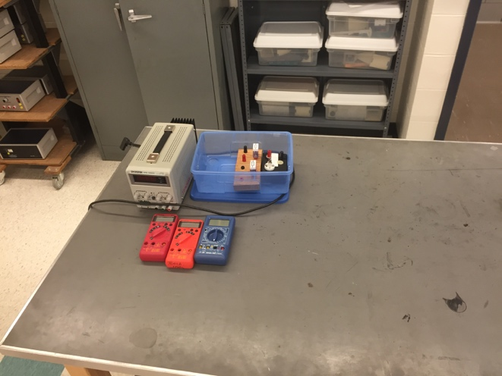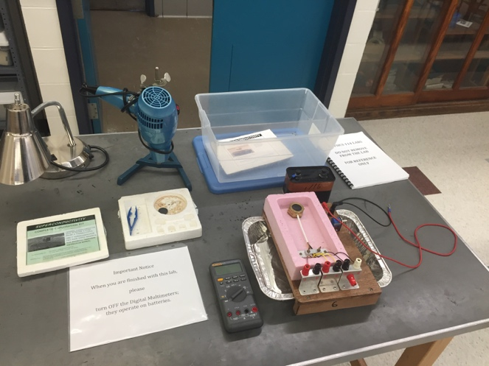
Hair Dryer

Box with 2 resistors & 1 light bulb

High Resolution Multimeter (Fluke)

Battery

Apparatus

Styrofoam Tray

1 Red Wire, 1 Black Wire

Empty box

3 Normal Multimeters

Power Supply

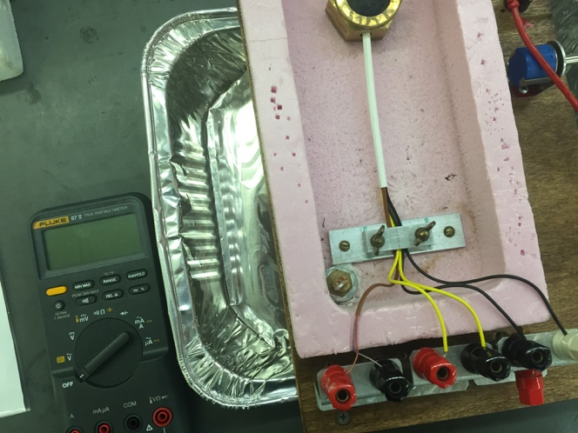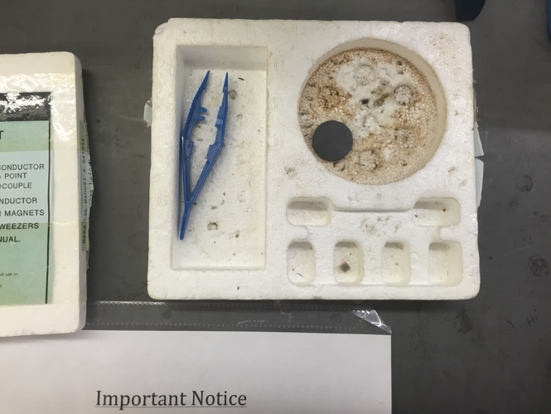
Magnet

(opt) chip of YCBO

Tweezers

Materials List:
- Power supply
- 3 normal multimeters
- Box with 2 resistors & 1 light bulb
- Hair Dryer
Items in room available to be shared by all students for all labs

- Scale
- Additional ruler

For this lab also Liquid Nitrogen Dewar

- Styrofoam Tray
- Box: empty
- Battery
- 1 Red wire, 1 Black wire
- Apparatus
- High Resolution Mulitmeter (Fluke)
- Magnet
- Tweezers
- (opt) chip of YCBO

Setup Notes:
- Attach red wire to positive, black to neg – black return plug into apparatus
- Multimeters in front glass cabinet, power supply & cords back corner (B&L 268)

EXPERIMENT 9
Superconductivity & Ohm’s Law
Lab 9 experiment prelab video. (12:20 min).
https://rochester.hosted.panopto.com/Panopto/Pages/Viewer.aspx?id=aa9dabf7-073e-459b-8402-ac0500497d90

1. Purpose
In the first part of this experiment you will observe a fundamental property of superconductors, the levitation of a magnet by a superconductor, illustrating the Meissner Effect. In the second part of the experiment, you will observe and verify Ohm’s Law in simple resistive circuits.
2. Introduction
2.1 Superconductivity

The flow of current in normal conductors dissipates energy producing heat. This "frictional" dissipation is measured by the resistivity of the material and is the origin of Ohm's Law.
At lower temperatures some materials called superconductors lose all measurable electrical resistivity. Without any driving voltage, superconducting currents will flow indefinitely with no discernible decay. This phenomenon was originally discovered in 1911 by the Dutch physicist Heike Kamerlingh-Onnes (Nobel Prize: 1913).
The superconducting transition (going from the normal, resistive state to a non-resistive, superconducting state) occurs over a relatively small change in temperature. The temperature at which it occurs, called the critical temperature , depends upon the material. Until recently, all known superconductors had a below 23K. The new ceramic superconductors (Nobel Prize: 1987) used in this experiment have much higher critical temperatures (90-100K). Since liquid nitrogen boils at 77K, the ceramic materials make superconducting phenomenon easily observable.
The theoretical understanding of superconductivity in these materials is not entirely understood. Before the discovery of the ceramic superconductors in 1986, the accepted model was the BCS theory (Bardeen, Cooper and Schrieffer, Noble Prize 1957). According to this theory a superconducting current is carried by bound pairs of electrons (Cooper pairs) which move through a metal without energy dissipation. The mechanism for the new ceramic superconductors remains unknown and is the subject of much present day research.
Another striking property of superconductors is that they are perfectly diamagnetic.
When below the critical temperature, a superconductor will not allow any magnetic field to penetrate it. This is the Meissner Effect. Any external magnetic field which would penetrate the superconducting material is canceled by an opposing field produced by electric currents induced in the superconductor. If this external field comes from a magnet, then the expulsion results in a repulsive force on the magnet. The magnet, above the superconductor, will be levitated. This magnetic repulsion is a manifestation of the Meissner Effect.

2.2 Ohm’s Law

In simple resistive electronic circuits, Ohm’s Law governs the relationship between voltage, current and resistance:
Equation 9.1

Ohm’s Law is a statement that there is a linear relationship between a driving voltage, V, and the resulting current, I, in an electrical circuit. The proportionality constant between voltage and current is the resistance of the circuit, R. Simple electronic circuits are usually made up of a direct current (DC) voltage supply, one that supplies a constant potential difference between 2 junctions in a circuit. A typical example is a battery. This DC voltage source is then hooked up to a combination of wires, individual resistors, and sometimes measuring devices like voltmeters and ammeters to measure voltage and current, respectively
Commonly used resistors are carbon-based and are color-coded to allow easy identification. Individual resistors can be combined in two ways to form complicated circuits: parallel (see Figure 9.1) and series (see Figure 9.2). Resistors that are combined in series have their individual resistances add together for the total. In parallel, the inverse total resistance is the sum of the individual inverse resistances:

Series Equation 9.2
Parallel Combination
Series Combination
Figure 9.2
R1
R2
R3
Figure 9.1
R1
R2
R3
Parallel Equation 9.3
3. Laboratory Work

3.1 Superconductivity (STUDENTS IN ODD TABLES DO THIS PART first. STUDENTS IN EVEN TABLES DO THIS PART second).

PRECAUTIONS!!!!

In this experiment you will handle liquid nitrogen which can cause severe "burns" because of its extremely low temperature. Certain precautions must be taken. You should read the following instructions carefully and practice these safety measures in the experiment.

1. Wear safety glasses at all times in the presence of liquid nitrogen (LN₂).
- Do not allow any liquid nitrogen to touch your body, and do not touch anything that has been immersed in it until that item warms to room temperature.
- Keep LN₂ away from the water.
4. Be extremely careful not to overfill or to spill liquid nitrogen from any vessel. Never store liquid nitrogen in a container with a tight-fitting lid because over pressure by the evaporated nitrogen may cause an explosion.
5. The superconductors are made of metal oxides that may be potentially toxic. For your safety, never handle the superconductor with your bare hands. Use the tweezers provided. Wash your hands with soap and water after the experiment is completed.

As you can see, parts of this lab are potentially hazardous. However, by understanding the procedures and taking the precautions listed here, you can perform this lab safely. If you have any questions or are not sure how to be safe while doing this lab, please ask the lab TAs or TIs.

3.1.1 Experimental Set-Up

- 1. Set up the apparatus and various meters as shown in Figure 9.3 below. Set-up the multimeter to measure DC voltage and attach the wires to leads 3&4. Set to measure 20mV. Attach a voltmeter to leads 5&6, set to measure DC voltage in the mV range. Attach an ammeter to leads 8&9, set to measure DC current in the 10A range (make sure to not plug into the 200mA setting, as this could blow a fuse). Attach the 6V battery to leads 1&2. Set the current to maximum (around .3 A) by turning the potentiometer located below leads 1&2 to adjust the variable resistance. Make note of this value in Table 9.1a, as it will remain constant.
2. Cooling: Make sure the cork is secured in the foam, and the aluminum foil tray is under the drainage pipe. Pour liquid nitrogen over the superconductor to bring the temperature down past the critical temperature. You will be measuring the temperature of the superconductor via its thermal conductivity (measured by the multimeter connected to leads 3&4). As the superconductor cools, the conductivity should go from ~0mV at room temperature to ~6mV when it is in equilibrium with the liquid nitrogen. When the multimeter connected to leads 5&6 reads 0.0mV the superconductor is sufficiently cooled.

1 2
9 9
3 4 5 6 7 8

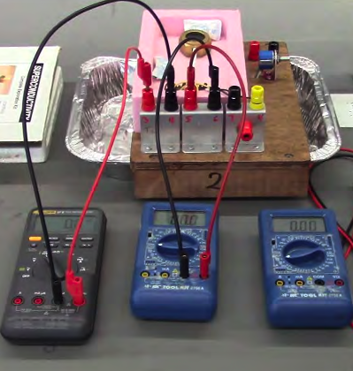

Figure 9.3
3. Using the tweezers, pick up one of the cubic magnets provided and place it on top of the superconductor disk. Try gently spinning the magnet with the tweezers. Observe whether the magnet is touching the surface of the disk. Be careful to not get your fingers or face close to the liquid nitrogen. Leave the cubic magnet there while continuing the experiment.
4. Warming: When ready to start taking data, USE THE TWEEZERS to remove the cork so the liquid nitrogen drains from your set-up. Be mindful of the liquid in the foil tray, and the tray itself which may get cold. Aim the light bulb at the setup to speed up the warming process.
5. Measuring: As the superconductor warms, make recordings of the thermal conductivity (leads 3&4) and potential (leads 5&6) in Table 9.1a. Make sure to record where the voltage changes from 0.0 mV to 0.1 mV and then with every 0.1-0.2 mV raise in potential until the voltage reads ~2mV. Also watch for the levitating magnet to fall, and make a record so you can mark at what temperature this occurs.
6. Disconnect the battery and various meters from the circuit. Your TA or TI will take your apparatus to bring the superconductor to room temperature safely. Use a hairdryer to evaporate the liquid nitrogen in the foil tray. Use the “low” setting and remain a safe distance away to prevent splashing.

3.1.2 Critical Temperature Analysis

- Fill in the second column of Table 9.1a by converting the thermal coupling values to temperature using Table 9.1b. Extrapolate temperatures if your measurements are in between values on the table.
- Use Ohm’s Law to fill in column five of Table 9.1. Plot the two shaded columns as instructed in the post-lab section.

3.2 STUDENTS IN ODD TABLES DO THIS PART second. STUDENTS IN EVEN TABLES DO THIS PART first).

3.2 Ohm’s Law

3.2.1 A Single Resistor

Connect your electronic components into the following circuit, as in Figure 9.4. Remember, the voltmeter (circled ‘V’) does not interrupt the “flow” of the circuit. It is measuring a potential difference “across” the resistor. On the other hand, the ammeter (circled ‘A’) is measuring current -all of the current- so it needs to interrupt the “flow” of the circuit. In other words, you will have one wire leave the output of power supply and go to the resistor. A wire will leave the other end of the resistor and go into the milliamp (mA) port of the ammeter. Another wire will exit the Common/Ground port of the ammeter and return to the ground of the power supply. The voltmeter will have 2 wires connected to it, one will tap into one side of the resistor, the other wire will tap into the opposite end of the resistor. Use a resistor of at least 1000 ohms. Use the color code in Section 3.3 to ensure that your resistor is 1000 ohms.
Figure 9.4
Power
Supply
R
+
-
I_{PS}
V_{PS}
A
V

Single Resistor Circuit
- Raise the power supply voltage up from zero. Take readings of voltage and current at 1 Volt intervals and record them in Table 9.2
- If you get negative values for voltage or current, disregard the minus sign and just record positive values.
- You should have 10 data points ranging from 1 – 10V.
- Measure the resistance of R using the ohmmeter capability of the multimeter.

3.2.2 Light Bulb

- In this section you will determine whether a common light bulb obeys Ohm’s Law.

- NOTE: IMPORTANT: CAUTION! You will use a similar circuit as in Figure 9.4 but will substitute the light bulb for the resistor and you MUST change the ammeter wires to

the highest current setting allowed. This will prevent blowing a fuse and making your time in lab so much more frustrating. Ask your TA or TI if you are unsure of what to do.

- The limiting rating of the light bulb is 6 volts. Keep your voltage from the power supply up to this level.

- Follow the same procedure as with the single resistor (Section 3.2.1). Record your current and voltage values in Table 9.3. Again, you should have 10 pairs of data points ranging from 0-6V. You may not see a linear relationship between V and I.

3.2.3 Resistors in Series: The Voltage Divider
The Voltage Divider
Figure 9.5
Power
Supply
R₁
R₂
+
-
V₁
I₁
I₂
A
V₂
I_{PS}
V_{PS}
Consider the circuit shown in Figure 9.5. It is a circuit with 2 resistors in series. In electronics lingo it is called a “voltage divider”. You will see why this is as you measure its characteristics.

Note:
- The current through each of the resistors must be the same because the resistors are in series,
i.e. I_{PS} = I₁ = I_{2.}
- If we add up the voltages across each resistor and the voltage of the power supply as we go around the loop, we find that they sum to zero, i.e. V_{PS} = V₁ + V₂. This is known as the Loop Rule.
- The resistance values of each resistor can be known by reading the color code on each. This code is included in Section 3.3.

Using these facts we can derive the fraction of the power supply voltage, V_{PS}, that appears across each of the two resistors. So for the first resistor, R₁,

Equation 9.4
Procedure

- Set up the circuit shown in Figure 9.5. You will need to include an ammeter as shown. You will also need to use the low current port of the ammeter, switching back from the high current port you used with the light bulb. You will be measuring voltages across each of the two resistors using a voltmeter.
- Let R₁ ~ 220 ohms, and R₂ ~ 1000 ohms.
- Set the voltage on the power supply to around 3V. Measure the voltage drops across each resistor, the current through the loop, and the actual values of each resistor. Record this information in Table 9.4

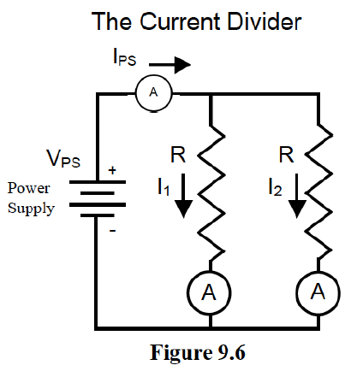
3.2.4 Resistors in Parallel: The Current Divider

Consider the circuit shown in Figure 9.6. It is a rearrangement of the previous circuit and puts the same 2 resistors in parallel, rather than in series. This time you have built what is called a “current divider” for reasons you shall verify. At the point labeled ‘X’ we can apply the Current Sum Rule and write an expression like this:

Equation 9.5

Next we can write Kirchoff loop rules for the left hand and right hand loops to find that,

Equation 9.6

We can then calculate the fraction of the current coming out of the power supply that pass through each of the resistors. For example,

Equation 9.7

Notice that now we have a current divider circuit analogous to the voltage divider except that the label of the numerator on the right hand side has switched from that of the voltage divider equation.

Procedure

- Assemble the circuit as shown in Figure 9.6. You may not have 2 ammeters as the figure shows, but the figure is trying to express that you have to measure the current in each branch. Use the same 2 resistors as before, keeping R₁ equal to 220 ohms and R₂ equal to 1000 ohms.
- Set the power supply to about 3V.
3. Using a current meter, measure each of the three currents labeled in the figure and record the data in Table 9.5. Measure I_{PS} directly.
  - Resistor Color Code

The resistance value of a resistor may be read from the color code printed on its exterior. Start from the first color band that is closer to one end than the other. The first 2 color bands represent the first two digits in the value of the resistance. The third color band represents the power of ten that the two digits are multiplied by to yield the final resistance value in ohms. If there is a fourth band present, it is a measure of the tolerance of the resistor, a measure of the uncertainty in the resistor’s printed value of resistance.

Below you will find an example of a resistor with gray-scale representations of colors and an example of how to read the resistance value from the color code table provided.

From left to right, the color order is Red – Red – Orange – Gold.
Figure 9.7
Red Red Orange Gold

Looking at the Color Code table, we see that this represents the numbers 2, 2, and 10³ or 10000. The fourth color band tells us the tolerance for this resistor is 5% (a high quality resistor). So the final resistance value is:

So we would expect to measure a resistance in the range of about 21000 to 23000 ohms.

Resistor Color Code

Color | Number | Multiplier
Black | 0 | 1
Brown | 1 | 10¹
Red | 2 | 10²
Orange | 3 | 10³
Silver | - | Tol = 10%
Gold | - | Tol = 5%

Last Revised on October 21, 2020

EXPERIMENT 9

Superconductivity & Ohm’s Law

4. Post-Laboratory Work [20 pts]

4.1 Superconductivity [5 pts]
Critical Temperature Analysis:

Thermal Conductivity (mV) | Temperature  (deg. K) | Voltage  (mV) | Current  (A) | Resistance  (mΩ)
Table 9.1a **TA Stamp: ________________

Conversion from mV to Kelvin
mV | 6.92 | 6.85 | 6.78 | 6.71 | 6.64 | 6.56 | 6.49 | 6.42 | 6.37 | 6.33
Deg. K | 70 | 71 | 72 | 73 | 74 | 75 | 76 | 77 | 78 | 79

mV | 6.29 | 6.25 | 6.21 | 6.17 | 6.13 | 6.09 | 6.05 | 6.01 | 5.97 | 5.93
Deg. K | 80 | 81 | 82 | 83 | 84 | 85 | 86 | 87 | 88 | 89

mV | 5.90 | 5.86 | 5.83 | 5.79 | 5.75 | 5.72 | 5.68 | 5.64 | 5.60 | 5.56
Deg. K | 90 | 91 | 92 | 93 | 94 | 95 | 96 | 97 | 98 | 99

mV | 5.52 | 5.48 | 5.44 | 5.41 | 5.37 | 5.34 | 5.30 | 5.27 | 5.23 | 5.20
Deg. K | 100 | 101 | 102 | 103 | 104 | 105 | 106 | 107 | 108 | 109

mV | 5.16 | 5.13 | 5.09 | 5.06 | 5.02 | 4.99 | 4.95 | 4.91 | 4.88 | 4.84
Deg. K | 110 | 111 | 112 | 113 | 114 | 115 | 116 | 117 | 118 | 119

mV | 4.81 | 4.77 | 4.74 | 4.70 | 4.67 | 4.63 | 4.60 | 4.56 | 4.53 | 4.49
Deg. K | 120 | 121 | 122 | 123 | 124 | 125 | 126 | 127 | 128 | 129

mV | 4.46 | 4.42 | 4.39 | 4.35 | 4.32 | 4.28 | 4.25 | 4.21 | 4.18 | 4.14
Deg. K | 130 | 131 | 132 | 133 | 134 | 135 | 136 | 137 | 138 | 139
Table 9.1b
Take your data from Table 9.1a and make a plot of Resistance vs. Temperature (y vs. x!!) on the axes provided. Include labels and units. What is the critical temperature of the superconductor? Mark on your plot where the levitating magnet fell.
4
.2 Ohm’s Law [15 pts]

Data

Single Resistor Data R = ______________

Power Supply Setting | Measured Voltage (Volts) | Measured Current (Amps)
Table 9.2 **TA Stamp: ________________

Bulb Data

Power Supply Setting | Measured Voltage (Volts) | Measured Current (Amps)
Table 9.3 **TA Stamp: ________________

Series Resistor Data Parallel Resistor Data

Power Supply Volts
R₁
R₂
I_{PS}
V₁
V₂
V_{PS}
Table 9.4

Power Supply Volts
R₁
R₂
V_{PS}
I₁
I₂
I_{PS}
Table 9.5

Ohm’s Law Analysis [15 pts]

Single Resistor Analysis [4 pts]
1. Take your data from Table 9.2 (Single Resistor Data) and make a plot of Voltage vs. Current (y vs. x!!) on the axes provided. Include labels and units. Is the relationship linear? If so, draw a best-fit line. (2 pts)

2. Calculate the slope of your best-fit line. Compare this value of resistance to the value labeled on the actual resistor and the value you measured from the multimeter. (1 pt)

3. Calculate the power dissipated in the resistor when V = 6.0 Volts. (1 pt)

Single Bulb Analysis [6 pts]
4. Take your data from Table 9.3 (Bulb Data) and make a plot of Voltage vs. Current on the axes provided. Include labels and units. (2 pts)

5. Is there a linear relationship between voltage and current (compared to the linearity of the single resistor)? (It should not be!) Calculate the resistance of the filament at V = 6.0 volts. (1 pt)

6. Calculate the resistance of the filament for V = 1.0 volts. (1 pt)

7. Do you think the temperature of the filament is higher at V=6.0 than at V=1.0 Volts? How does this information compare with what you learned about metal superconductors as the temperature decreases? (2 pts)
Series Resistors Analysis [2 pts]
- Use Equation 9.4 and verify whether your measured value of V₁ is comparable to that from the equation. Show all your work. (1 pt)

- From the value of I_{PS} and V_{PS}, calculate the equivalent or total resistance of the circuit. Compare this with the theoretical value. Use Equation 9.2. (1 pt)

Parallel Resistors Analysis [3 pts]
- Use Equation 9.7 and verify whether your measured value of I₁ is comparable to that from the equation. Show all of your work. (1 pt)

- Show that the sum rule is satisfied from your measured current values using Equation 9.5. (1 pt)

- From the value of I_{PS} and V_{PS}, calculate the equivalent or total resistance of the circuit. Compare this with the theoretical value. Use Equation 9.3. (1 pt)

