Science: Christian and Natural

I.H.Hutchinson
Plasma Science and Fusion Center
and Department of Nuclear Engineering
Massachusetts Institute of Technology
Cambridge, MA, USA

ASA Conference, 4 August 2002

1 Faith and science, a personal view
I became a Christian while I was an undergraduate at Cambridge University, and was baptized on my 20 birthday in King's College Chapel. The courses I was studying were mathematics and physics, but I had read quite widely both at Cambridge and before, since a breadth of knowledge and interest seemed to me the mark of a serious intellectual, which was what I intended to be.
My prior exposure to Christianity had given the impression of a vague and unsatisfactory sentimentality, a psychological prop that I felt no need of, and a system of thought that was in the process of repudiating its roots. I was, despite that exposure, almost completely ignorant of the historical message of Christianity. That perhaps seems strange since I had attended a school where prayers were regularly said in the assembly, and which had a close relationship to Worcester Cathedral. Nevertheless, it seemed really a totally new revelation to me, when at the invitation of some Cambridge student friends, I attended a series of lectures by Michael Green (later published under the title ``Jesus Spells Freedom''). The ideas that seemed so novel to me were, for example, that there are strong historical reasons to believe that Jesus was who he said he was; that the theological teachings of Christianity had an inner consistency that made sense of the world, and of human experience; and strangest of all, that a personal relationship with God was possible, entered into by faith, but lived out in action in the world.
Many of my secular friends thought that I was commiting intellectual suicide by my conversion to Christianity. I can't say that I was surprised by their reaction - I was perfectly aware of the antagonism between much modern thought and Christianity - but I definitely had no sense of repudiating my intellect. If God and Christ were true, as I had come to believe, then that truth must be consistent with intellectual truth and I would with time understand how their respective claims might be reconciled.
I did well academically at Cambridge, and I also grew rapidly in my understanding of the Faith, largely through the college Christian fellowship, affiliated with the Cambridge Intercollegiate Christian Union (and hence the Intervarsity Fellowship). On graduation, I worked for a few months in a Church Army hostel for homeless men, seeing at first hand both the degradation to which some fall and the dedication of those who feel a call to serve them full time in the name of Jesus. I went to Australia where I did a PhD in plasma physics, and studied various Christian topics in my spare time: theology to become an accredited Methodist Local Preacher; Hebrew for interest, to complement the Greek I had learnt at school.
During this time, and ever since, I have felt remarkably little direct intellectual conflict between my faith and my science. Perhaps the greatest intellectual challenge to Christianity I sensed, was during my theological studies, a course fully committed to liberal theology and higher criticism. In the end, though, it seemed absurd to me that theology should adopt the naturalist presuppositions that dominate liberal theology, and then, after constructing elaborate stories about how the scriptures came to be what they are, conclude that the Bible is nothing but a human book. Of course, the conclusion is already effectively embodied in the presupposition. It might be useful to study the Bible in that way, but it could hardly be considered the most natural or fruitful way to study it. For natural science, though, the naturalist presupposition seems completely ... well ... natural.
One challenge that I wrestled with was the question: ``Why is it that in natural science, knowledge seems eventually to gain almost universal acceptance, whereas in theology the same sense of consensus and certainty almost never exists''. I came to the conclusion that the persuasiveness of science is a function of its subject matter. Natural science takes as its purview to study those aspects of the world which are truly reproducible and about which common agreement can be reached by all observers[1].
If this view of science, or rather perhaps one should say, this functional definition of what constitutes nature, is correct, then it immediately raises the question whether there is true knowledge that does not have this character: that is not about reproducible phenomena which lend themselves to consensual observation.
The driving force behind the scientization of all intellectual disciplines, during the nineteenth and the first half of the twentieth centuries, is undoubtedly the answer no. During that movement, the underlying presupposition was that in order to be true knowledge, any discipline had to be science, implicitly pursued in the manner of the natural sciences. This attitude was explicitly reinforced by the scientism of some famous and successful scientists and popularizers; and often still is today. But more than anything it was promoted by those who took it as their mission in the late nineteenth century to free higher education from its enthralment to `sectarian' theology.
Andrew Dickson White makes clear in his preface to the famous ``History of the warfare of science with theology in christendom'' [2] that the work is intended as a manifesto in support of his battle, associated with his presidency of the newly founded Cornell University, against denominational control of higher education. Therefore, in his portrayal of the `warfare', alongside natural science he includes chapters on philology, comparative mythology, economics, and biblical criticism, referring to all as science, and implying that the intellectual methodologies of all are similar. This approach bolsters his case for universal liberalism, by tying all disciplines to his contention that for centuries orthodox Christianity has viciously opposed every new discovery that threatened its traditional theological positions. Thus there is strong reason to suspect that the adoption of scientism was, in part, a tactical manoeuvre to gain secular independence for universities[3]. By portraying all real knowledge as being science and science as implacably opposed by, but eventually victorious over, Christian doctrine, that doctrine could be effectively neutralized as an intellectual force.
I conclude on the contrary that the answer is obviously yes: that non-scientific knowledge is, or can be, true knowledge in the many disciplines that don't lend themselves to the methods and presuppositions of natural science, for example the arts, humanities, history, most social studies, and theology.
Of course, the past decade or two of postmodernism have overturned the dominance of scientism in the academy. Not perhaps in a way that is particularly friendly to Christianity, but nevertheless reshaping the debate in ways that often place science and Christianity more in consonance than in conflict.
I take the position [1] that science and faith are complementary views of the world; that science studies the world insofar as it behaves in regular ways readily investigated using the reductionist methods of the physical sciences, and that theology finds its place along with many other disciplines, in understanding the human, personal, purposeful, and spiritual aspects of the world, which are not describable in reductionist terms.
Science-and-faith philosophers might label such a position as dividing intellectual endeavour into distinct `spheres of influence'. But I resist that designation both because I see the division as a matter of perspective more than subject, and because the expression implies that the spheres are chosen arbitrarily or for the convenience of the protagonists. The division of Europe into spheres of influence after world war II reflected no particular political or cultural characteristics of the countries on the two sides. In contrast, I regard the intellectual divisions as being logically inherent in the methods chosen for study. In other words, science has no choice but to limit its scope of study by the presuppositions in its methods of study, just as do other disciplines by theirs.
Such a position gives freedom for both science and faith, but that freedom is not unconstrained. The discoveries of science and the picture of the universe it has developed do not allow theology the freedom to adopt whatever view of cosmology (for example) might seem most comfortable for traditional doctrines. We don't, and can't, now believe the earth to be flat or covered by a crystal firmament, in which are embedded the stars. We don't, and can't, believe that the sun, moon and planets revolve around the earth. We don't, and can't, believe that the earth is only 6000 or so years old. These beliefs are all more easily reconciled with a literal reading of the first few chapters of Genesis, and with much of the apparent world-view of the New Testament writers, than modern cosmology. But science says, insofar as the world is governed by repeatable events accessible to consensual observation, it appears the earth is spherical, in orbit around the sun, and roughly 3 billion years old. It would be possible for a perverse theology to say, fine, but the reason is that God created the world in such a way that it just appears this way, whereas the reality is that Genesis is a literal description of nature. However, such a position, while not logically untenable, is theologically untenable, making God into a trickster.
There are many tensions between the natural sciences and the traditional embodiments of Christian doctrines, but these tensions are not fatal. The church hierarchy did resist the heliocentric model. They did so, in large part, because church teaching was entangled in the old cosmology, and they feared the consequences of any untangling. Nevertheless, Christian faith outlasted their fears. The same can be said of many other deeply held beliefs; it can also be said of many popular superstitions thankfully dispelled by scientific understanding.
I believe that the calling of the American Scientific Affiliation is to help Christians to understand what is and is not true scientific knowledge and to promote an understanding of the world consistent with science and with the Lordship of Jesus. To do this requires us to engage in a prophetic role towards the Church as much as to the world.

2 Distinctively Christian Science
There have been a number of initiatives fairly recently among Christian scholars to rediscover a distinctively Christian approach to their studies. The Society of Christian Philosophers is one notable example. Their influence has been considerable, in their discipline, in the church, and in theology. I think there is much merit in their efforts. In discussions with scholars outside the sciences, this idea naturally leads scientists, myself included, to ask, is there such a thing as a Christian Science? By this phrase I mean not the peculiar sect it has unfortunately become associated with, but natural science, within the mainstream of scientific thought (or at least not off in some fantasy land like so called ``Creation Science'') that is distinctively Christian.
In thinking about this question with students and other Christians, I soon came to two conclusions. The first is that there are many aspects of science that are obviously the same whether pursued by Christians or atheists. It is not possible, I hold, to solve a differential equation (for example) by techniques that are different for a Christian than for someone else. Some knowledge and thought is truly common, regardless of conviction. Scientific knowledge perhaps more than any other discipline, is common, because of its methods of investigation. The second conclusion is that if Christian Science means an approach to natural science that seeks scientific data in the scriptures or some other religious authority rather than in nature itself, then I am deeply suspicious of it. That would sound too much like a return to the sterile Aristotelian and Scholastic philosophizing that modern science has overthrown. I hold that the Book of Nature contains different aspects of revelation than the written Word of God. God intends the unwritten book to be read, as he intends the Bible to be read: on its own terms, before all else.
Going further, though, I believe there is a constructive case to be made for the phrase Christian Science.
First, as represented by the theme of this conference ``Christian Pioneers'', we should recognize that modern science is built upon the foundational work of people who more than anything else were Christians. Christians were the pioneers of the revolution of thought that brought about our modern understanding of the world. MIT, my home institution, the high-temple of science and technology in the United States, has a pseudo-Greek temple architecture about its main buildings. The fluted columns are topped not with baccanalian freizes, but with the names of the historical heroes of science (not to mention William Barton Rogers, the founder). A rough assessment was carried out by a few of us some years ago of the fraction of the people listed there who were Christians. The estimate we arrived at was about 60%.
Any list of the giants of physical science would include Copernicus, Galileo, Kepler, Boyle, Pascal, Newton, Faraday, Maxwell, all of whom, despite denominational and doctrinal differences among them, and opposition that some experienced from church authorities, were deeply committed to Jesus Christ.
Second, I observed over the years in my interactions with Christians in academia, that far from scientists being weakly represented in the ranks of the faithful, as one would expect if science and faith are incompatible, they are strongly overrepresented. The sociological evidence has been studied systematically for example by Robert Wuthnow[4], who established that while academics undoubtedly tend to be believers in lower proportion than the US population as a whole, among academics, scientists were proportionally more likely to be Christians that those in the non-science disciplines. The common misconception that scientists were or are inevitably sundered from the Christian faith by their science is simply false.
Third, the question arises, why did modern science grow up almost entirely in the West, where Christian thinking held sway? There were civilizations of comparable stability, prosperity, and in many cases technology, in China, Japan, and India. Why did they not develop science? It is acknowledged that arabic countries around the end of the first millenium were more advanced in mathematics, and their libraries kept safe eventually for Christendom much of the Greek wisdom of the ancients. Why did not their learning blossom into the science we now know? More particularly, if Andrew White's portrait of history, that the church dogmatically opposed all the ``dangerous innovations'' of science, and thereby stunted scientific development for hundreds of years, why didn't science rapidly evolve in these other cultures?
A case that has been made cogently by Stanley Jaki[5], amongst others, is that far from being an atmosphere stifling to science, the Christian world view of the West was the fertile cultural and philosophical soil in which science grew and flourished. He argues that it was precisely the theology of Christianity which created that fertile intellectual environment. The teaching that the world is the free but contingent creation of a rational Creator, worthy of study on its own merits because it is ``good'', and the belief that because our rationality is in the image of the creator, we are capable of understanding the creation: these are theological encouragements to the work of empirical science. Intermingled with the desire to benefit humankind for Christian charity's sake, and enabled by the printing press to record and communicate results for posterity, the work of science became a force that gathered momentum despite any of the strictures of a threatened religious hierarchy.
So I suggest that there is a deeper reason why scientists are puzzled about how one might pursue a Christian Science distinguished from what has been the approach developed over the past half millenium. It is that modern science is already in a very serious sense Christian. It germinated in and was nurtured by the Christian philosophy of creation, it was developed and established through the work of largely Christian pioneers, and it continues to draw Christians to its endeavours today.
Obviously this view is very different from the common misperception of the relationship between science and faith, which is far more like White's warfare. The common misperception is fed by many science popularizers, and many leading scientists. I was at my son's graduation from Bates college this May. The speaker was Steven Weinberg, outstanding scientist, nobel prize-winner in physics, and a highly articulate advocate of scientism. The gist of his commencement message was to welcome the students to the enlightenment, explicitly disparage all religions as superstition and mediaevalism - Islam came in for special criticism, which was at least a change from the usual academic anti-Christian bias - and debunk postmodernism while praising science. Weinberg is of course just one of the highly influential scientists who have gained media attention as the champions of scientism. A more nuanced understanding of science and society does not make such good copy. The media loves the extremists.
What troubles me more than this, though, is that the common misperception is fed just as much by well-meaning Christians. The opinion that established science and Christian faith are at war, seems to be promoted deliberately by ongoing debates suggesting that incompleteness of scientific knowledge or understanding should be cause for satisfaction on the part of Christians.
Certainly it is incumbent upon us Christians to point out, forcefully if need be, when scientists or others turn the success of science into advocacy for materialism or atheism. When, for example, the inability of science to detect purpose in nature is interpreted as a proof that the universe is purposeless, rather than an obvious consequence of science ruling out purpose from its methodology right at the beginning. But what needs to be opposed is bad logic; it is not science but scientism: the unjustified belief that all useful knowledge is science.
The United States is remarkable in being the culture above all others that continues to promote the warfare misperception. My observation (albeit only anecdotal) is that Christians in most of the rest of the world spend far less of their time worrying about how to undermine evolutionary teaching in schools. Perhaps part of the reason is that Christians are a smaller fraction of other societies, and see their priorities as more to do with getting out a positive message rather than continuing intellectual arguments from the nineteenth century[6]. However, I have a theory that the main reason for the prevalence of this argument in the U.S. is the interpretation of the non-establishment clause of the First Amendment that has mostly banished faith from public schools. Christians want faith to be part of their childrens' background in schools. If only science is permitted by the constitution, then the only way this can happen is to make faith into science, hence the popularity of Creation Science, and more recently of Intelligent Design. I take this to be a potentially disastrous mistake.
My son in his elementary school days once did a school project around Christmas time collecting together the words of songs. On the cover of his project he put the title ``Christmas Carols''. His teacher was scandalized, and told him that he must not call them that, even though that was largely what they were, but he must call them ``Holiday Songs''. This is the sort of anti-Christian dogma that we should oppose. Non-establishment is not the establishment of atheism, but we don't do our cause any good by trying to get equal time for creationism in biology class by arguing that it is a scientific theory.
If I am right, and the expression Christian Science is not an oxymoron but a reflection of history and reality, despite the warfare advocates on both sides, then I think it becomes clear what our task as scientists and Christians is. It is to help the church respond to, and accommodate what science is showing us about the natural world, including those facts that are uncomfortable for traditional or literalistic scriptural interpretation. And it is to bring our faith and commitment to science. It is to this second aspect that I now turn briefly.

3 Scientific Spiritual Service
When I argue that science is in a deep sense Christian, I don't intend to say thereby that all of science or of its products are good. I think an incarnational approach here is critical, which I like to explain by an analogy, imperfect though it is. To practice science is Christian in some analogous ways as it is Christian to drink wine. The drinking of wine is enjoyment of the benefits of a good creation, it is explicitly sanctioned and blessed by our Lord. Indeed Jesus has raised the drinking of wine to our most hallowed spiritual sacrament. Nevertheless not all wine drinking is beneficial. Some of it is deeply fallen. But it is by the way we humans participate that the wine drinking becomes what it is - a blessing or a curse. I think much the same is true of science.
There is much more that I could say about ways in which I think we can make our science a spiritual service. But the organizers asked me to include some discussion of my own scientific field and my experience in it. Perhaps that material will address some of those questions, though more indirectly.
My research for practically the whole of my career has been in plasma physics, the study of the collective behaviour of ionized gases. The motivating application of my work is to make fusion energy, the energy source of the sun and stars, available on a human scale. The fusion reaction of most interest is show in in Figure 1.
  Figure 1: The Deuterium-Tritium fusion reaction.
  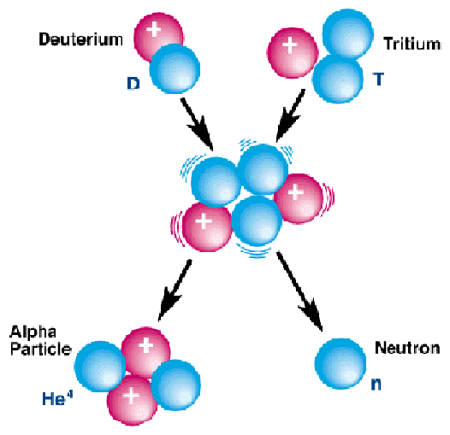
This reaction has the potential to produce energy that could be turned into electricity, utilizing roughly 250 lbs of hydrogen fuel per year to power a large (1 GW) generating station. No climate-damaging emissions would be produced.
To make the reaction happen, though, requires very high temperatures, roughly one hundred million degrees Celsius. At that temperature all matter is turned into plasma and a solid containment device is useless. Creation's fusion reactors, the stars, have plasma confined by the weakest fundamental force: gravity. This is a gloriously stable and efficient design, but unfortunately too large for human control.
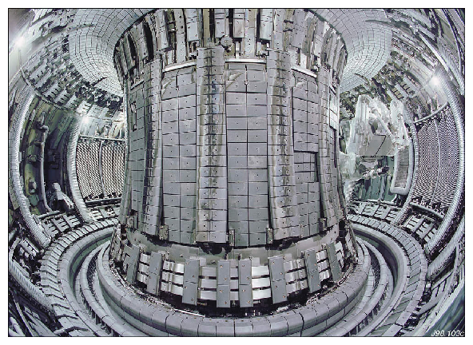
Figure 2: Wide-angle view of the inside of the world's largest tokamak, JET. The large ports allow heating of the plasma via energetic neutral particle beams, and radio wave launchers allow direct resonant heating. The plasma exhaust is managed by a so-called ``divertor'' in the bottom of the chamber.
The humans scale needs a different non-material force for plasma containment: the magnetic field. I began fusion research not long after the tokamak, the magnetic confinement configuration pioneered by the Soviet Union's scientists, became predominant by virtue of its excellent performance. Since then plasmas heated to temperatures even beyond those necessary for efficient fusion reactions have been achieved. Figure 2 shows an internal view of the vacuum vessel in which the JET tokamak plasma is formed.
On the way, we have learned the science of MagnetoHydroDynamics (MHD) which describes the global equilibrium and stability of a plasma whose multi-atmospheric pressure is constrained by nothing but the magnetic field. The knowledge gained allows us to predict with remarkable reliability these aspects of plasma performance. See figure 3.
  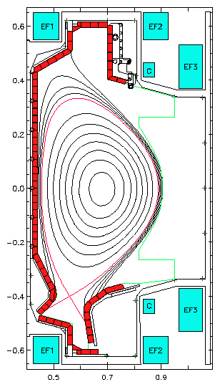
  Figure 3: An example of a section through the Alcator C-Mod tokamak showing the field lines of the tokamak which are responsible for containing the plasma pressure. The detailed shape of this equilibrium is accurately described by MHD.
Our knowledge of the mechanisms that transport heat and particles across the field lines, leading to slow leakage of the plasma from the magnetic bottle, is less complete. This is a grand challenge of physical science. It is no less than to understand how to calculate turbulent transport, not of neutral fluids such as water or gas (which are tough enough), but of electrically conducting plasmas which combine many of those fluids' challenges with additional degrees of freedom. We are making striking progress. A theoretical simulation of the sorts of density fluctuations that are responsible for plasma losses is shown in Figure 4.
  Figure 4: Turbulence simulation of tokamak transport (Courtesy G.Kerbel).
  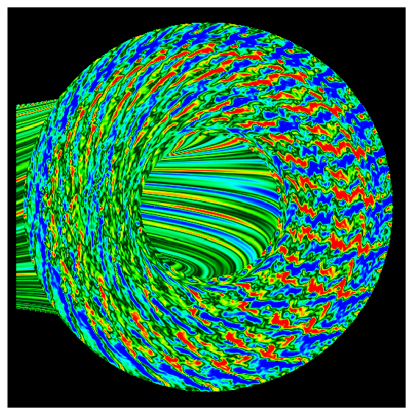
Progress in plasma performance has, if anything, been even more striking. The rate of increase of experimentally achieved fusion power generation over the past 30 years has exceeded Moore's law (more than doubling every 18 months). So that, in 1997, 16 MW of fusion power was briefly produced from the JET experiment.
To progress to the next stage in fusion research, exploration of a plasma kept hot by its own internal fusion heating, needs a new experiment. An international design called ITER has been developed, illustrated in Figure 5.
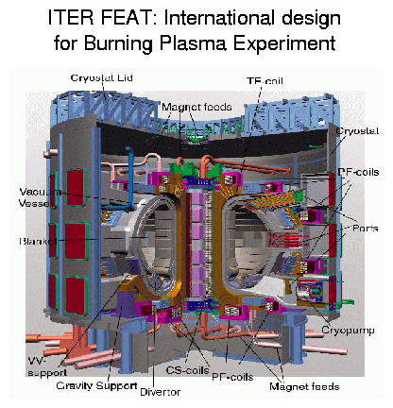
Figure 5: A burning plasma experimental design.(See http://www.iter.org/)
This design is not yet funded for construction. It will be expensive, about $5b shared among three or four international partners. The decision to proceed with such an experiment must be made at the highest levels of government. And it is an experiment. We believe the science is sound, but whether devices like this can be engineered into an economically competitive energy system, is still unknown, in part because economics is not a law of nature.
I know many Christian people among the scientists of the fusion community. I suspect there are so many because of the high ideals of the program and the underlying motivation to benefit mankind. Indeed most of my colleagues, whether Christian or not, can testify to some degree of idealism motivating their choice of fusion as a research career. What is perhaps more remarkable is that the fraction of my students that have been either Christians or at least strongly interested in spiritual matters, is probably at least 25%. Again supporting my use of the phrase Christian Science.
Large scale science like fusion research places many non-technical challenges before a scientist such as myself. Leading a group of 100 people (rather a small group by fusion standards) is more akin to running a small company than to the ivory-tower intellectual individualist experience that is commonly portrayed. Following Jesus Christ in such a situation calls for the same commitments as in many such positions of leadership: clarity of thought, integrity, compassion, as well as resisting the temptations that go with power and intelligence: arrogance, self-justification, self-aggrandisment, and so on. Moreover, it demands management skills that scientists are often poorly prepared for. I find that my Christian experience in small group dynamics, in personal interactions, and speaking from the pulpit, is often far more important than that I know how to evaluate an integral or operate a lab instrument. My wife is a nursery school teacher and I am reminded of a book she showed me once entitled something like ``All I really needed to know I learnt in Kindergarten''. Being a scientist, I would remove the hyperbole, but I would still be able to say in somewhat the same spirit that ``most of what I need for scientific leadership I learnt in Sunday school'' (in my case Adult Sunday school and small group Bible study).
At MIT I have had opportunities to speak the Gospel to colleagues, to pray with students in my group stuggling with personal or educational challenges, to share in exploring the faith with Christian faculty and students, and to lead seminars specifically focussed on Christian content. These `extra-curricular' activities are precious gifts from God - to be part of His Kingdom's direct action in the world. But I believe these are but the tip of the iceberg of what it means to be a Christian scientist.
The marvels of the scientific world are little revelations of God's creative thoughts. They are uncovered by attention to Christian mental virtues of objectivity, and truthfulness - which a secular scientific establishment finds, to its surprise, don't necessarily come naturally to a post-Christian society. They are part of a centuries-long heritage built by remarkable thinkers, many of whom were devout Christians, on a Christian philosophy of the world as an intelligible but contingent free creation. And they give opportunities for benefitting humankind, relieving hunger, need, and suffering, as Jesus calls us to do.
What a travesty of this heritage it is when natural science is put at war with Christian faith either by the bigotted arrogance of scientific secularists blind to the epistemological presupposition of science, or, more distressingly for me, by often equally bigotted Christian apologists, who fall into a similar error when they pit specific scriptural interpretations against observations of nature.
I am honored to be here at the ASA among a group of faithful believers who have committed themselves to helping to understand and show how science is both: Christian and natural.

References
[1]
I have explained my view somewhat more completely in ``Faith's Failure of Nerve'' Cross Currents: Religion and Intellectual Life, 40, 213, (1990).
[2]
A.D.White A history of the warfare of science with theology in christendom, Appleton, NY (1896).
[3]
I use White here as a representative of the much wider forces at work. These have been treated in detail by George Marsden in The Soul of the American University, Oxford U. Press, New York, (1994).
[4]
Robert Wuthnow The Struggle for America's Soul, Eerdmanns, Grand Rapids, (1989), p146.
[5]
Stanley L. Jaki The road of science and the ways to God, U. Chicago Press, Chicago, (1978).
[6]
A recent study by P.J.Bowler Reconciling science and religion the debate in early-twentieth-century Britain, U. Chicago Press, Chicago, 2001, explores other causes of the different trajectory of the science-religion debate in the UK.

File translated from T_{E}X by T_{T}Hgold, version 3.13.
On 30 Aug 2002, 16:21.

